

Applied Data Science

Assignment

Submitted by

Norbert Szilvasi

22073183

Table of contents

Section 1: Statistical Data Analysis 3

1.1 Task 1: Domain understanding and research question 3

1.2 Task 2: Dataset and data preparation 4

1.3 Task 3: Data Analytical Methods 33

1.4 Task 4: Evaluation and Conclusion 56

Section 2: Data Modelling 60

2.1 Task 1: Design a relational database using Crow Foot notation. 60

2.2 Task 2: MySQL code to database design. 63

2.3 Task 3: How database design will support the business scenario 103

List of figures

Figure 1. Crow Foot Notation Symbols 60

Figure 2. Full set of cardinality constraints in a relationship between two entities 61

Figure 3. Entity database relationship design 62

Figure 4. EDR from MSQL 103

List of tables

Table 1. Summarised table with all attributes 3

Table 2. Parametric methods and nonparametric methods 33

Table 3. SQL summary tables 104

# Section 1: Statistical Data Analysis

## 1.1 Task 1: Domain understanding and research question

The dataset belongs to the automotive research and analysis domain. Specifically related to fuel efficiency and emissions of vehicles.

Table 1. Summarised table with all attributes

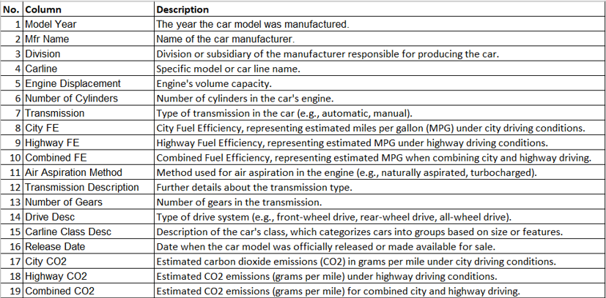

source: own creation

The report of the Intergovernmental Panel on Climate Change (IPCC) reveals that the surface temperature on the planet has risen by 0.89 degrees Celsius over the past century. More than 90% of climate change in the past 50 years is linked to the rise of greenhouses gases from burning fossil fuels (Lyu *et al.,* 2021). Because of the significant rate of climate change, estimates of oil consumption and pollution are essential to determine the impacts of resources and strict emission control plans (Hien and Kor, 2022).

**Research paper review analysis**

Transmission systems with automatic gearshifts have grown into the standard expectation for comfortable driving in luxury passenger vehicles. Due primarily to the viscous shear losses in the power converter, standard automatic transmissions (ATs) are less efficient than manual transmissions (MTs) (Vacca *et al.,* 2017). Despite the fast advancement of ATs technology, the conventional MTS will still have a significant role for a while due to its cost effectiveness, efficiency and consistent operation (Chen and Chen, 2021).

The research written by Luo *et al.,* 2021, using Monte Carlo simulation and petrol consumption of automated and human-driven vehicles was examined. It turned out that automated vehicle’s fuel consumption rate under the car-following scenarios was 11.944 litres per 100 km. With the same driving conditions, the human-driven had a fuel consumption rate of 10.124 litres per 100 km. It uses more frequent acceleration and braking steps and a greater average speed than human drivers. These features increase the automated vehicle’s fuel consumption rate.

The manual transmission connects the engine to the transmission by the means of an inflexible clutch, as opposed to the torque converter on an automatic transmission or slipping v-belt on a transmission that is continuously variable. Manual transmissions do not have the secondary power consumption of the hydraulic pump found in automatic transmissions. As a result, MTs typically provide greater fuel economy Ats or continuously variable transmissions. Depending on driving circumstances and driving skills, the higher fuel economy of a correctly driven MTs cars versus a similar ATs car can vary from 5 to 15 percent (Sheth, Gajjar and Chauhan, 2014).

**Formulation of an appropriate hypothesis**

H0:

There is no significant difference in Combined CO2 between manual and auto transmission.

**H1:**

**There is a significant difference in Combined CO2 between manual and auto transmission.**

Based on the previous research papers, H1 hypothesis is supposed to be accepted in further analysis in order to be in line with the research paper results.

## 1.2 Task 2: Dataset and data preparation

**Missing values**

There aren’t any missing values.

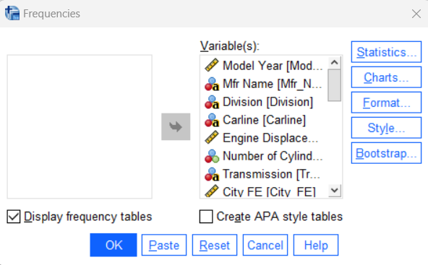

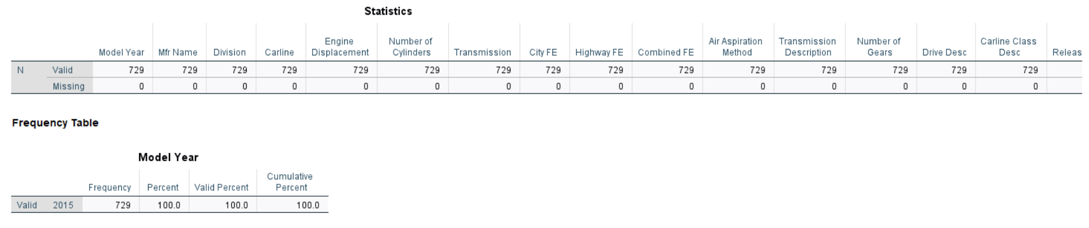

**Renaming the columns**

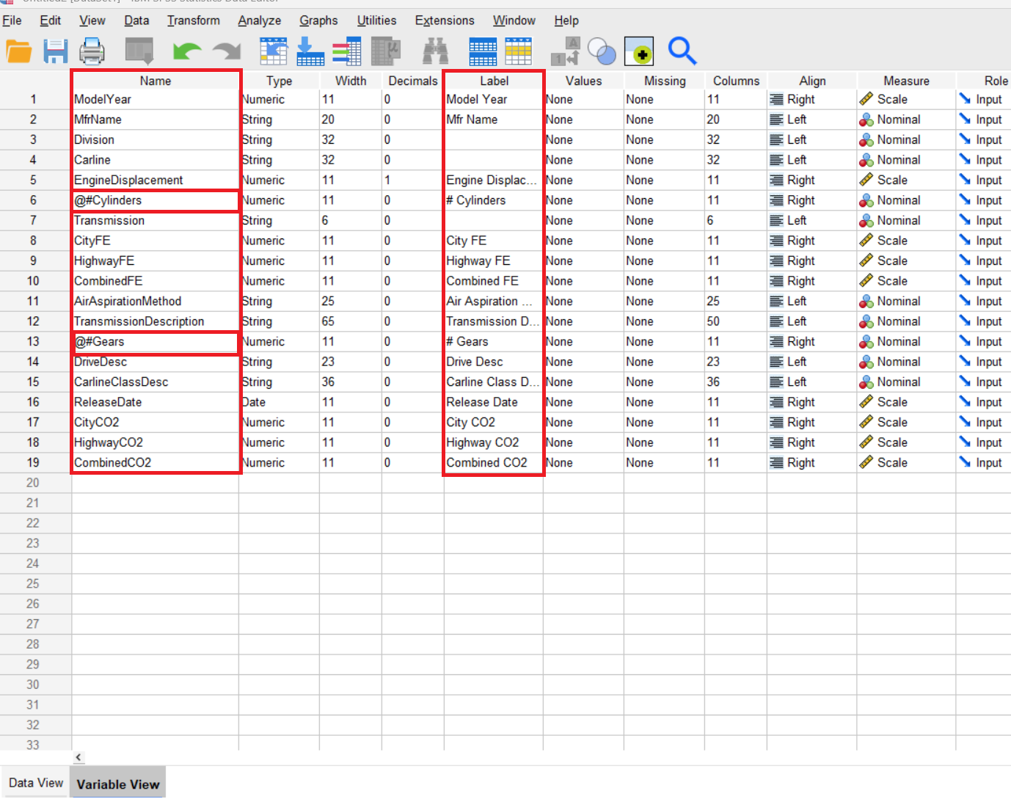

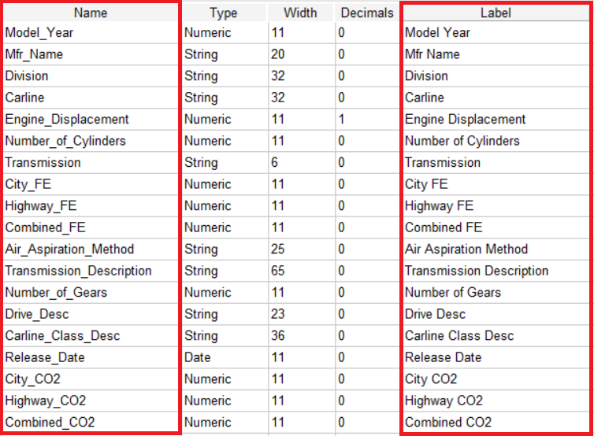

The corrected name columns with underscore appear.

**Replacing the incorrect “d” value**

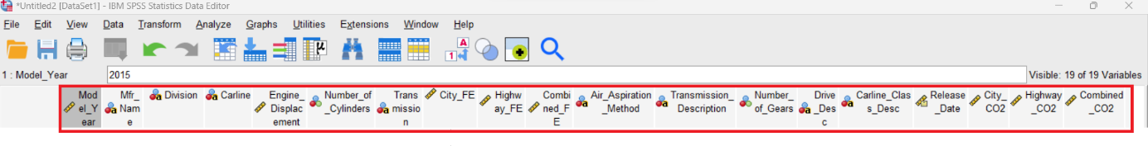

Drive_Desc column contains a “d” value which can be replaced.

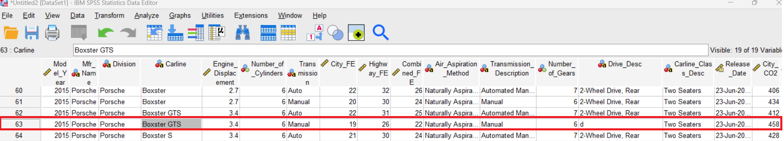

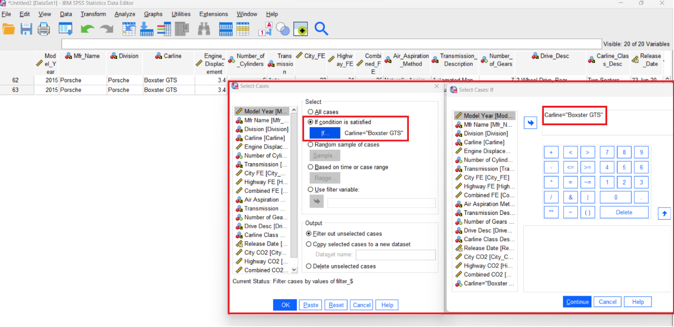

“d” value can be replaced by 2-Wheel Drive, Rear value.

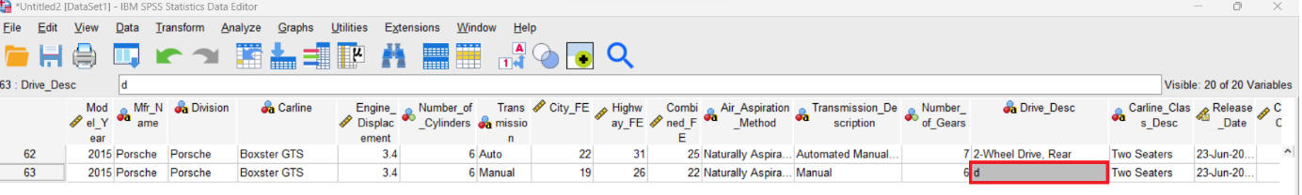

Supported by.

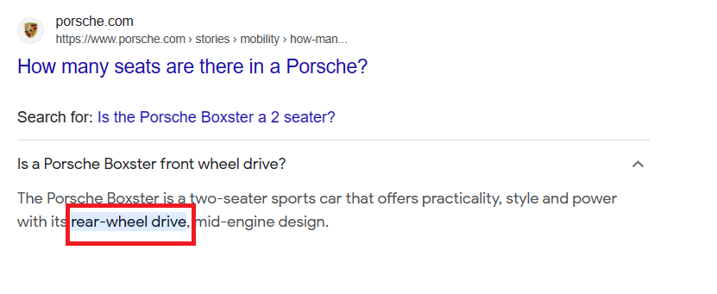source: [www.porsche.com](http://www.porsche.com)



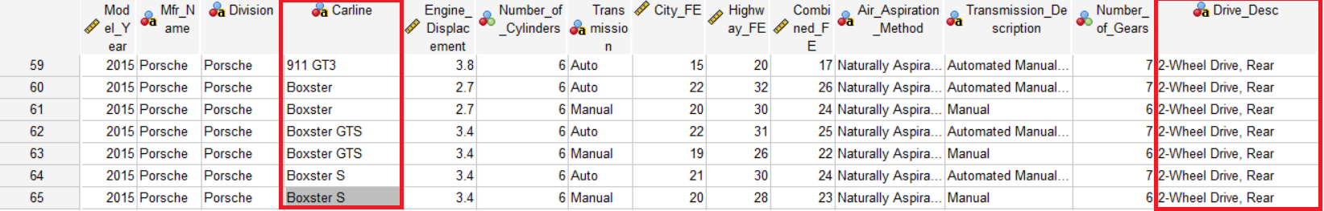

**Changing the letters**

There are columns such as Mfr_Name, Division and Carline with different upper and lower letters. In order to follow consistency, they can be unified.

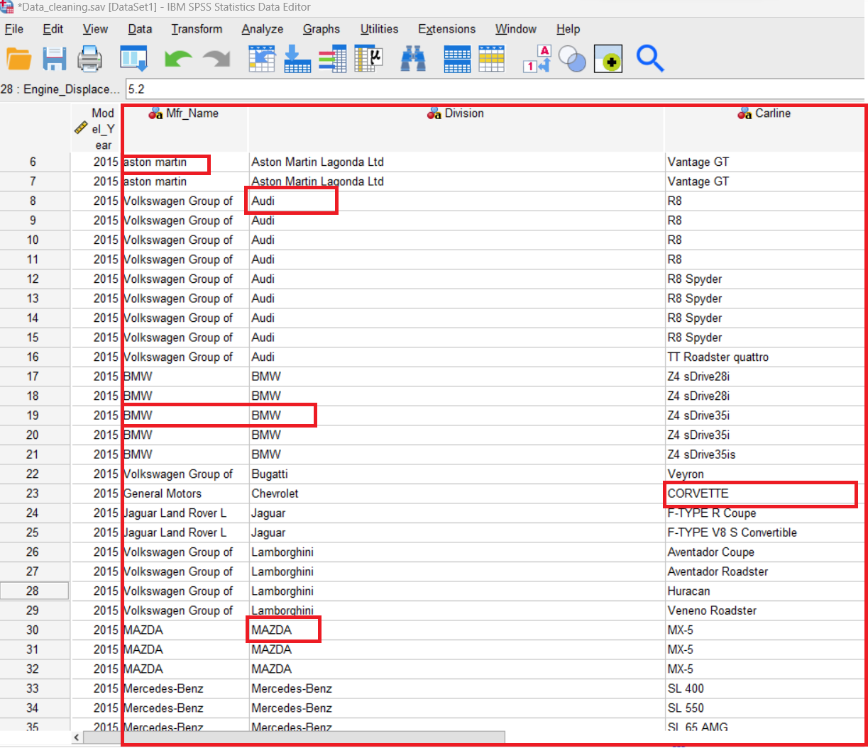

To unify them, syntax must be created in the following way.

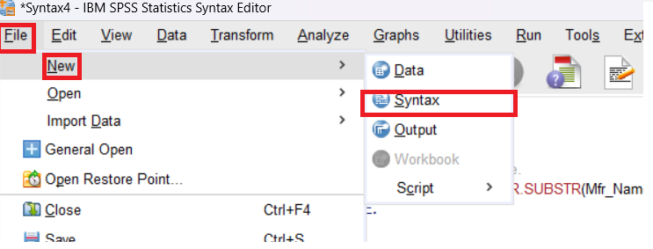

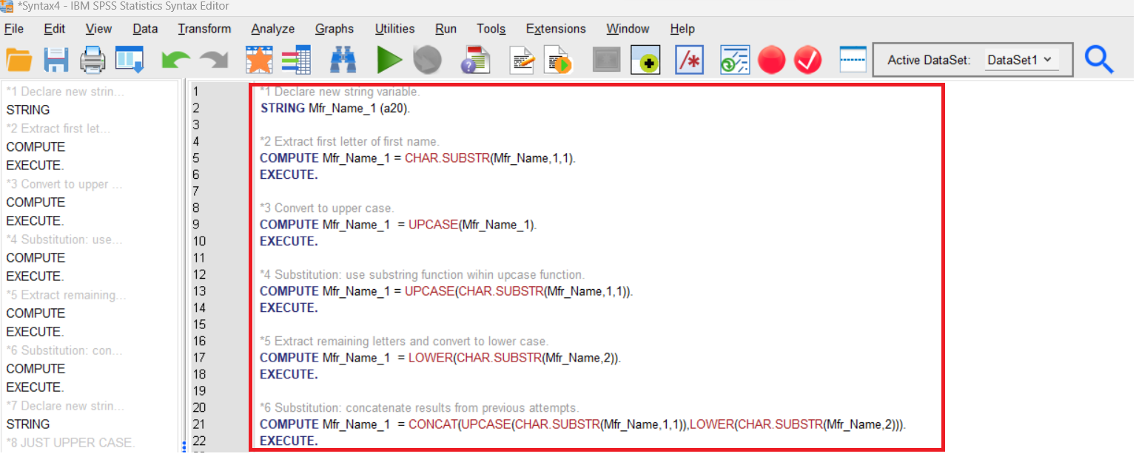

Firstly, Mfr_Name_1 extra column is created that contains the first letter uppercase only by using the following above syntax.

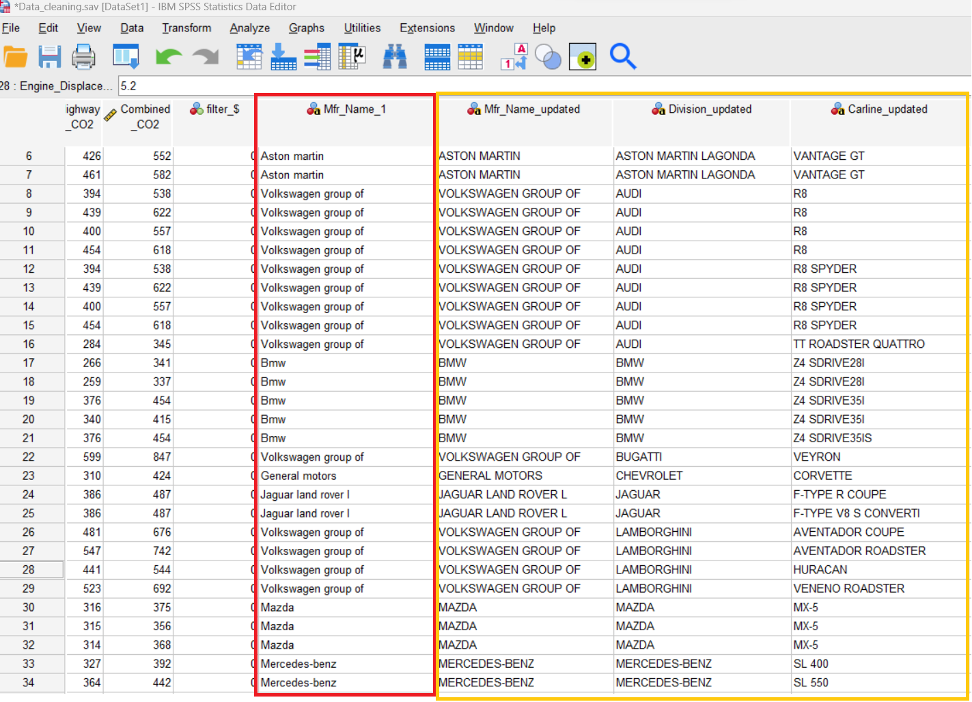

It seems to be more consistent to have all letters just in uppercase in the following way.

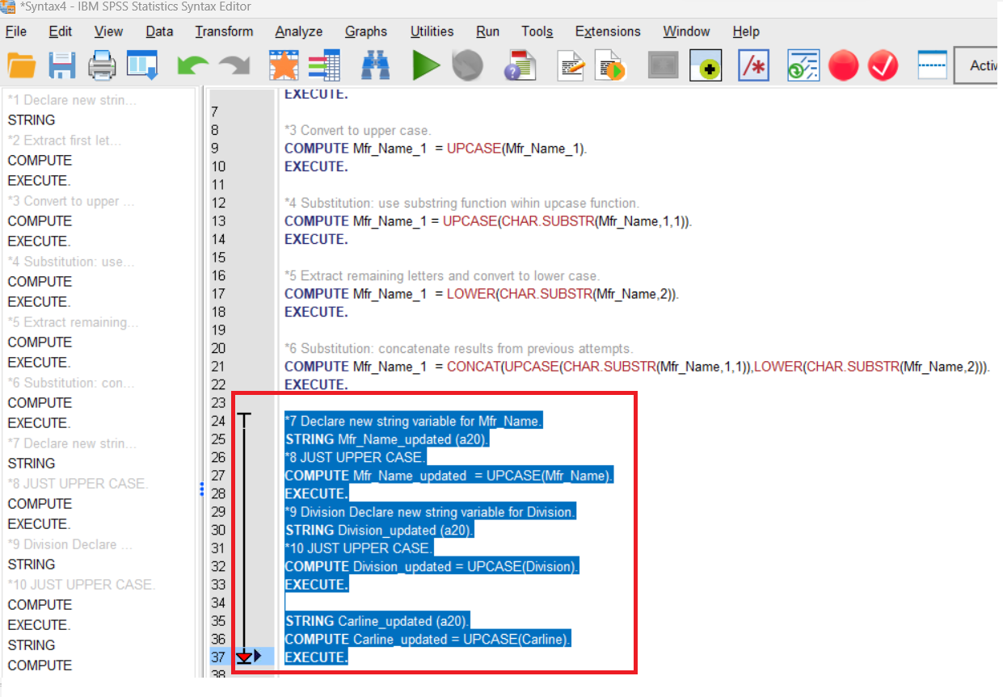

Then values are consistent.

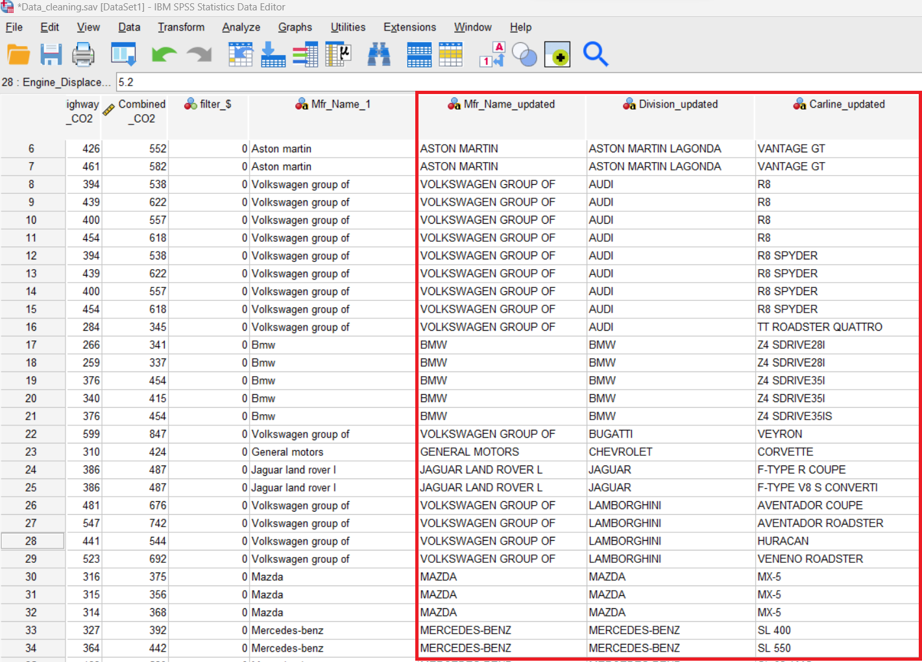

**Duplicated values**

They indicate the presence of exactly same data parts in the dataset. It is important to identify and remove them because they result in inaccurate results in statistical analysis.

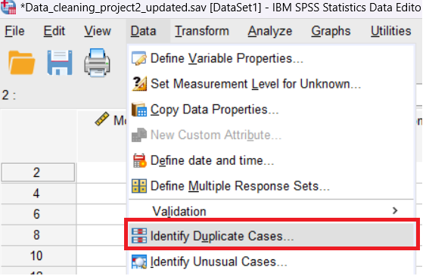

In order to perform duplication analysis, all attributes must be used.

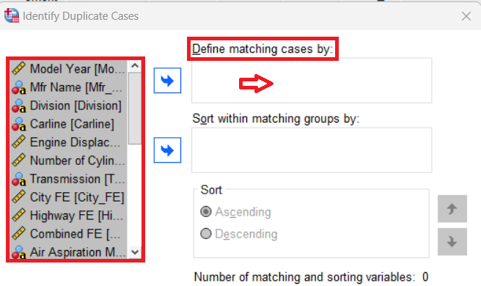

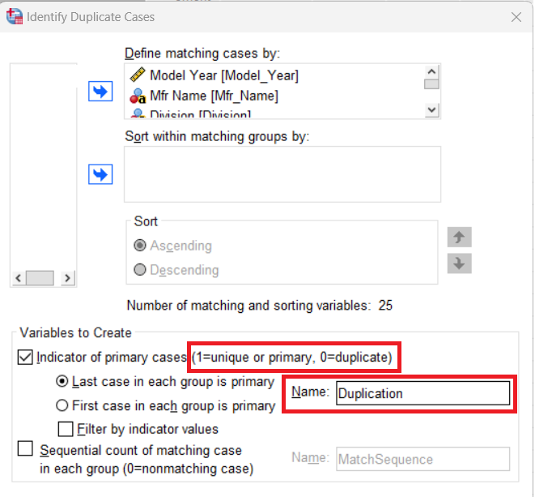

There are 7 duplicates.

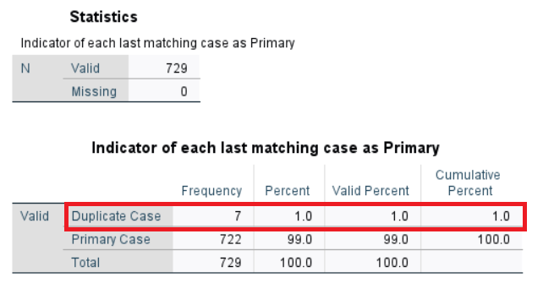

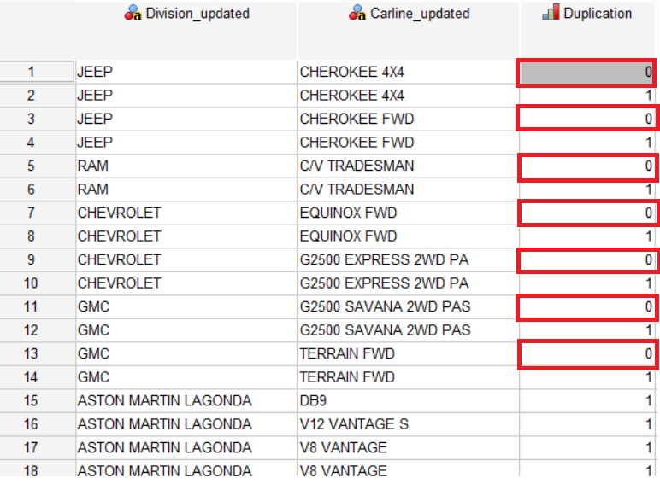

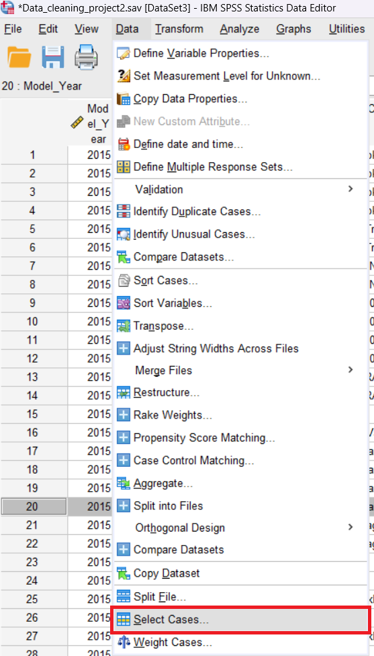

Duplicates must be filtered out in the following way.

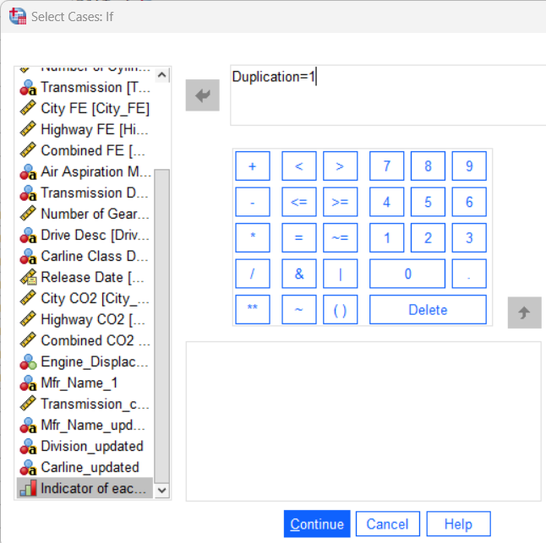

Total frequency is now 722.

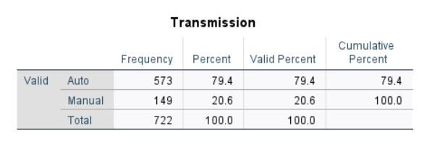

**Data transformation (encoding)**

Transmission column have only two values: Manual and Auto. In order to use those values in the further analysis, it is possible to code (one-hot encoding) them into 0 and 1. It is a well-known technique in data preprocessing, particularly in machine learning and statistical analysis.

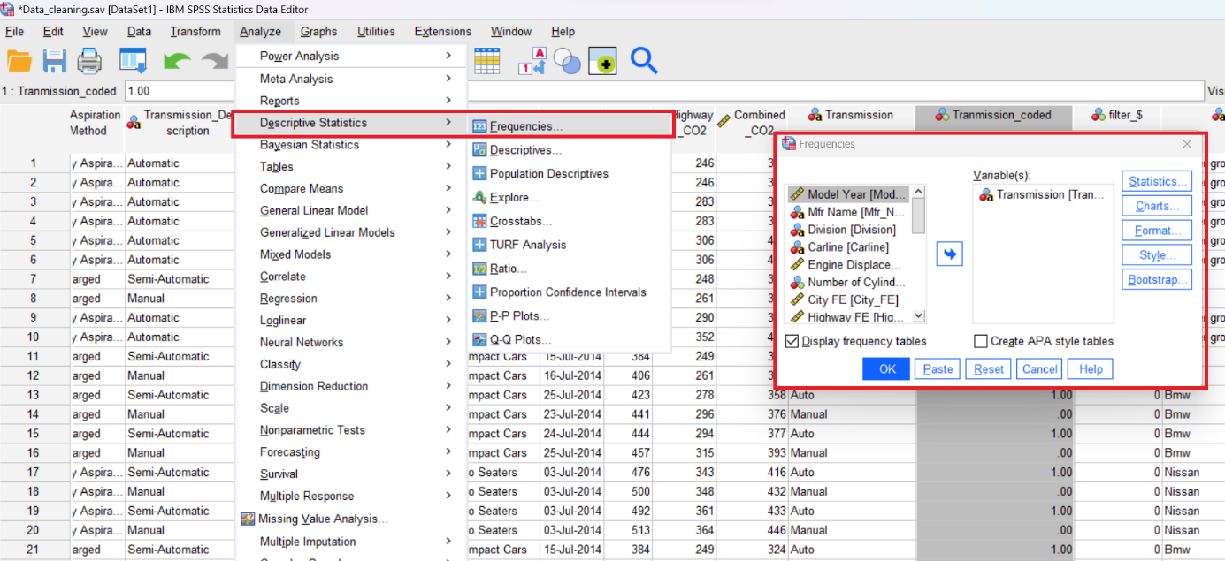

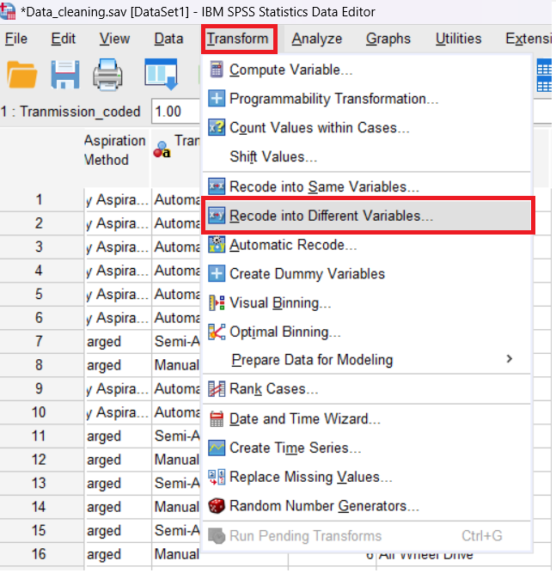

Transform/Recode into Different Variables creates the 0 and 1 values for the new Transmission_coded column with **Auto->1 and Manual->0** values.

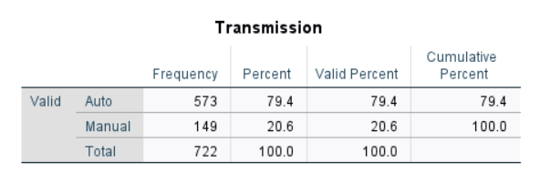

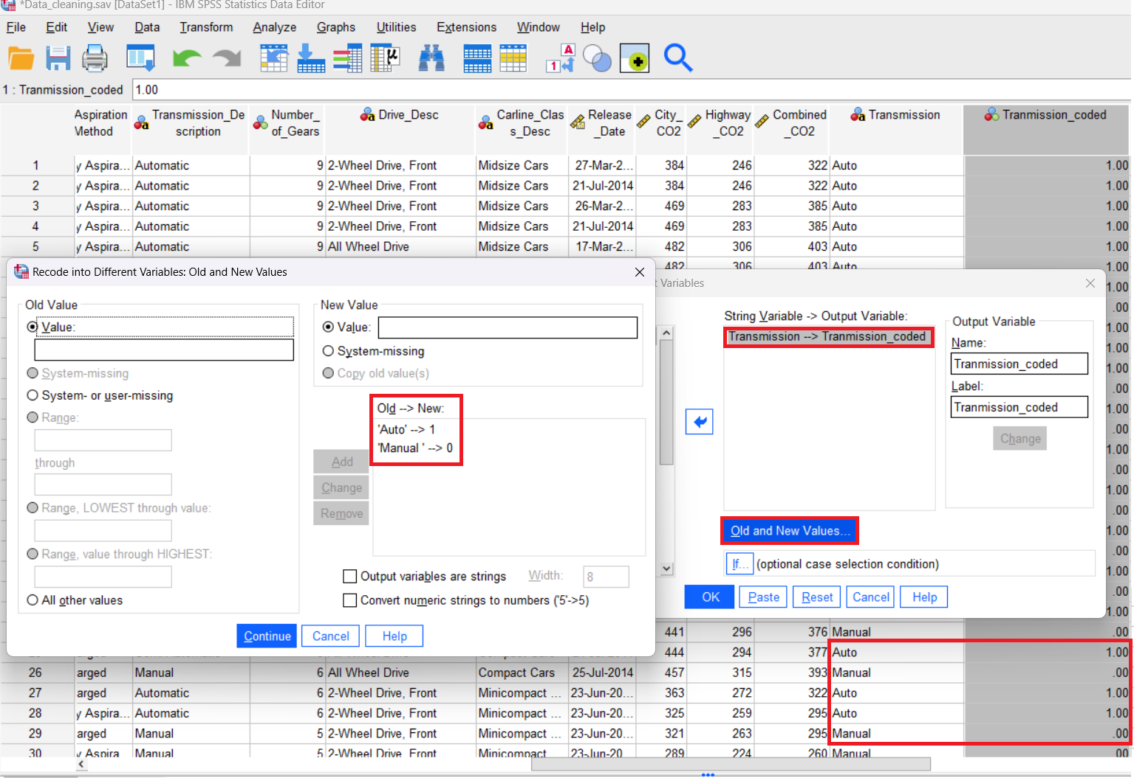

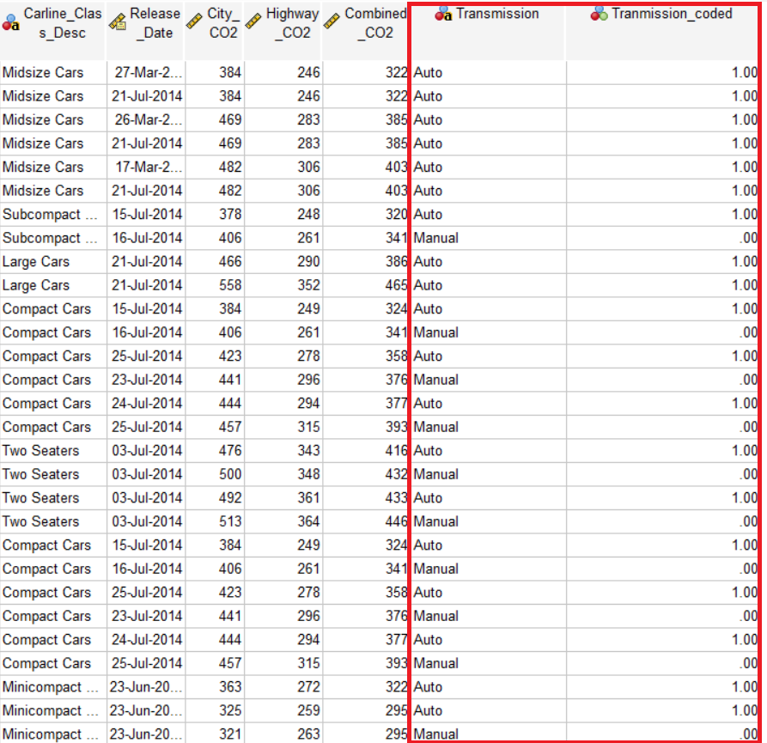

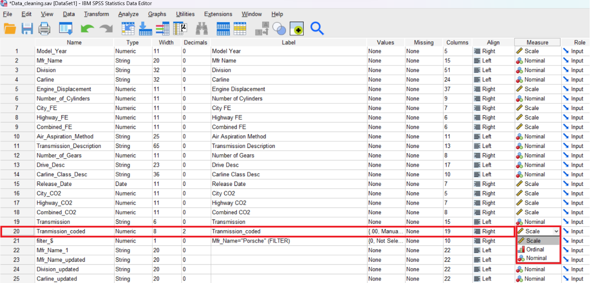

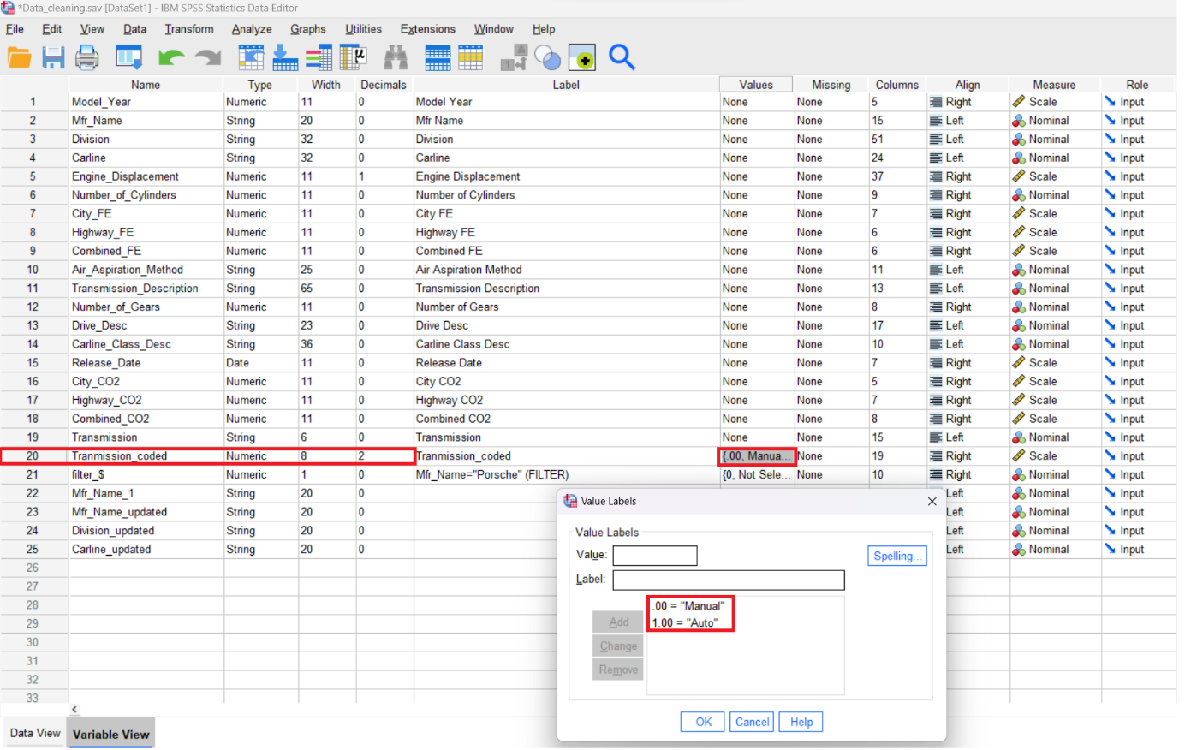

**Outlier detection**

In certain scenarios, outliers are also referred to as anomalies, abnormalities, errors, surprises (Panjei, 2022). Boxplots are useful for detecting outliers because of clear visual representation of data distribution and showing possible outliers outside of the boundaries while being resistant to extreme values.

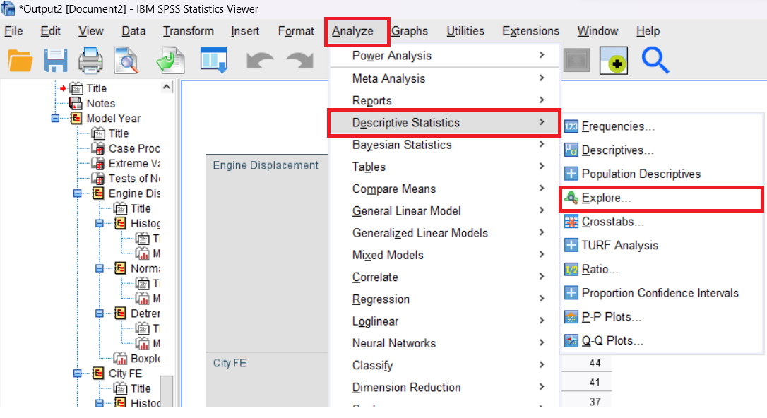

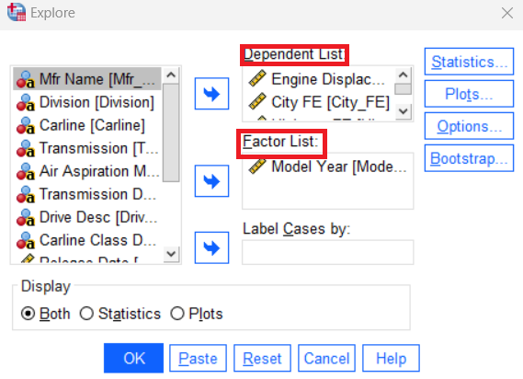

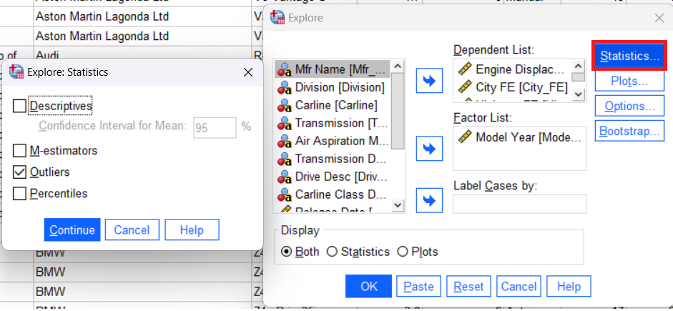

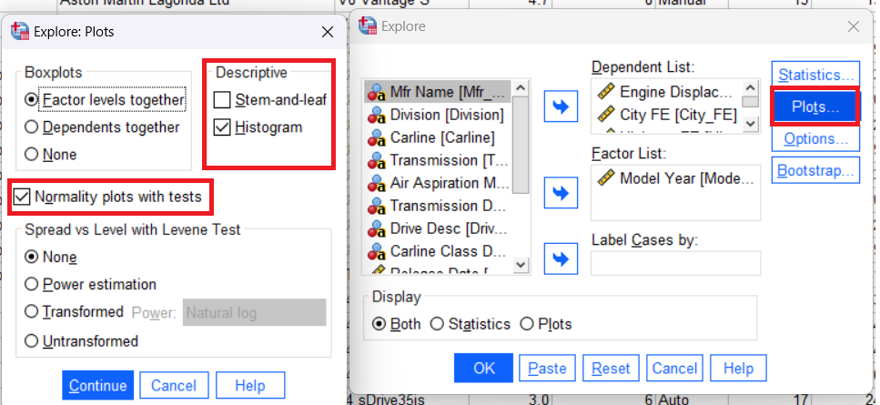

The 22nd value does not seem to be extreme for Engine Displacement.

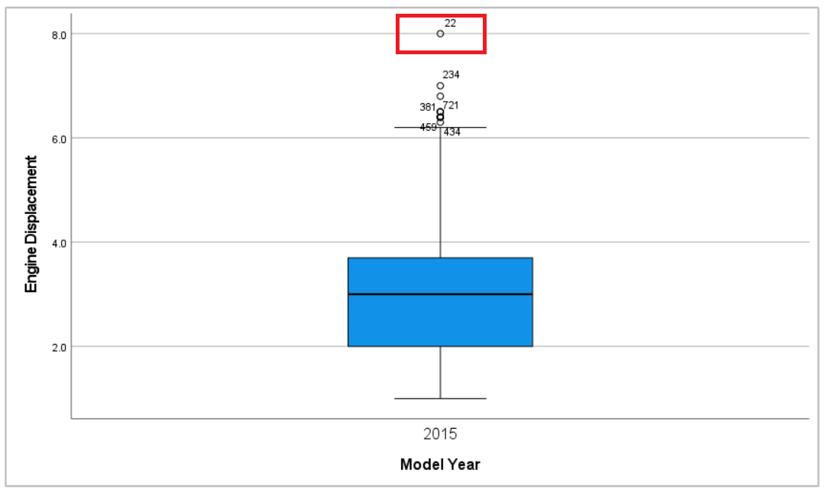

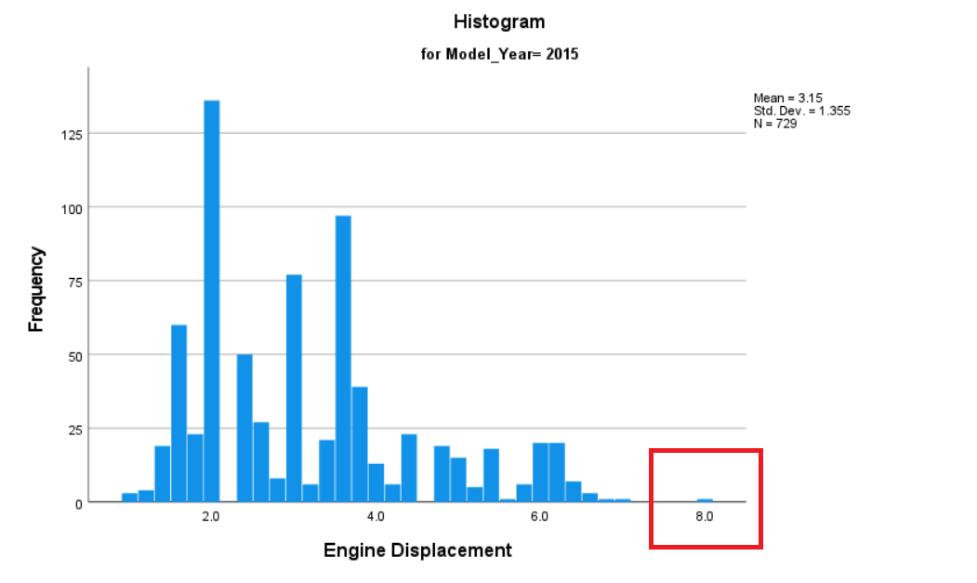

The 22nd value does seem to be extreme for City CO2.

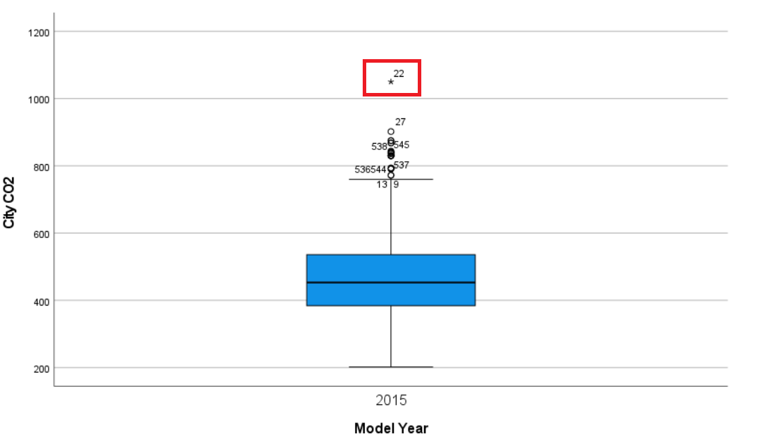

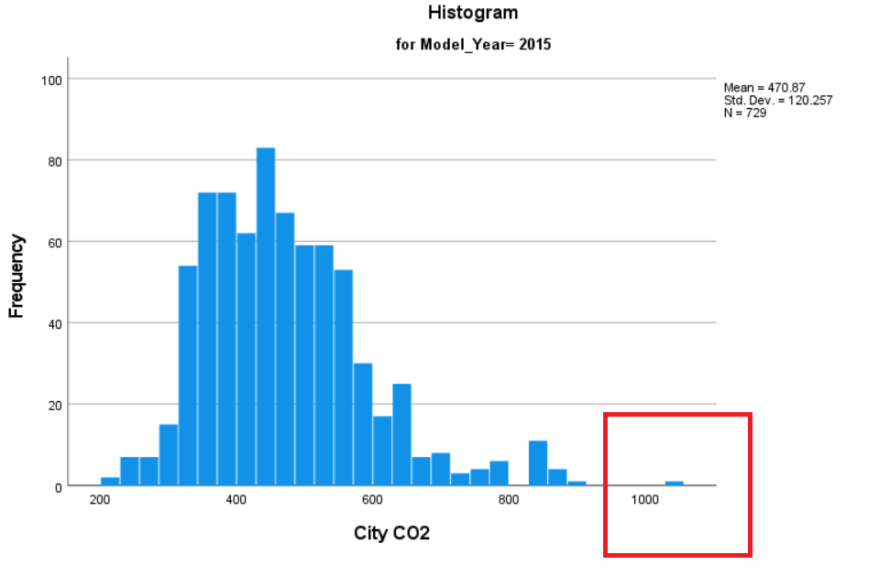

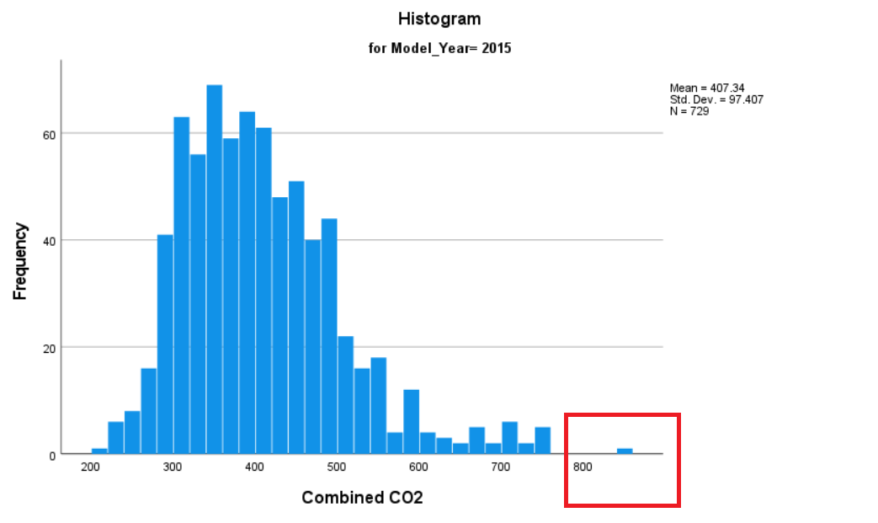

The 22nd value does seem to be extreme for Combined CO2.

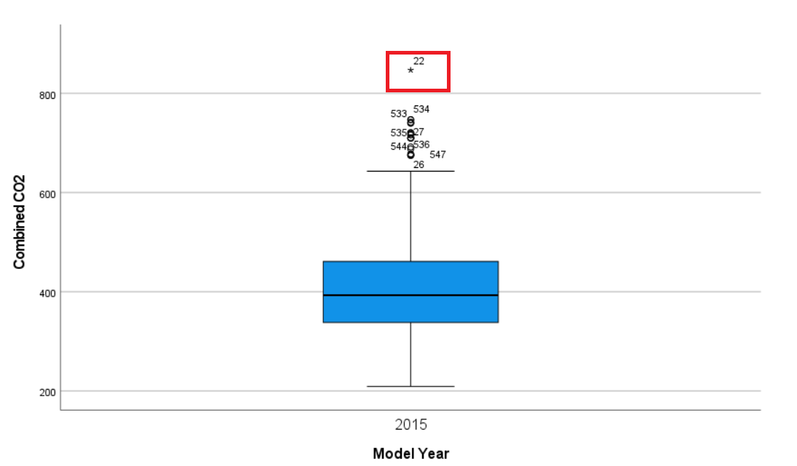

The 22nd value does seem to be extreme for Number of Cylinders.

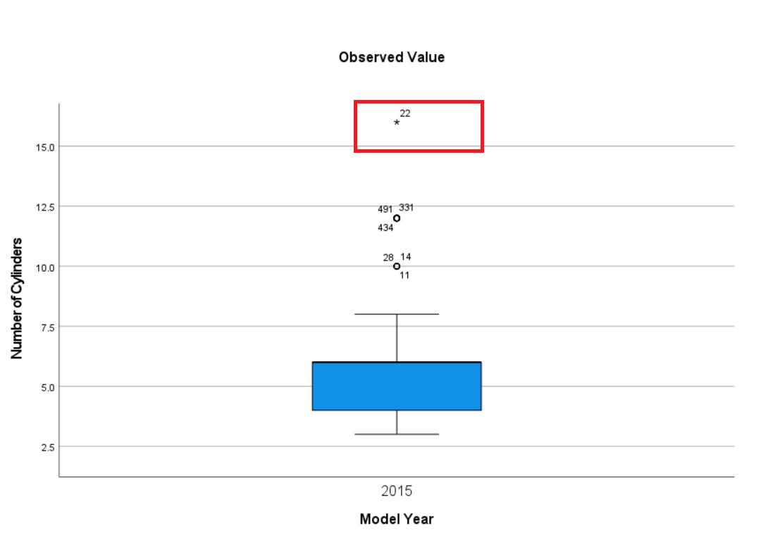

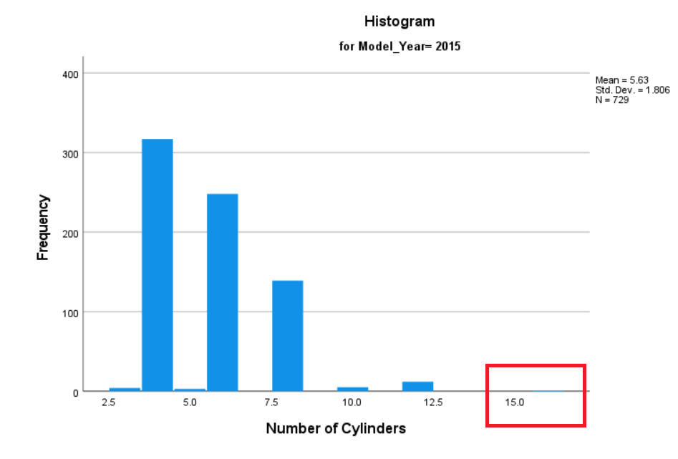

The 22nd value in the dataset seem to be outlier according the most the boxplots. This Bugatti Veyron car is very extreme; therefore, it can be deleted.

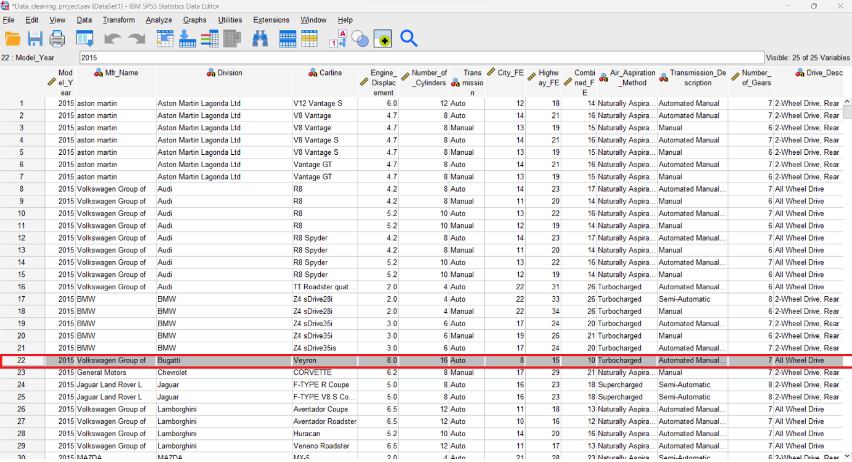



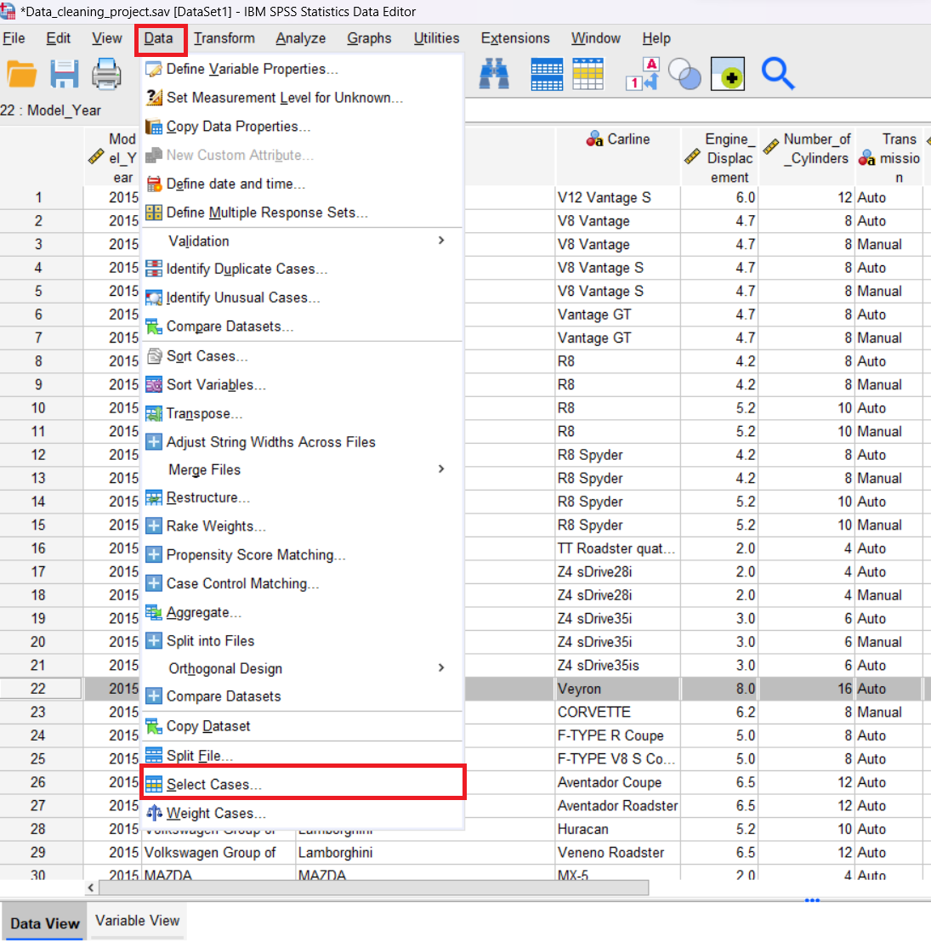

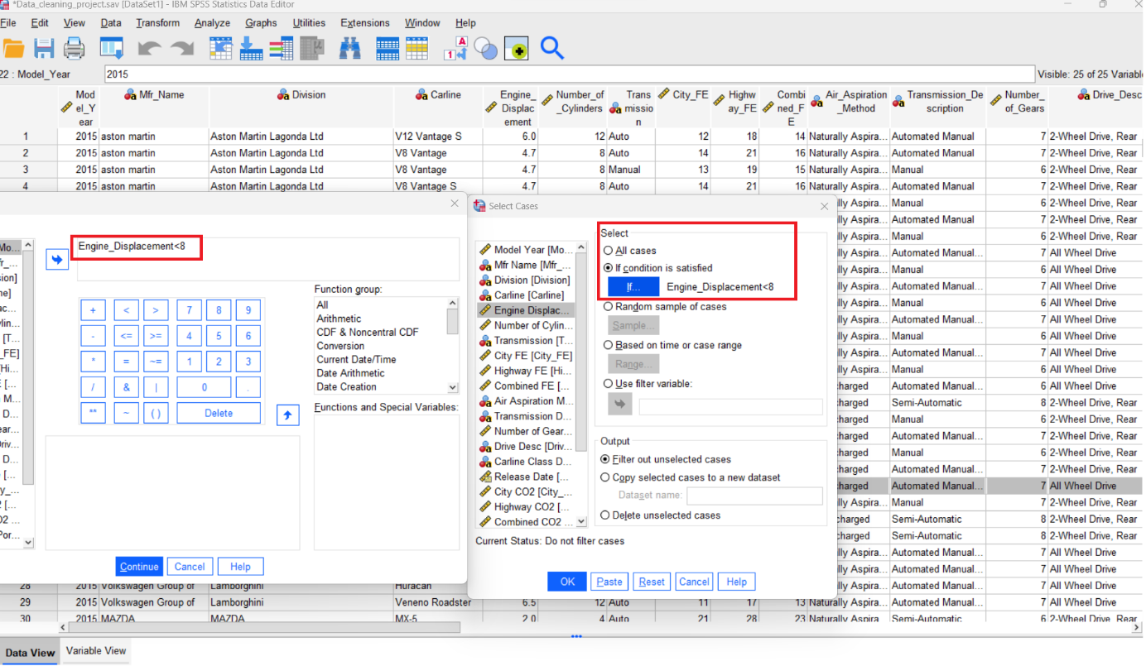

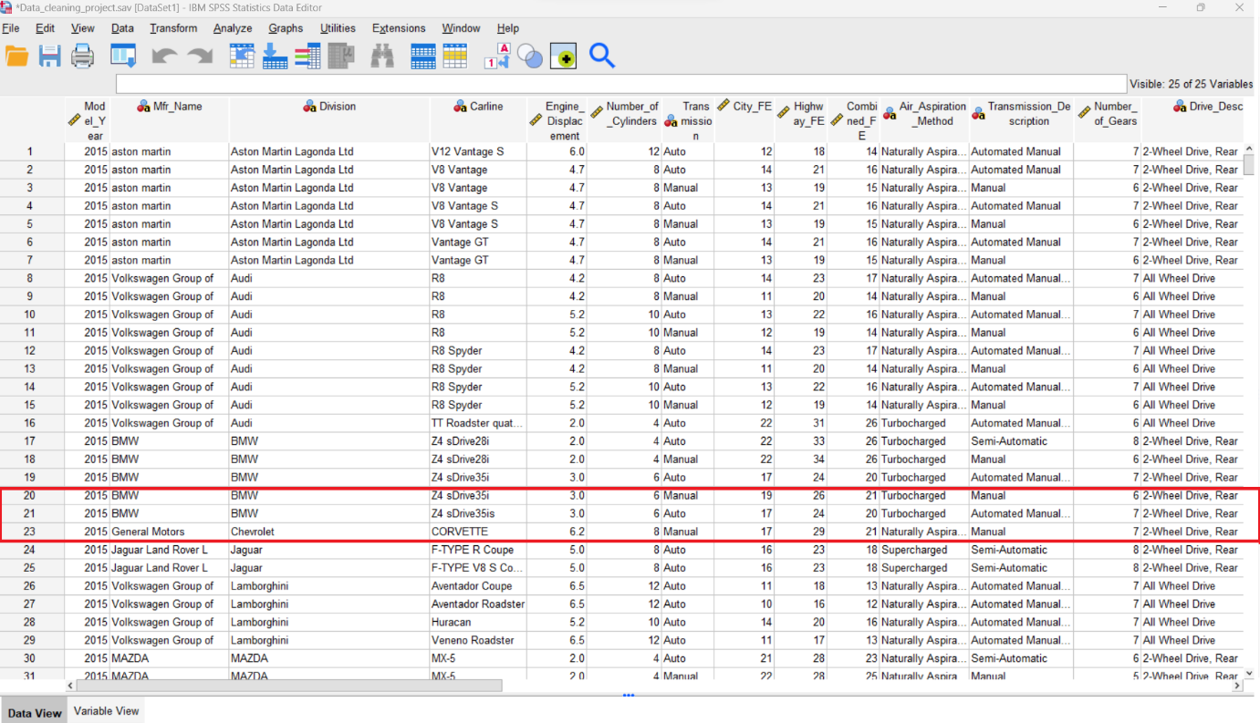



Other outliers which are not extreme that are will not be excluded.

Number of gears seems to have outliers with one gear.

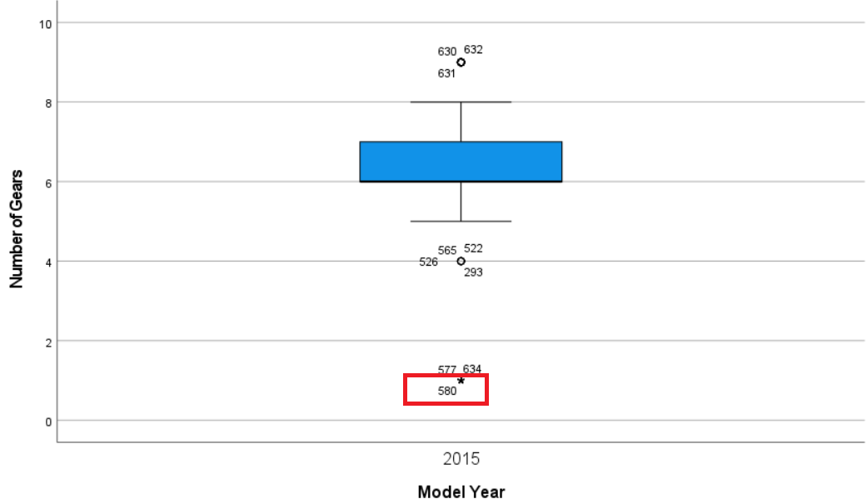

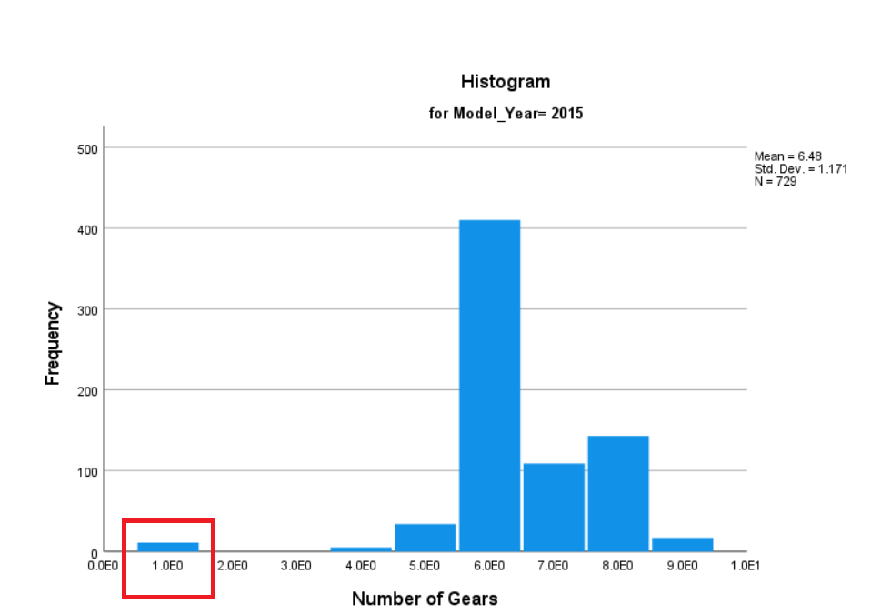

11 cars have one gear in the dataset and all these cars have automatic transmission.

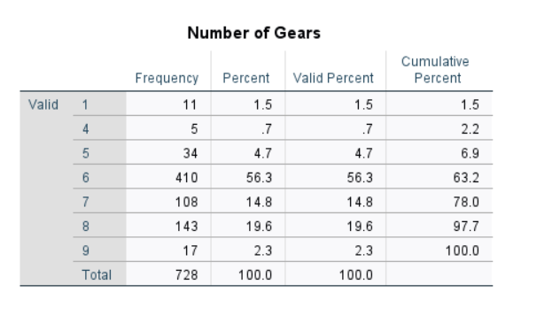

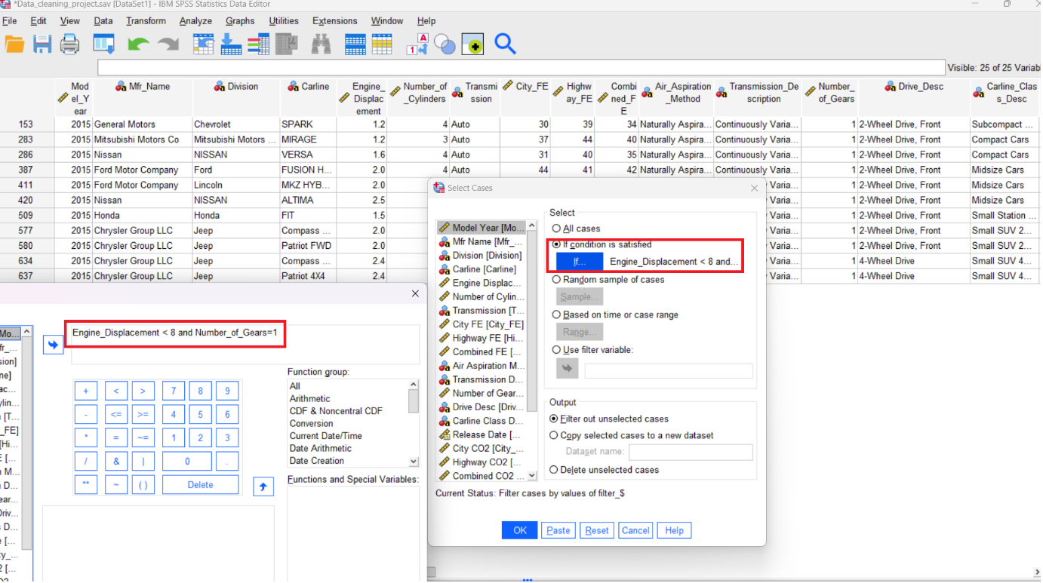

There are only cars with automatic transmission with one gear which is in the line with the fact that all electric cars are automatic and use the single-gear transmission.

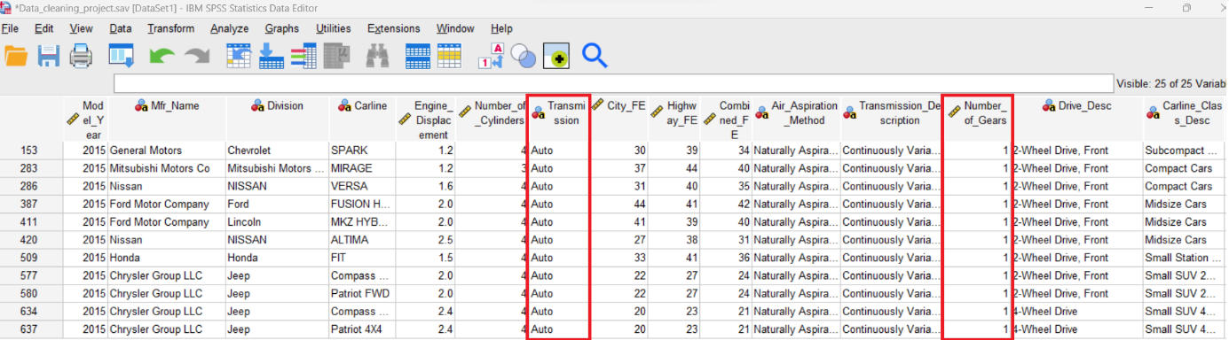

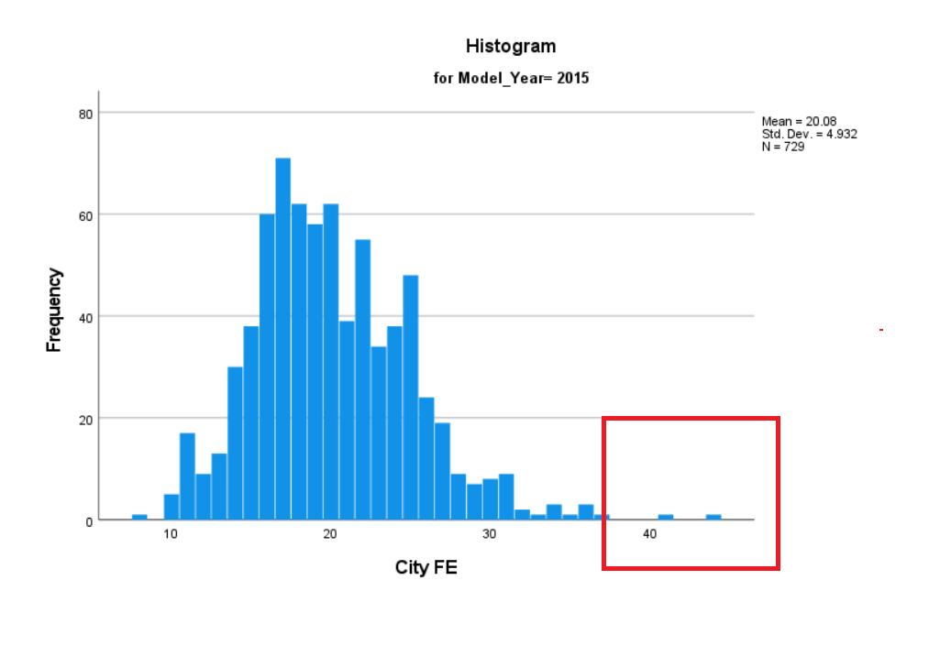

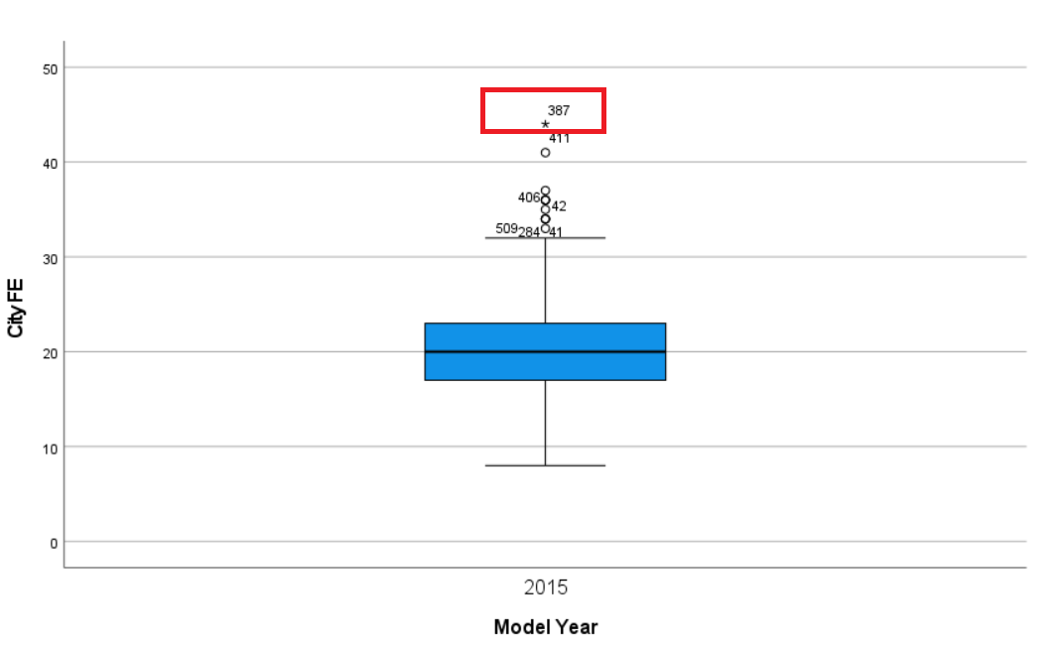

This value is displayed as an outlier. It is not so far from the last value which does is not an outlier. Further analyses show that this value is not an extreme outlier the case of City FE and Combined FE.

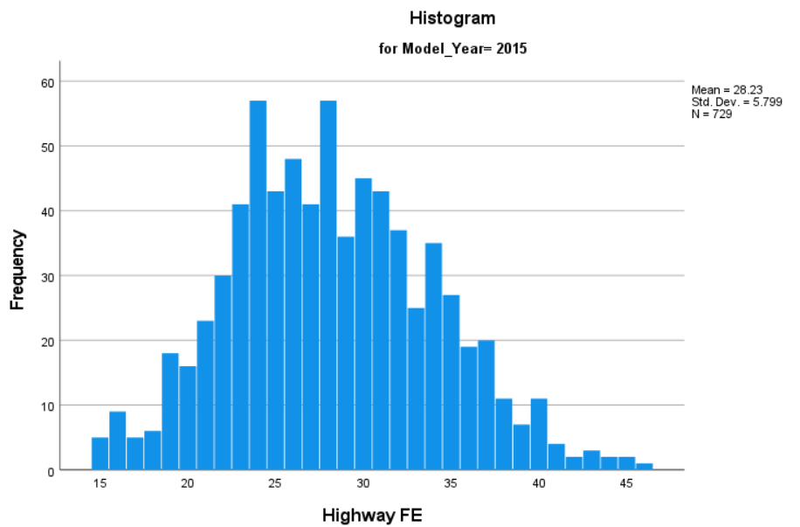

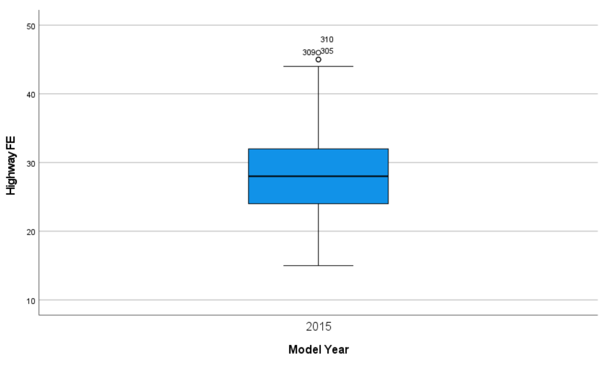

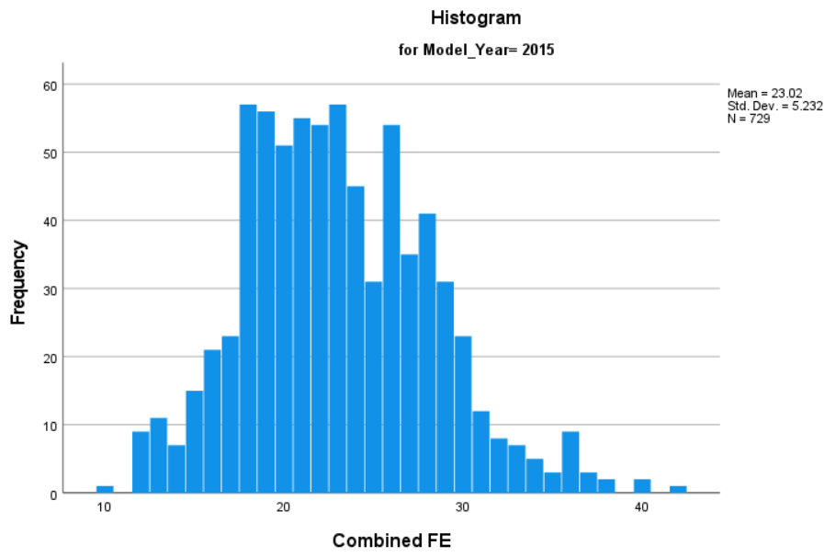

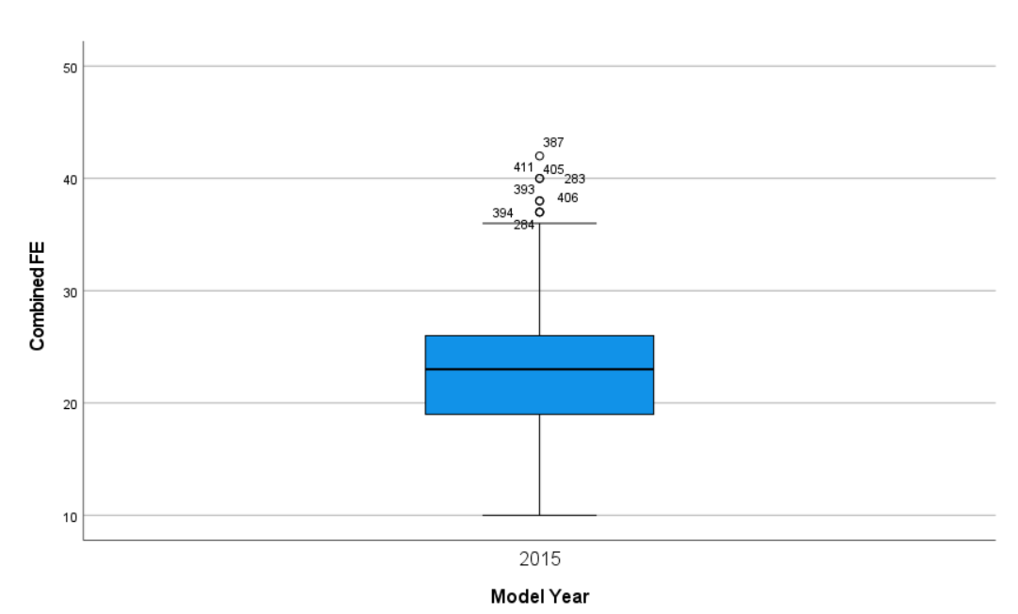

To sum up, only one outlier (22nd) is removed.

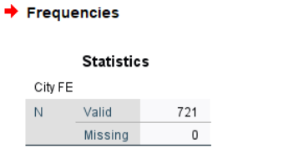

## 1.3 Task 3: Data Analytical Methods

In order to cross check, the distributions for the different numerical attributes (above with different histograms), **Tests of Normality** is used. I have more 50 observations in my sample. As a result, Kolmogorov-Smirnov Goodness must be considered. The p-value has lower than 0.05 value, so the null hypothesis where data is normally distributed can be rejected.

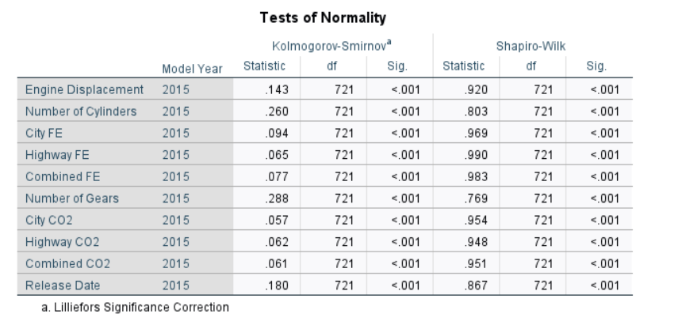

The selection of either parametric or non-parametric statistical tests for the analysis of continuous data that does not follow normal distribution has been a subject of ongoing debate. It is generally advised to employ non-parametric testing (Wadgave, 2019). Accordingly, non-parametric testing will be used.

Table 2. Parametric methods and nonparametric methods

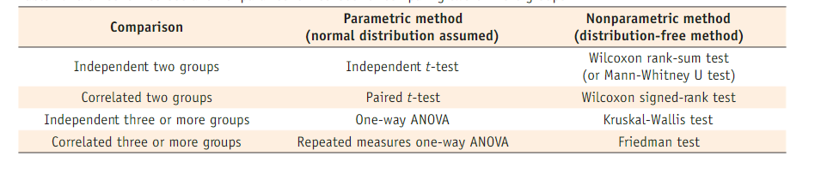

source: Kim, 2014

**Data visualization**

The following graph shows the relationship between CO2 and FE. Negative correlation shows that one variable increases (such as CO2), the other variable decreases (FE).

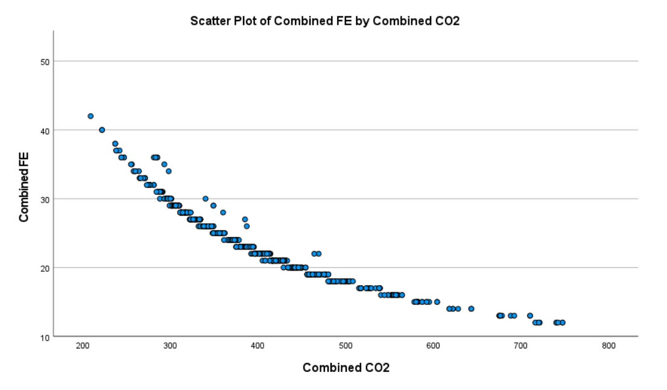

Ntziachristos *et al.,* (2014) stated that CO2 the amount of fuel used have a strong and clear relationship.

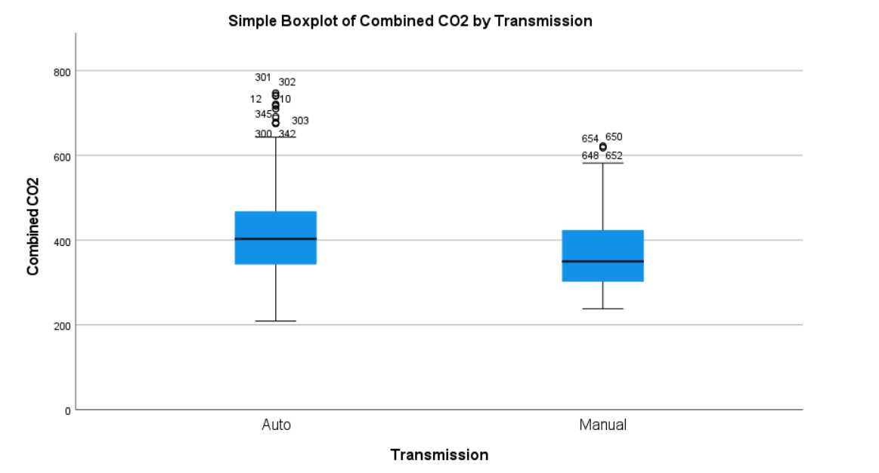

Cars with auto transmission emit more CO2 than manual.

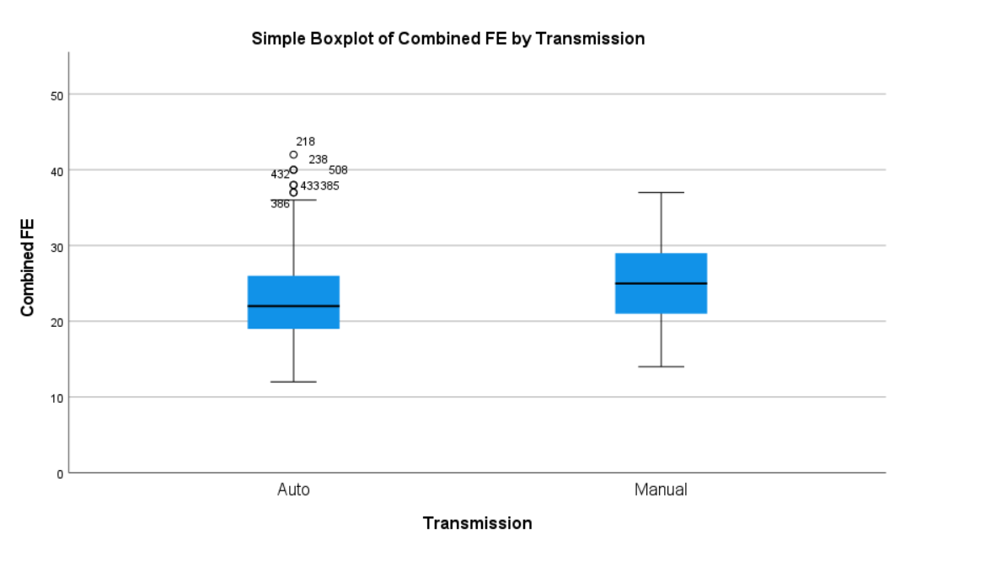

Cars with manual transmission have better Combined FE auto.

**Chi-Square Test**

The Chi-square test is a non-parametric method for analysing differences between groups when the variable that is dependent is determined at a nominal level. It is robust regarding to the data distribution (McHugh, 2013).

H0: Combined CO2 is not associated with Transmission coded.  
H1: Combined CO2 is associated with Transmission coded.

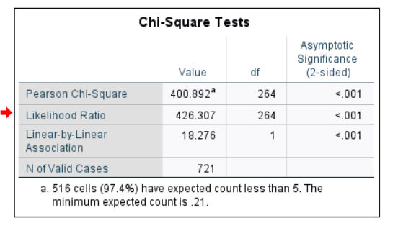

H0 can be rejected and H1 accepted because p-value is lower than 0.05, therefore, there is a **relationship between Combined CO2 and transmission coded** (transmission type of manual or auto).

**Imbalanced data**

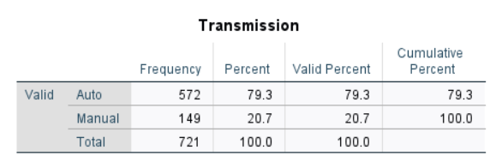

In cases of extreme imbalance, it may be necessary to think of different statistical analyses that are more robust to imbalanced data. For imbalanced datasets, there are modified t-tests and non-parametric tests, for instance. Non-parametric tests will be used in this analysis.

The Mann Whitney U test is analogous to the parametric Student’s t-test. It contrasts the medians of two independent groups if the data does not follow a normal distribution (Sundjaja, Shrestha and Krishan 2020).

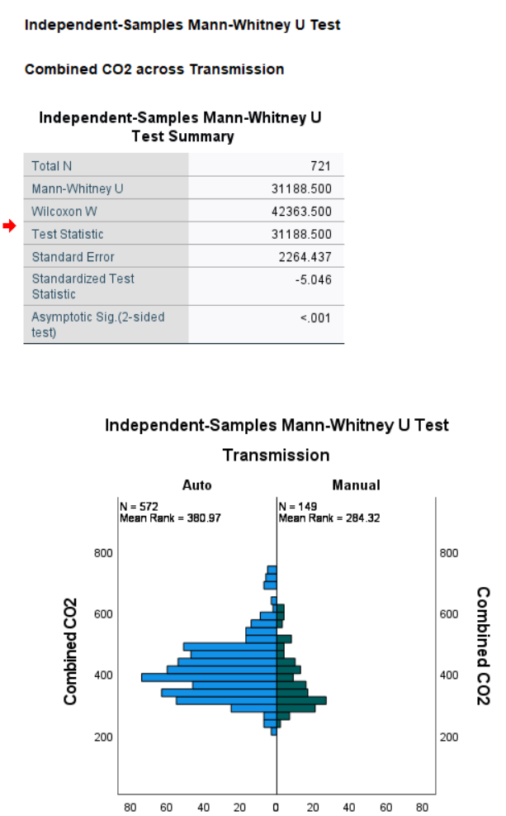

**Hypothesis for the Mann Whitney U test:**

H0: There is no significant difference in Combined CO2 between manual and auto transmission.

H1: There is a significant difference in Combined CO2 between manual and auto transmission.

Significance level (of < 0.01) is lower than p=0.05 (alpha=5%), therefore, H1 is accepted.

This is in accordance with the visualization where cars with auto transmission display similar results (emit more CO2 than in the case of manual).

**Research questions justification**

The boxplots show the Manufacturer name and CO2 emissions in city, highway, combined conditions. Cars manufactured by ASTON MARTIN emit the most CO2 and MITSUBISHI MOTORS CO emit the least.

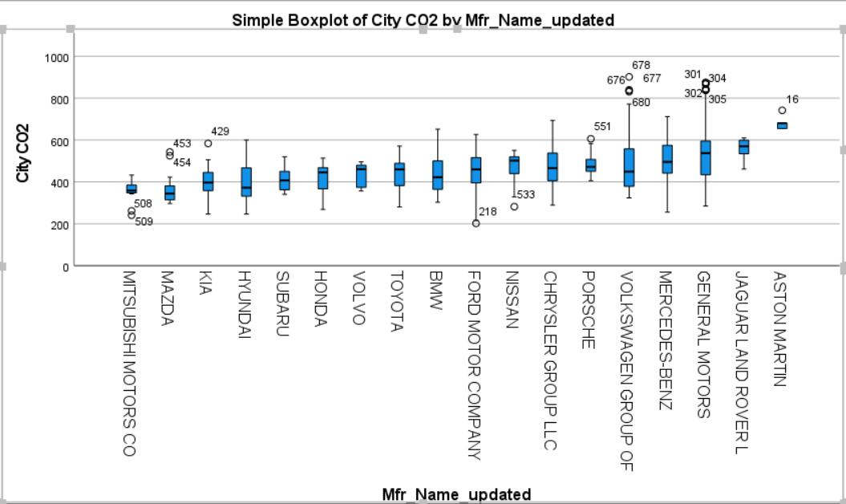

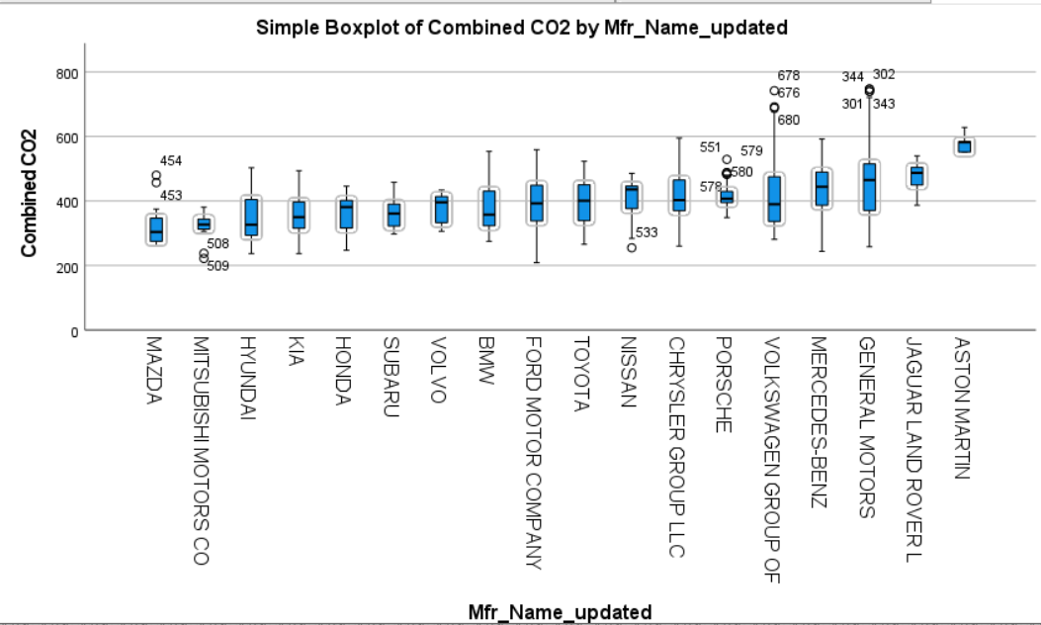

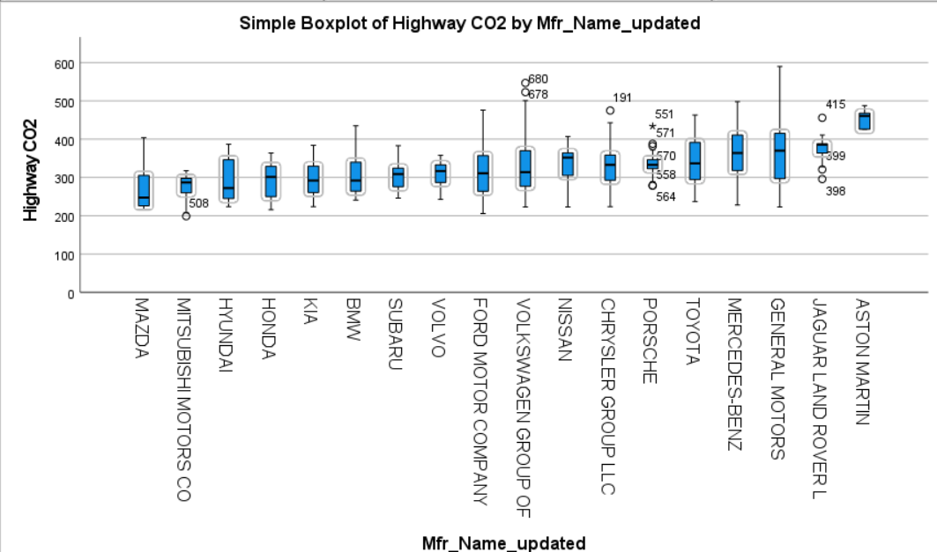

**Kruskal-Wallis test**

This test is a nonparametric test that is used to assess whether there are statistically significant distinctions among two or more groups of an independent variable regarding to a continuous or ordinal dependent variable (Ghoodjani, 2016).

**H0:** The median of combined CO2 across the manufacture groups is equal.

**H1:** The median of combined CO2 across the manufacture groups is not equal (at least one is different from others).

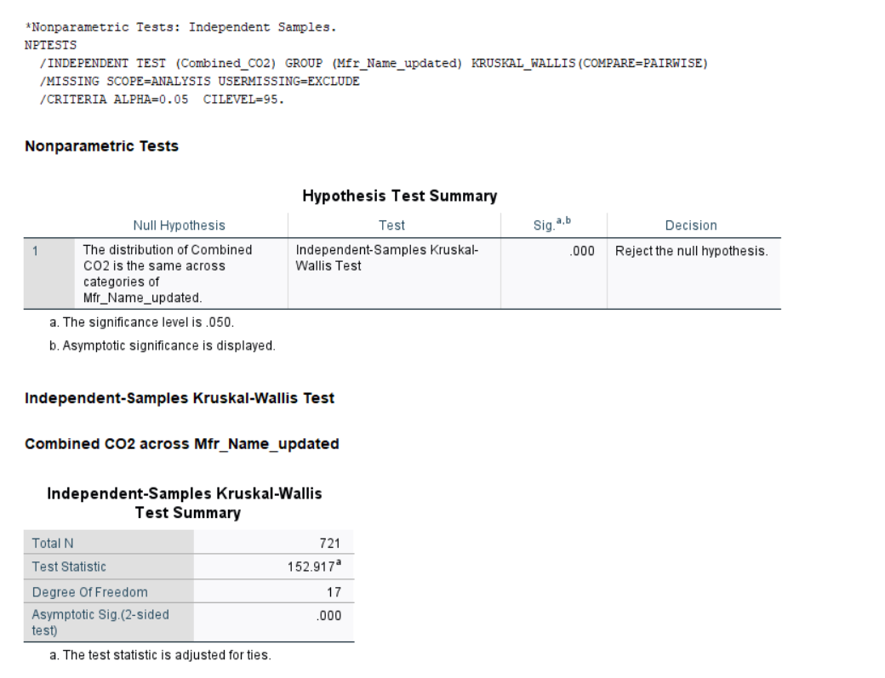

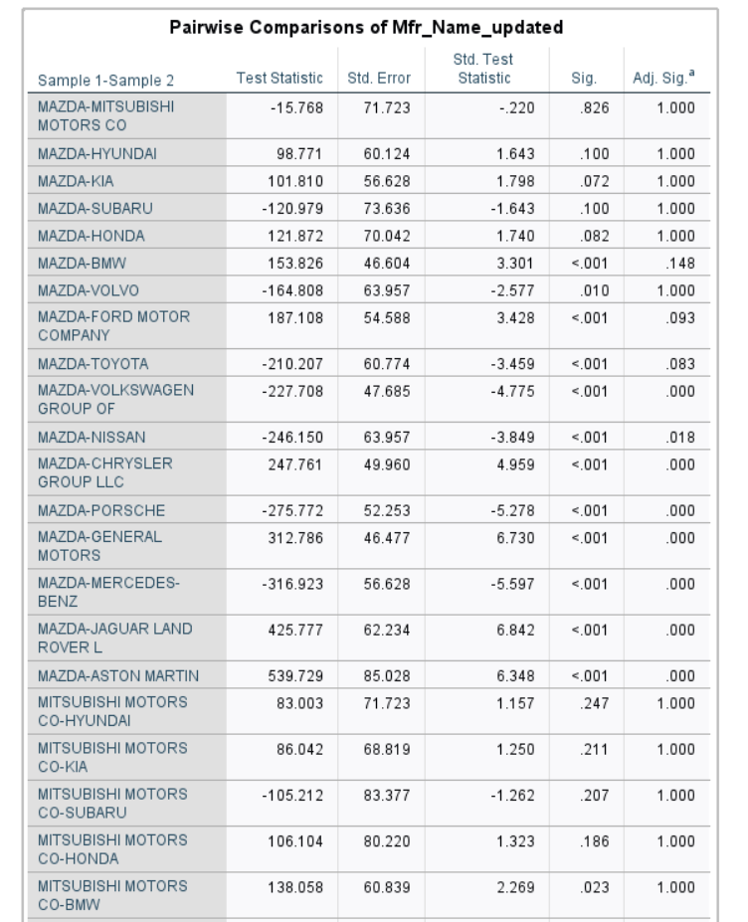

…

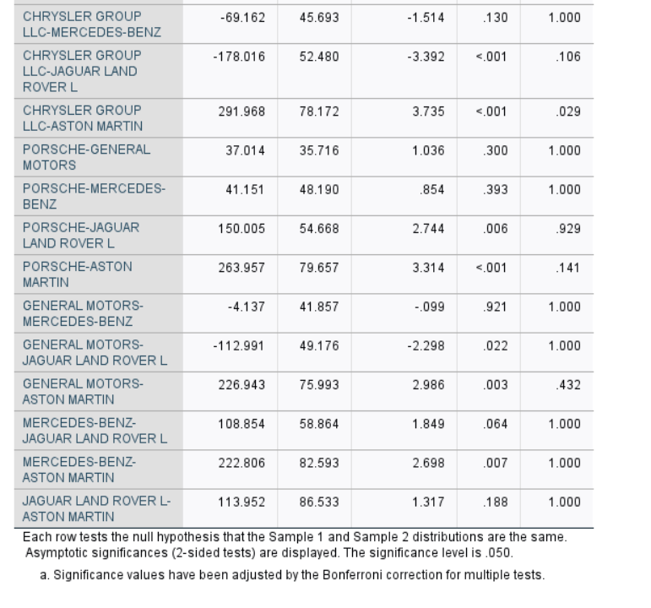

JAGUAR LAND ROVER L -ASTON MARTON and MAZDA -MITSUBISHI MOTORS CO show not significant results (p-values > 0.05). As a result, Mann-Whitney U test is needed for those pairs in order to prove the difference between them.

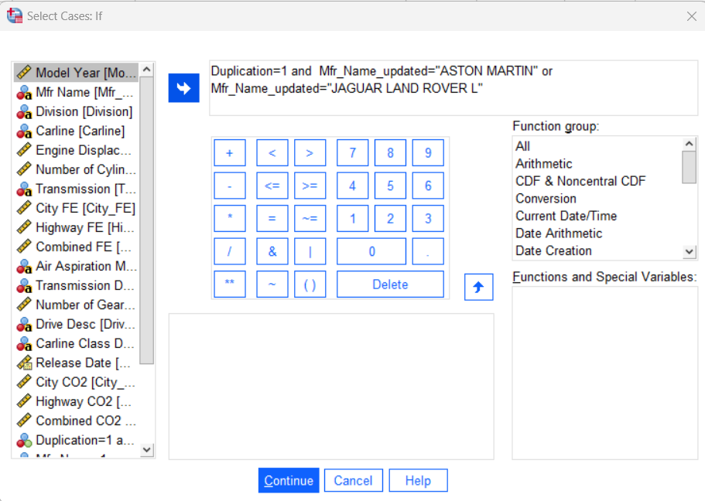

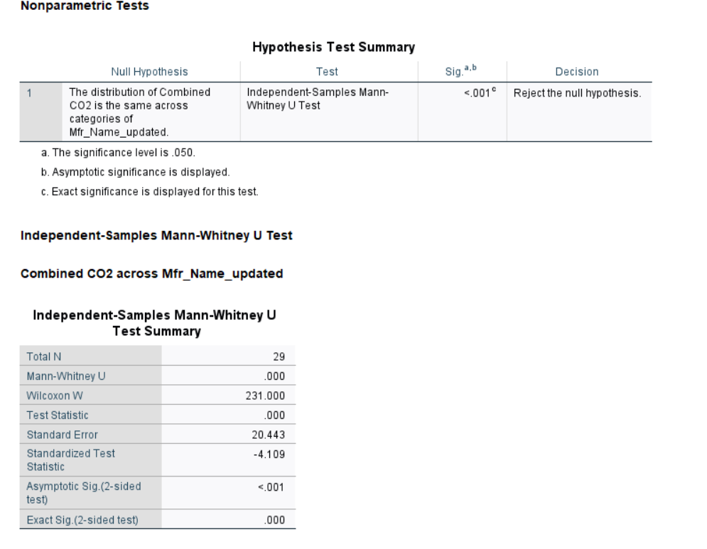

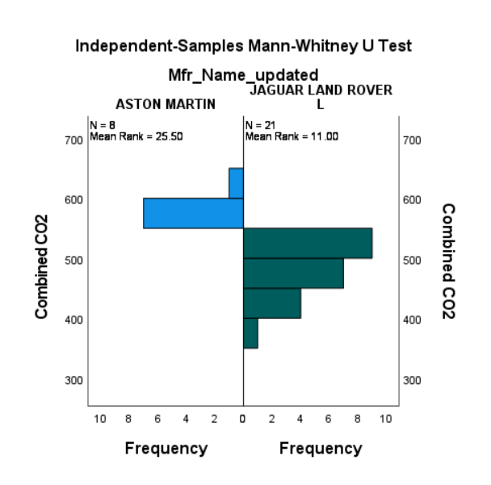

H1 is accepted (there is a significant difference regarding COMBINED CO2) which means ASTON MARTIN has higher emission.

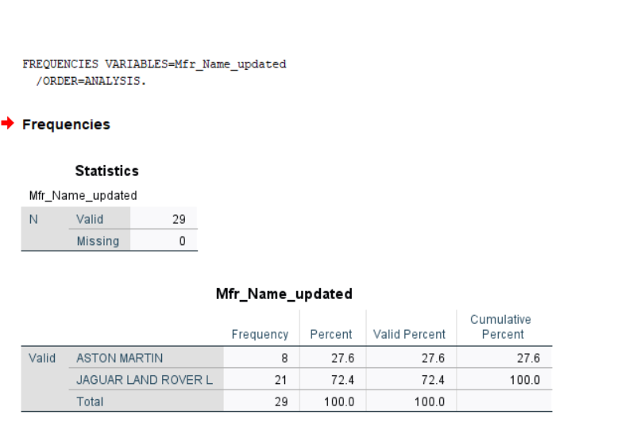

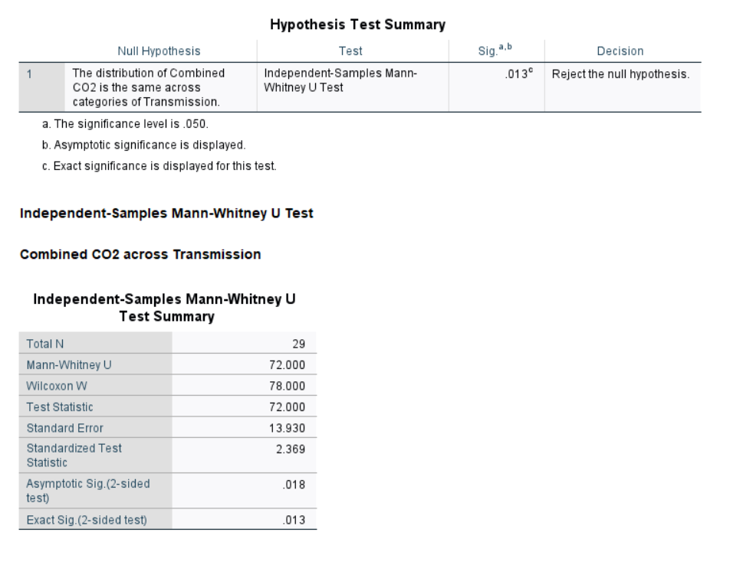

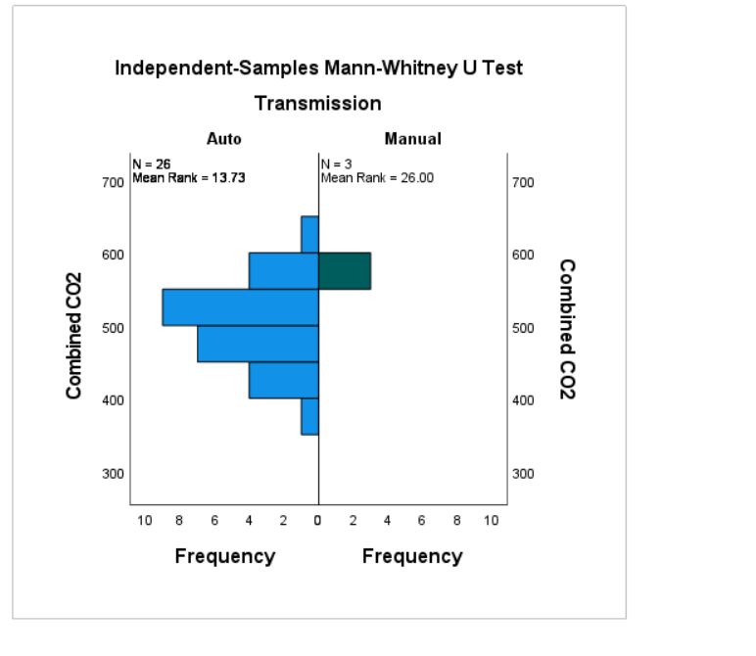

H0 is rejected, there is a significant difference between manual and auto transmission in Combined CO2 in the case of JAGUAR LAND ROVER L and ASTON MARTIN CARS (only 3 data points for manual).

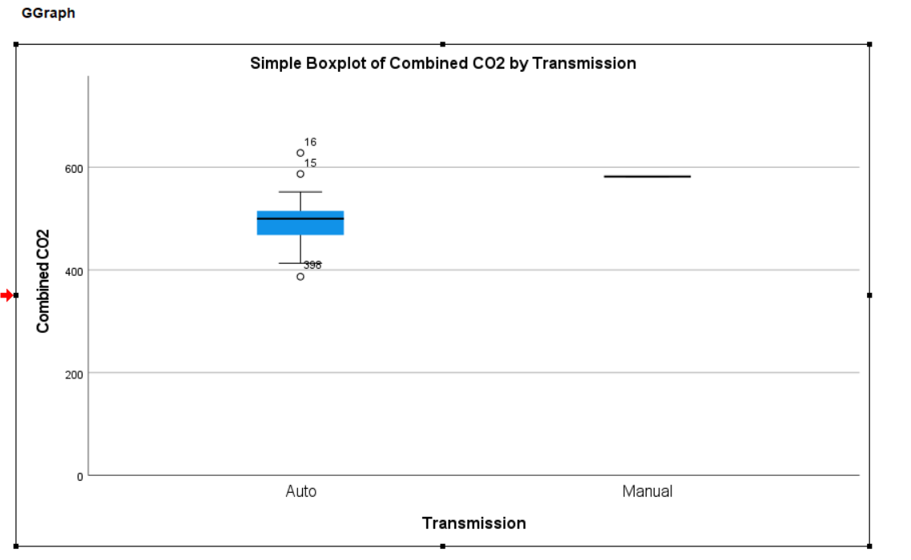

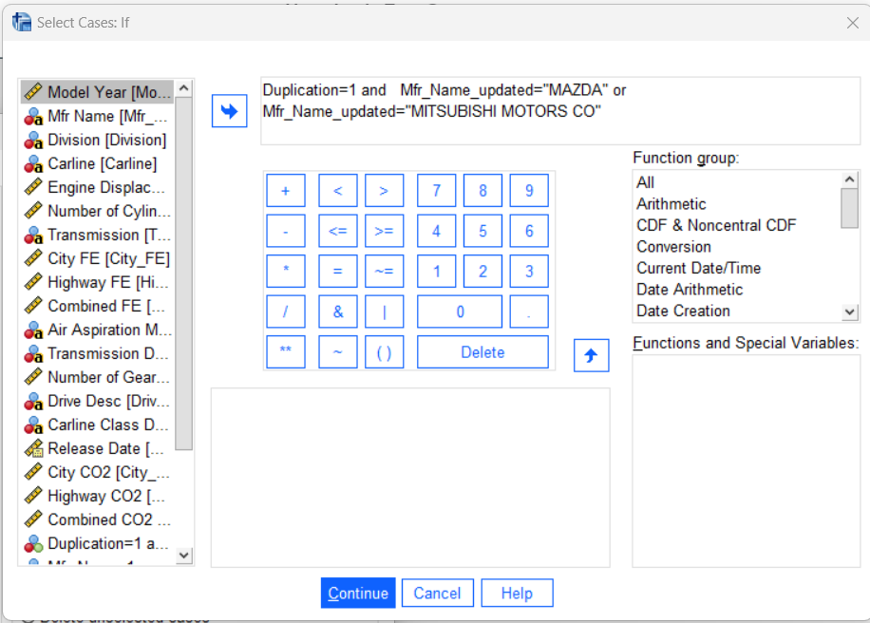

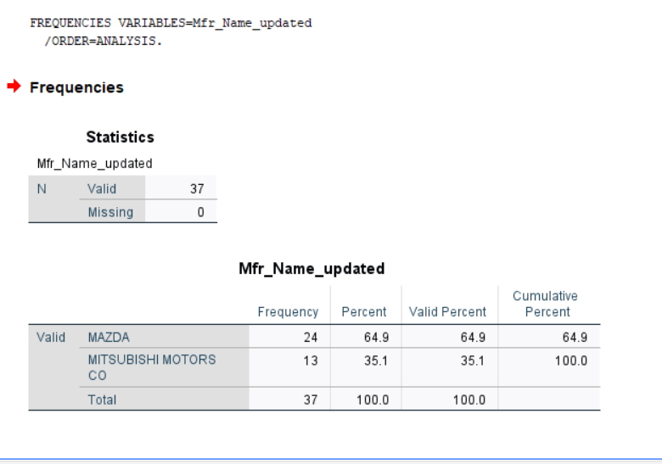

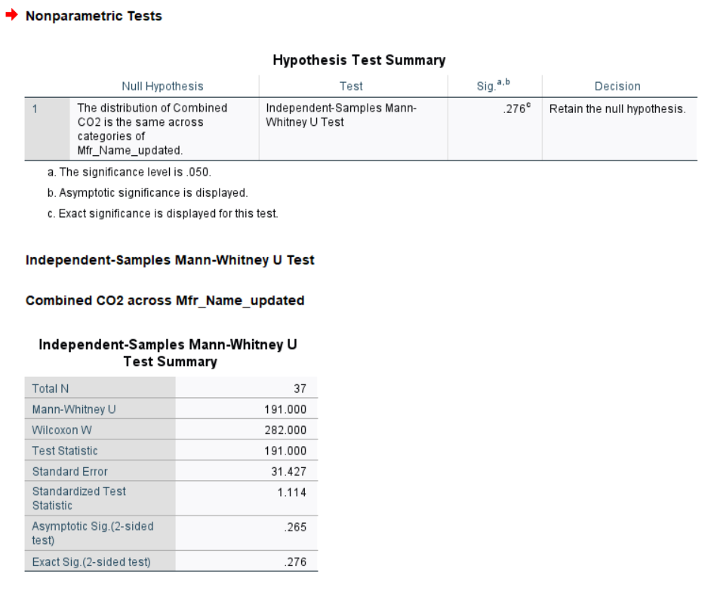

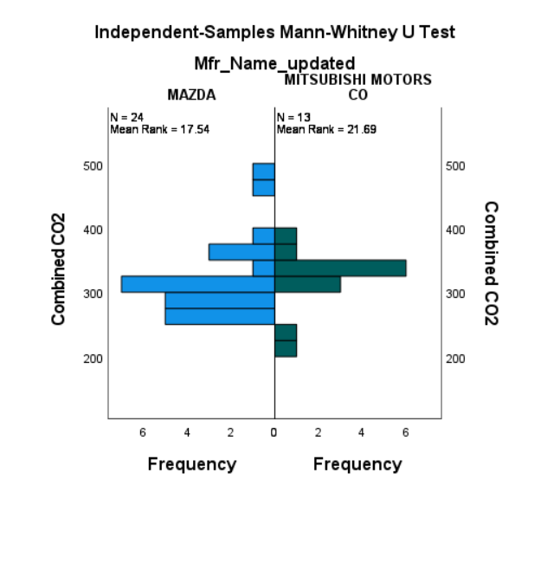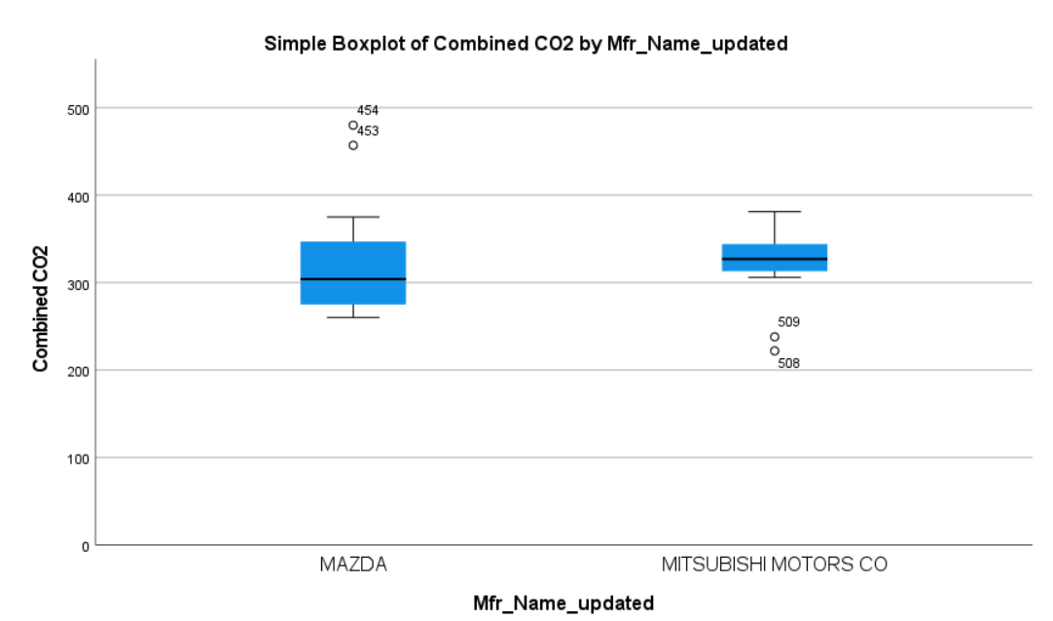

H0 is accepted so MAZDA and MITSUBISHI MOTORS CO cars are significantly not different regarding COMBINED CO2.

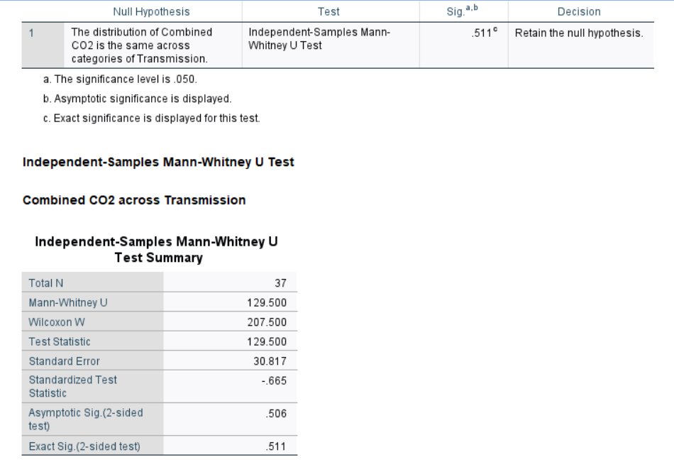

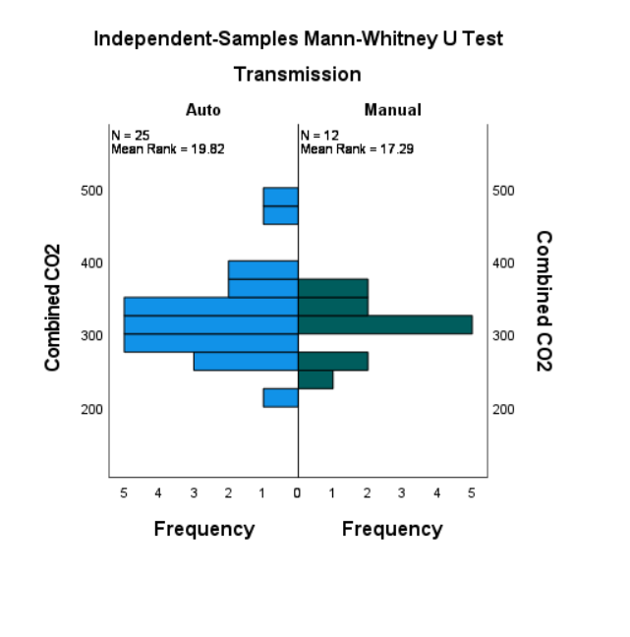

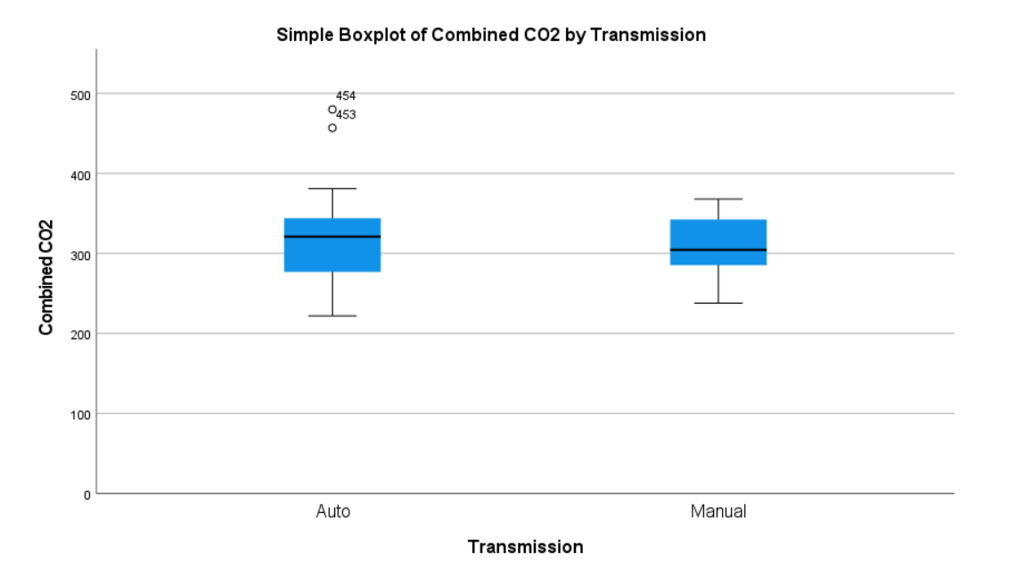

H0 is accepted so MAZDA and MITSUBISHI MOTORS CO cars are significantly not different regarding auto or manual transmission.

**Correlation**

The Spearman rank correlation can be employed as a measure of a monotonic association for nonnormally distribution (Schober, Boer, and Schwarte, 2018).

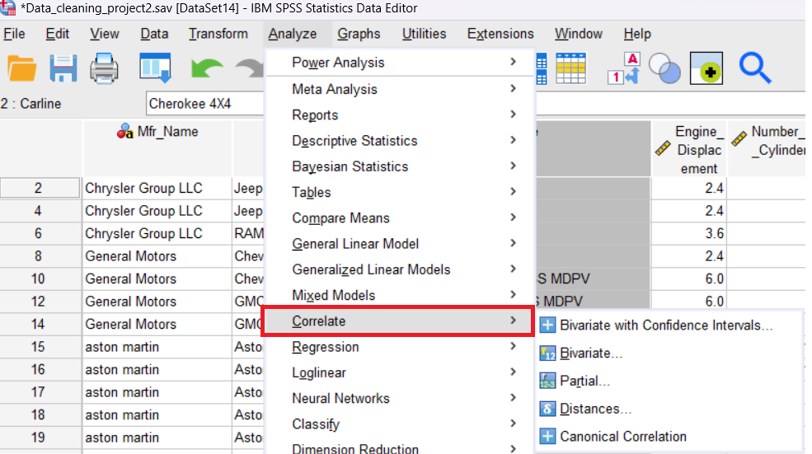

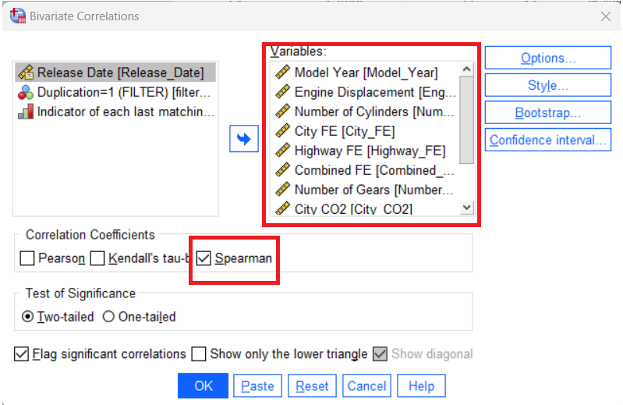

The Spearman rank correlation matrix shows the correlation between the different numerical values.

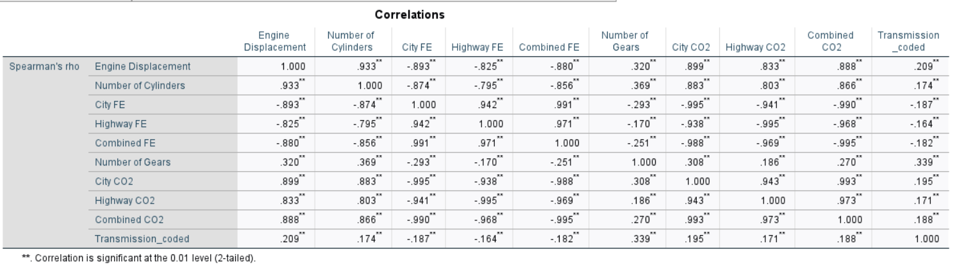

The strong correlation between Highway CO2 and Engine Displacement is 0.833, which indicates that there is a positive relationship between the variables. The strong correlation between Highway FE and Engine Displacement is -0.825. The relationship between these variables is negative, which indicates that as Highway FE increases, Engine Displacement decreases.

**Descriptive statistics**

Descriptive statistics is a word used for a statistical examination of data that helps explain, show, or outline data in an insightful manner so that, trends can be identified from the data.

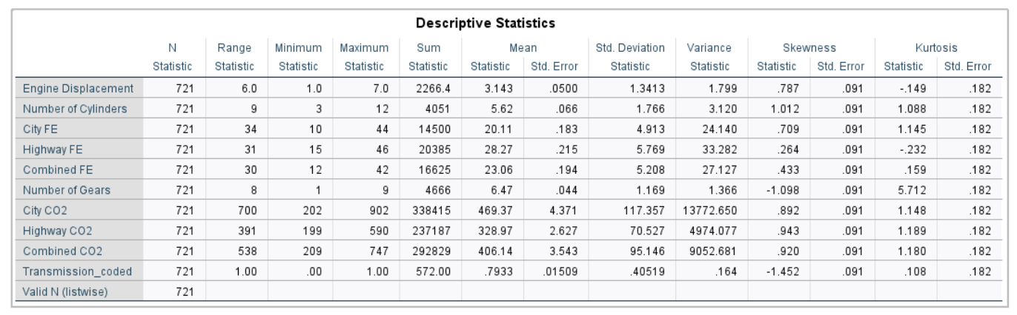

**Regression**

The regression model shows the relationship between one or more independent variables (such as Number of Cylinders, Engine Displacement etc) and one dependent variable (Combined CO2 only for manual transmission cases).

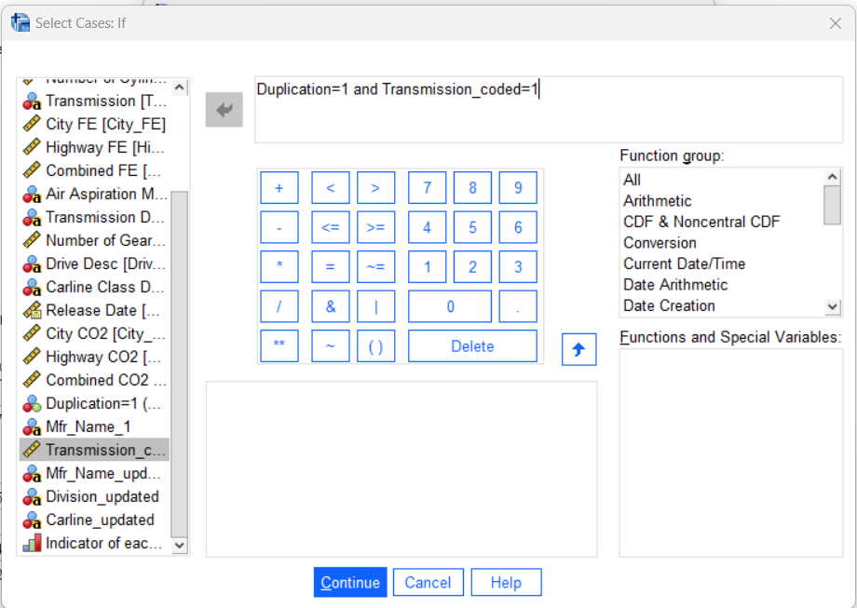

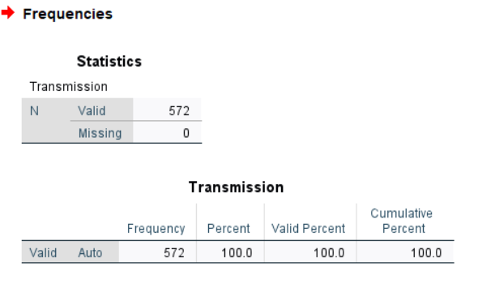

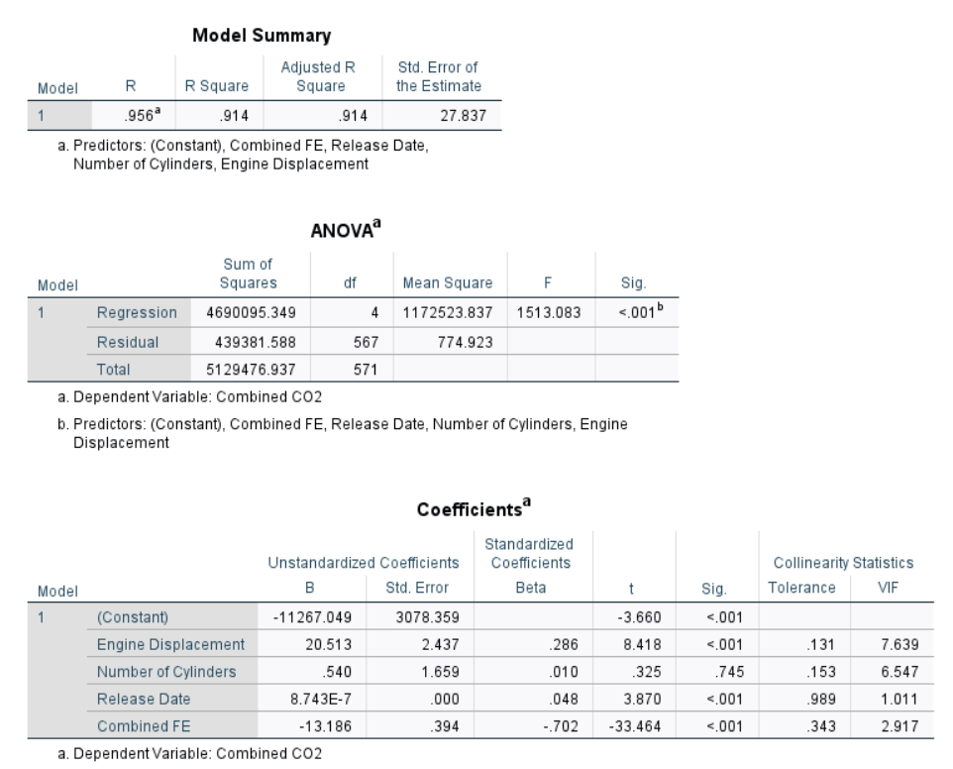

This regression model is a good fit of the dataset because ANOVA p value<0.05 and the model has a high R square. Only the number of cylinders (and Engine Displacement have high VIF which shows multicollinearity, one of them can be removed) has p-value>0.05, other values are significant.

## 1.4 Task 4: Evaluation and Conclusion

The dataset has some possible limitations which can affect the analysis.

Possible limitations:

* release date has only values from 2014 (cars are released only in 2014) so that the analysis does not consider other older models.
* manufacturer name does not include all the manufacturers.
* the categories are imbalanced according to the frequency which can affect the statistical results (resampling or creating other categories could help to mitigate the impacts)

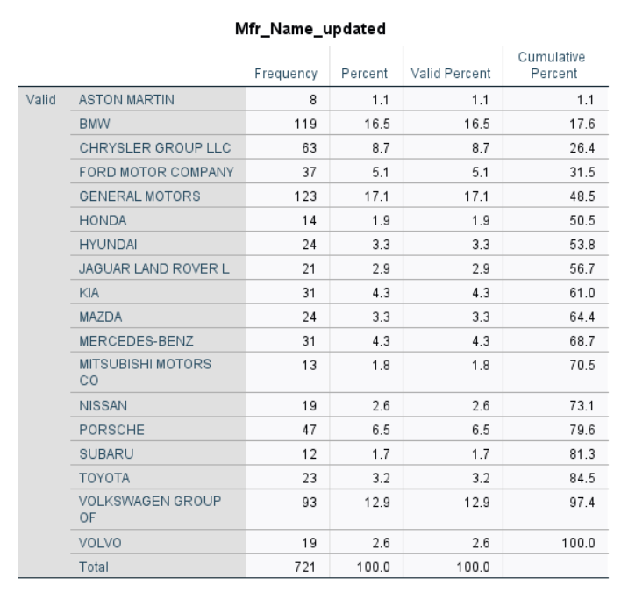

**The answers to the research questions.**

Most environmentally unfriendly

According to this analysis, cars manufactured by ASTON MARTIN emit the most CO2 which means the most environmentally unfriendly cars. Furthermore, ASTON MARTIN cars with auto transmission have the highest emission values which is the line with the research article findings. Kruskal-Wallis test does not give significant difference for ASTON MARTIN and JAGUAR LAND ROVER L. Accordingly, Mann Whitney U test shows for this pair that there is a significant difference regarding Combined CO2. which shows significant difference between themThese results are in line with the related boxplot visualization.



In the case of Combined FE other way around due to the relationship between them.



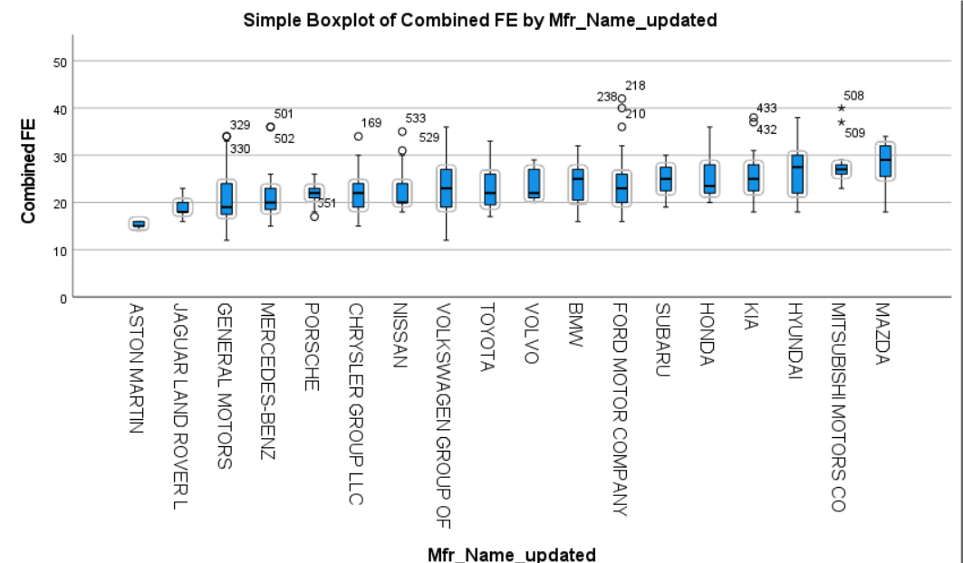

Most environmentally friendly

Cars manufactured by MAZDA and MITSUBISHI MOTORS CO emit the least CO2 which means the most environmentally friendly cars. Kruskal-Wallis test does not give significant difference for MAZDA and MITSUBISHI MOTORS. Accordingly, Mann Whitney U test shows for this pair that there is no significant difference regarding Combined CO2.  Cars produced by both manufacturers are environmentally friendly. However, the related Mann Whitney U test shows that there is no significant difference regarding auto or manual transmission in case of those manufacturers.

Regression

In the case of regression model, cars’ COMBINED CO2 with manual transmission how is affected by the different attributes. Engine displacement has the highest impact on COMBINED emission in case of manual transmission. This means one unit increase in engine displacement will significantly increase the emission for those cars. Engine displacement and number of cylinders show very high correlation (0.933) and the corresponding VIF values are very high. They seem to have multicollinearity; therefore, number of cylinders can be removed.

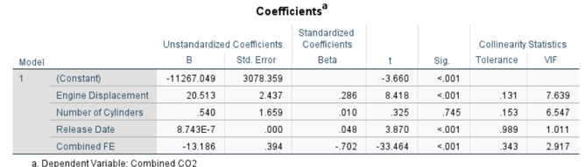

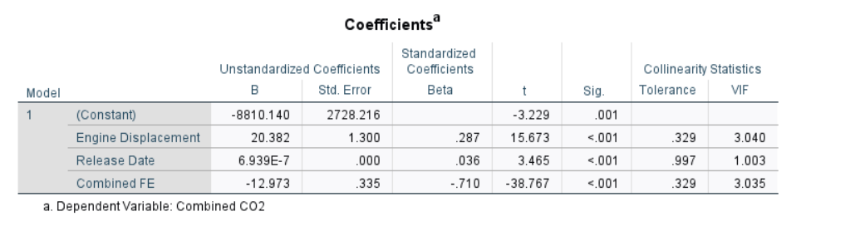

Davis and Knittel (2017) suggested that automobile companies should pay taxes and get included incentives to manufacture fuel-efficient vehicles. In this case, this solution can be beneficial in order to reduce the number of cars with high CO2.

# Section 2: Data Modelling

### **2.1 Task 1: Design** **a relational database using Crow Foot notation.**

**Entity relationship diagrams**

Database design is a crucial element of the database building procedure that includes a problem definition analysis, containing constraints and requirements, and delivers all required information for creating a logical data structure. The problem description outlines the intended purpose in a formal manner, necessary requirements and constraints regarding data that is anticipated to facilitate different business processes. Entity relationship diagrams (ERDs) and modern database design tools provide the capability to convert the diagrams into metadata. The process of such a change is commonly named as forward engineering. Certain tools also can have reverse transformations, allowing for the conversion of metadata into ERDs (Letkowski, 2015).

**Crow Foot notation**

Crow Foot notation symbols with cardinality are used to show the relationship and cardinality of entities in and ERD.

Figure 1. Crow Foot Notation Symbols

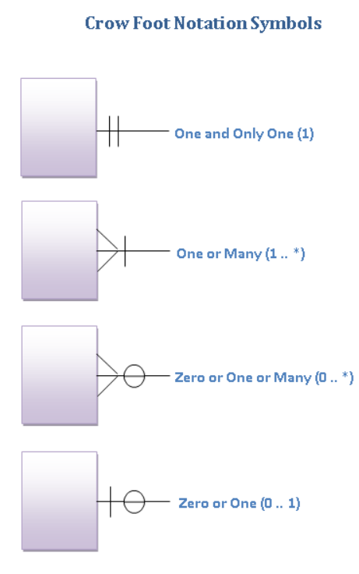

source: Rayan, 2015

In order to draw the database design and create EDR, <https://app.diagrams.net/> was used to complete the design task for the given scenario. 13 different tables: customer addresses, managers, customers, drivers, motorbikes, licenses, orders, order items, items, item groups, pricings, branches, restaurants were created to design the possible dataset scenario for the given business.

EDR can be see below that contains all tables with the appropriate constraints.

Cardinality constrains in databases show what kind of relationship there is among a set of entities based on the types of those entities. Most models show two main types of cardinality constraints: connectivity and participation.

Connectivity constraints (known as maximum cardinality constraints) say how many links can be established between entities in a certain relationship. For the entity type, connectivity is generally written as single (maximum of 1) or multiple (maximum of N). Participation constraints (known as minimum cardinality constraints) say whether participation in a relationship is optional (minimum-0) or mandatory (minimum-1) for the given entity (Hvalshagen and Samuel, 2014).

Figure 2. Full set of cardinality constraints in a relationship between two entities

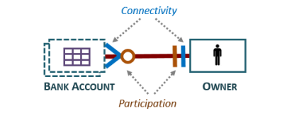

source: Hvalshagen and Samuel, 2014

`

Figure 3. Entity database relationship design



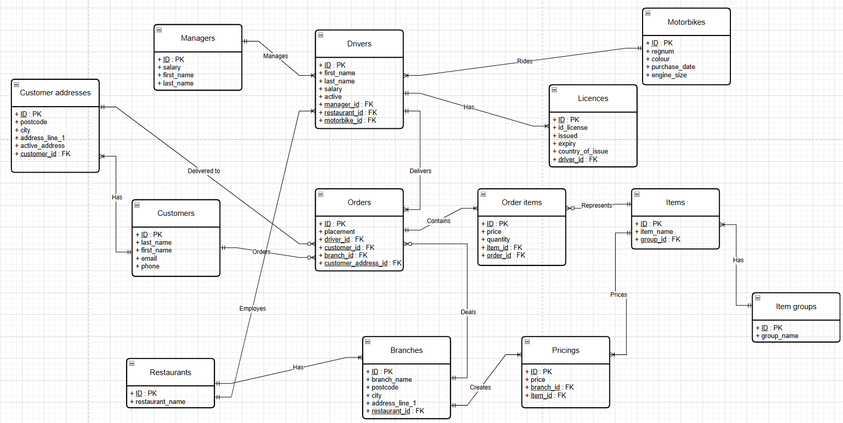



source: own creation in draw.io graph ([draw.io (diagrams.net)](https://app.diagrams.net/))

[delivery_database_Norbert_Szilvasi.drawio - draw.io (diagrams.net)](https://app.diagrams.net/#G1Vzn7JNyrXg5Xd1OpCpIu5ouaNnvSTLg-)

The red circles represent zero or many participations constrain. This means that a customer can have zero or more orders, one customer address can have zero or more orders, one branch can have zero (in the worst case can happen from the business point of view for instance due to bad location or economic recession- this can be a valid assumption realistically in this business scenario) or many, and one item can have zero or many order items. The red circle shows 1: N relationship between motorbike and drivers. However, it was given in the scenario that one motorbike can belong to one driver which assumes 1:1 relationship. This assumption is since one active driver can have only one motorbike if the driver works for the company (during the period nobody can have, but the motorbike belongs to the company if the driver leaves the job, the motorbike will be used by another new active driver which is referred to as active driver and assigned to Boolean value in the drivers’ table. One driver can have one license which is represented by the grey cycle to have 1: 1 relationship. Other cases show 1: N relationships which can be seen on the diagram such as one restaurant can have one or many branches, one customer can have one or more addresses, one manager can have oner or more drivers etc.

### **2.2 Task 2: MySQL code to database design.**

All 13 available tables in the dataset:

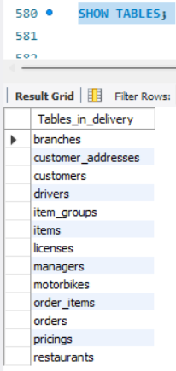

The delivery database can be created in the following way.

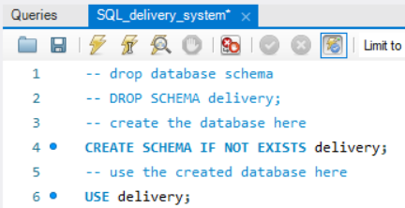

**Customer table**

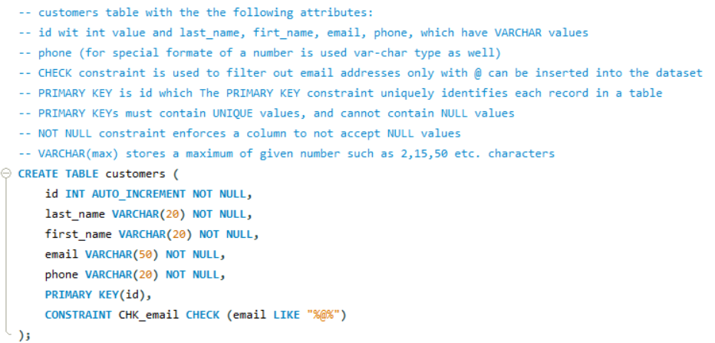

Insert 10 random correct values with correct email address including @ into the customers table and one insert without @ to test CHECK constrain for email.

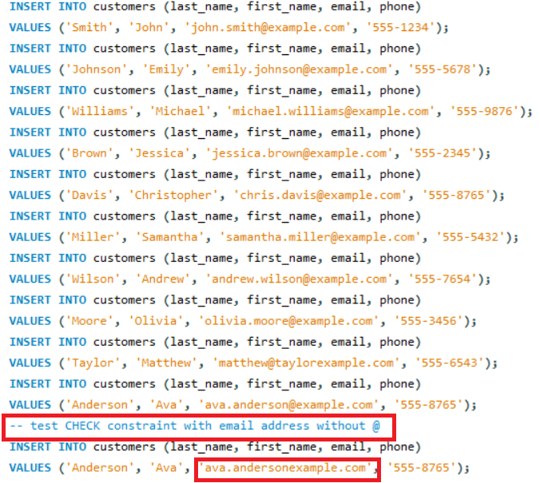

After inserting all values, CHECK constrain works well because error code comes up.

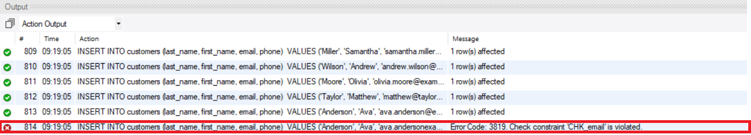

Customers table contains only 10 rows.

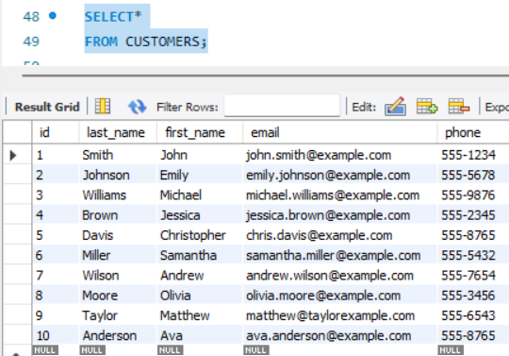

The following query is used for demonstration.

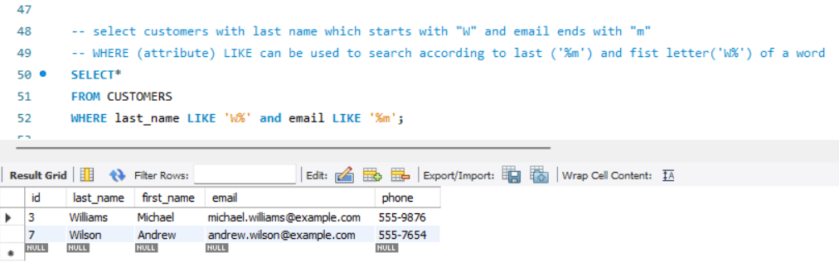

**Manager table**

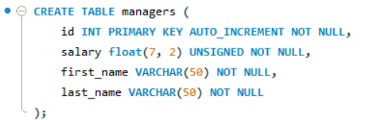

Insert 10 random correct values with correct positive values into the managers table and one insert with negative salary to test UNSIGNED constrain.

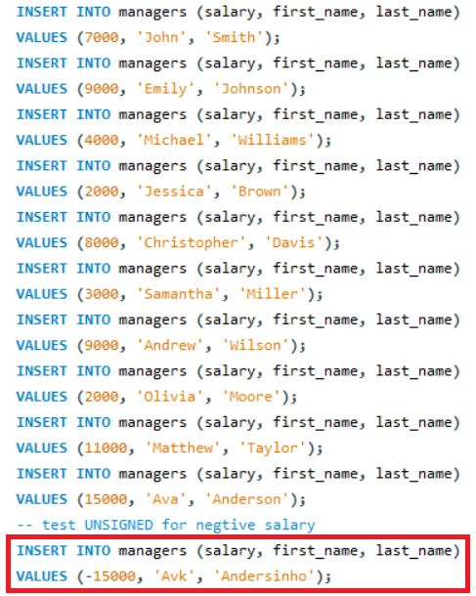

After inserting all values, UNSIGNED constrain works well because error code comes up.

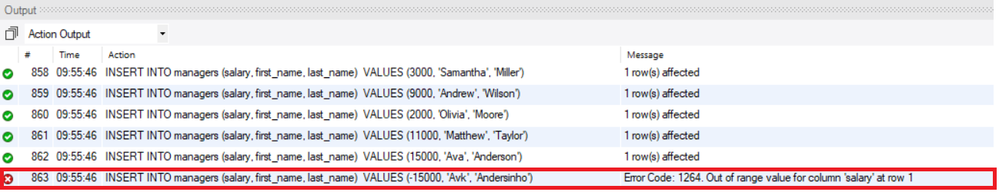

Managers table contains only 10 rows.

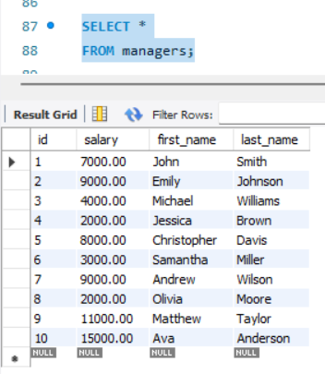

The following query is used for demonstration.

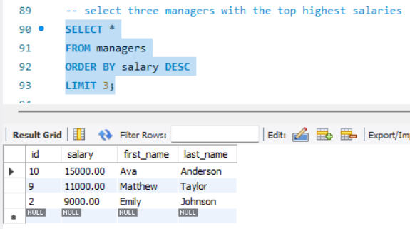

**Customer addresses**

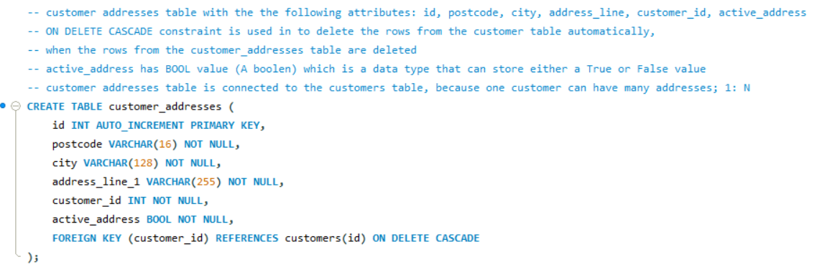

Insert 10 random correct values into the customer addresses.

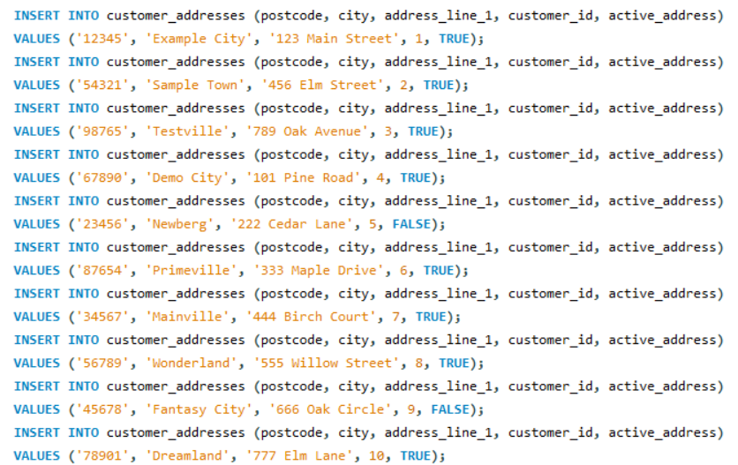

Customer addresses table contains only 10 rows.

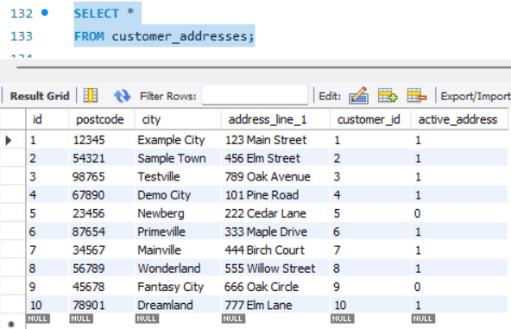

Customer table still contains 10 rows.

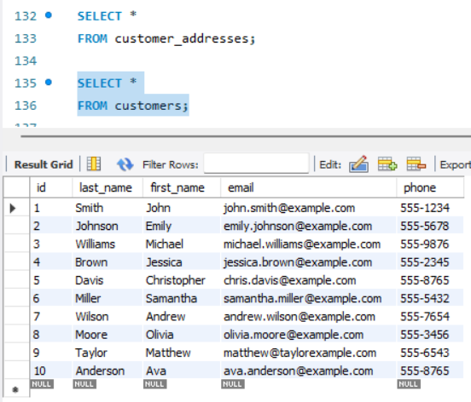

One row is deleted in the customer’s table (only 9 rows).

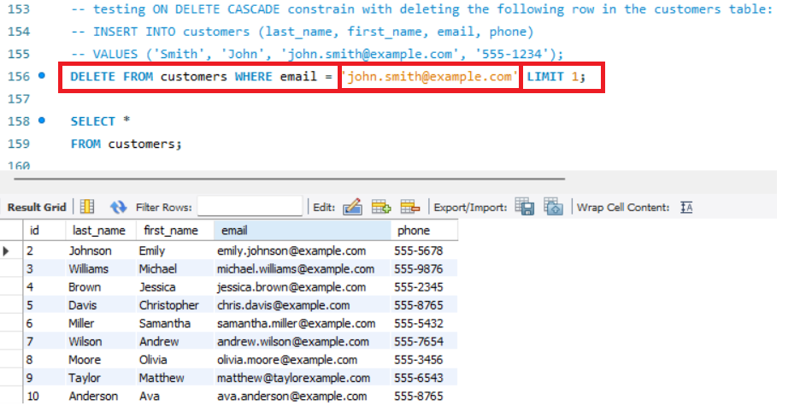

The corresponding value in the customer addresses table is deleted (only 9 rows). ON DELETE CASCADE constrain works (deleting one row in the customers table will delete one related row with the same customer id in the customer address table).

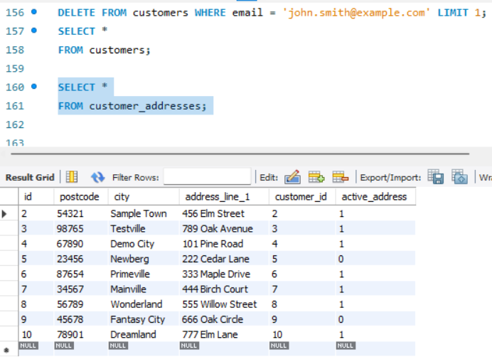

The following query is used for demonstration.

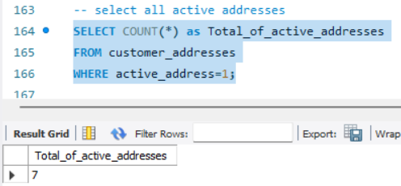

**Motorbikes table**

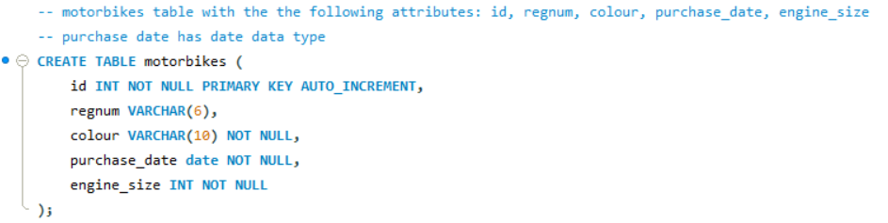

Insert 10 random correct values into the motorbikes table.

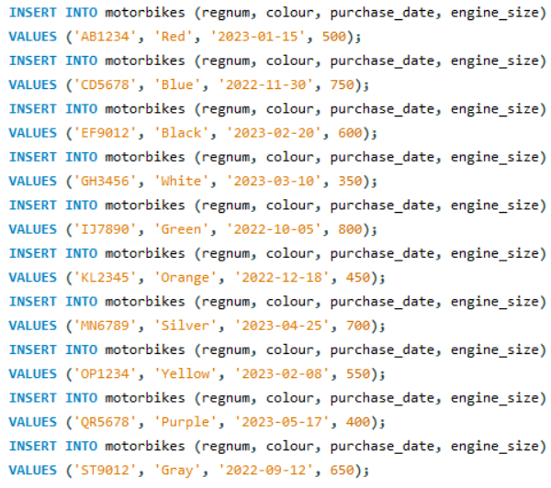

Motorbikes table contains 10 rows.

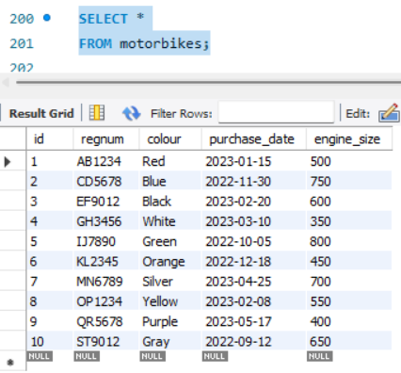

The following query is used for demonstration.

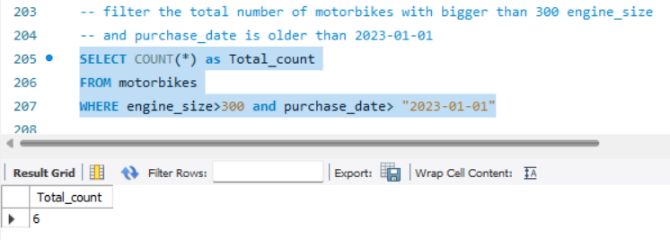



**Restaurants table**

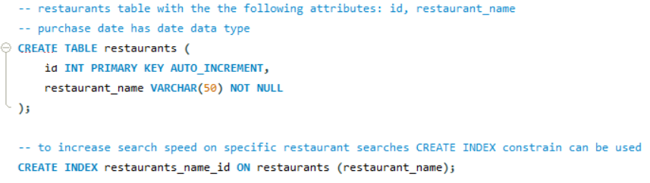

CREATE INDEX constrain can be used to boost search speed for a specific column, however, it can be tested and demonstrated only with a table with many rows.

Insert 10 random correct values into the restaurants table.

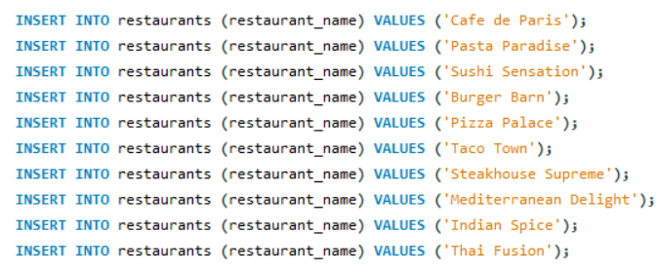

Restaurants table contains 10 rows.

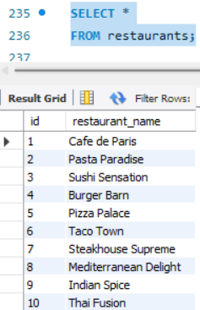

The following query is used for demonstration.

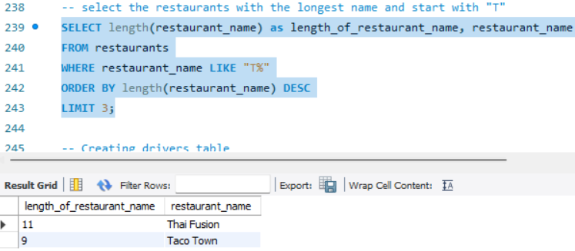

**Drivers table**

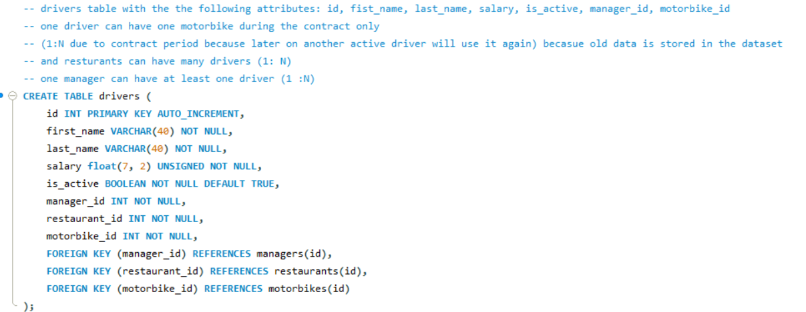

Insert 10 random correct values into the drivers table.

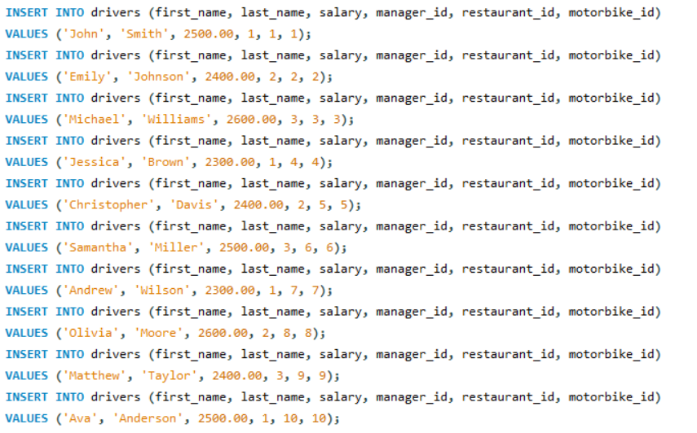

Drivers table contains 10 rows.

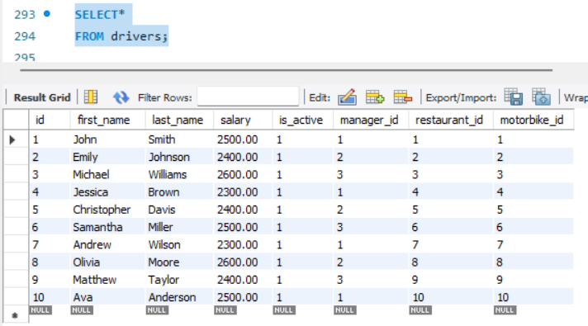

The following query is used for demonstration.

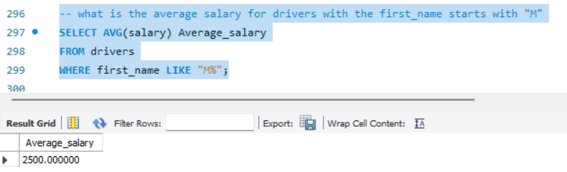

**Licenses table**

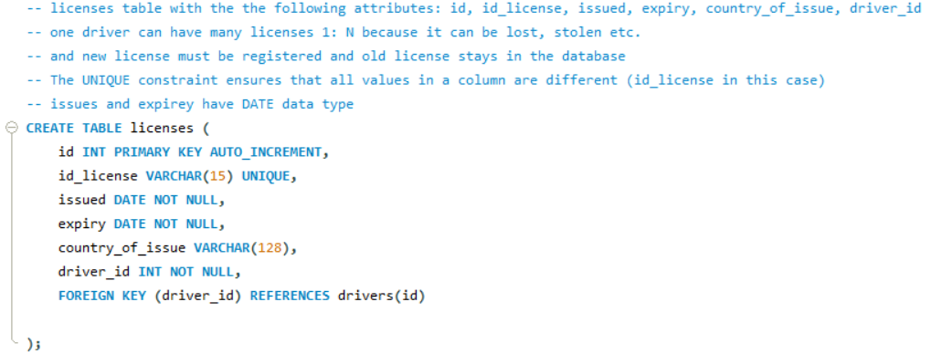

Insert 10 random correct values into the licenses table.

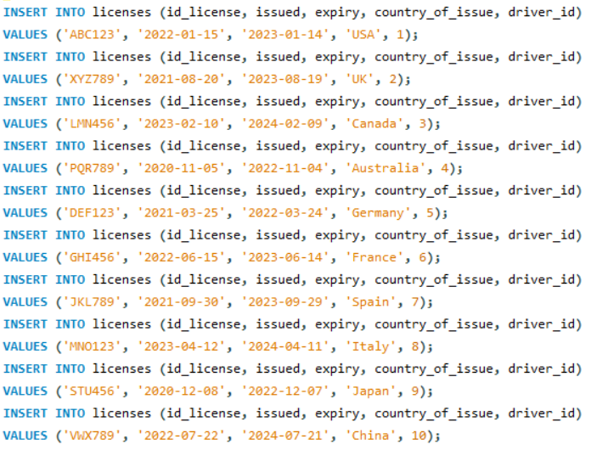

Licenses table contains 10 rows.

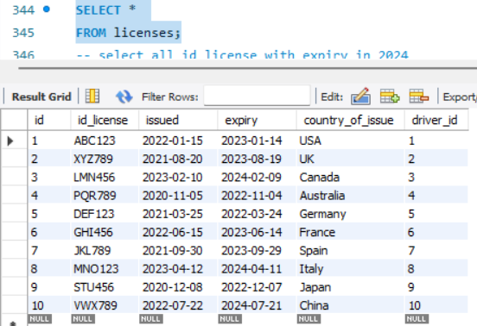

The following query is used for demonstration.

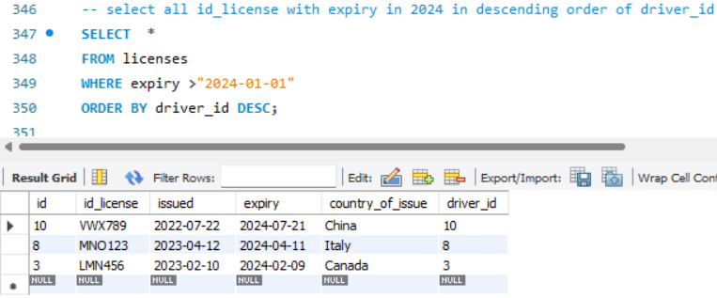

**Branches table**

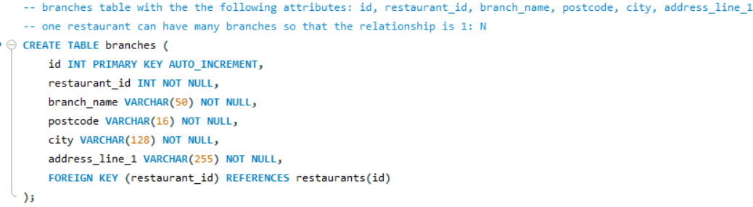

Insert 10 random correct values into the branches table.

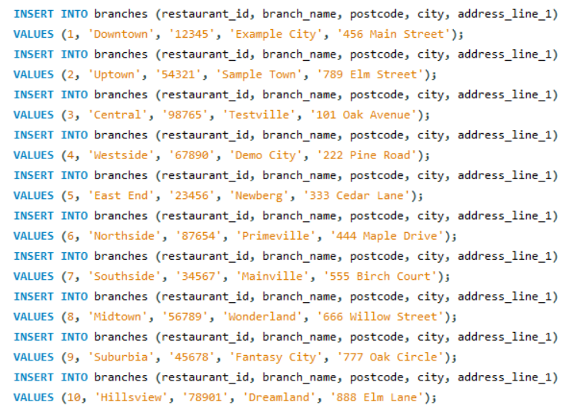

Branches table contains 10 rows.

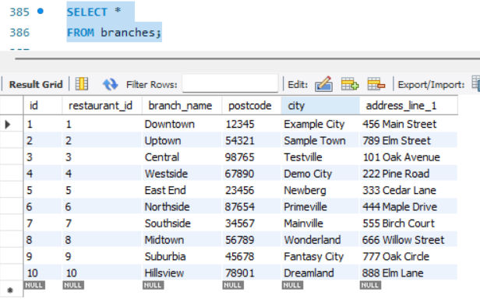

The following query is used for demonstration.

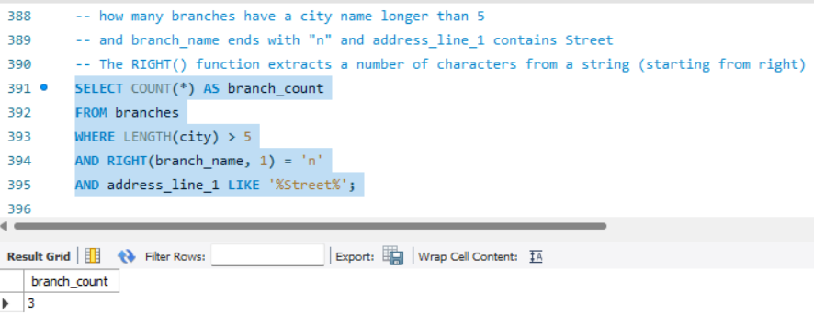

**Item_groups table**

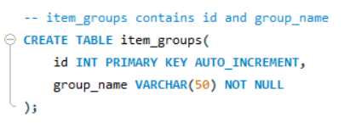

Insert 10 random correct values into the item_groups table.

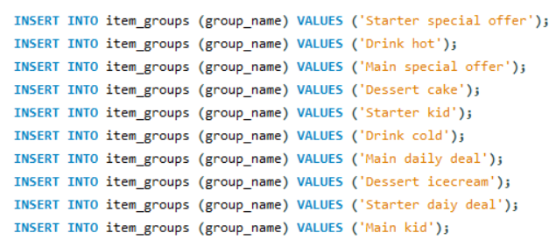

Item_groups table contains 10 rows.

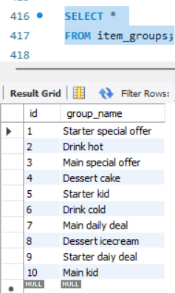

The following query is used for demonstration.

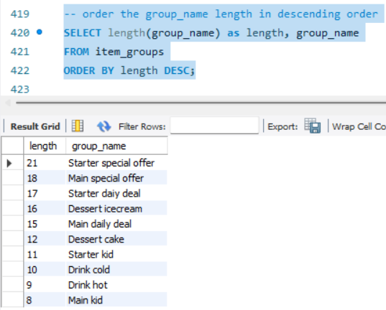

**Items table**

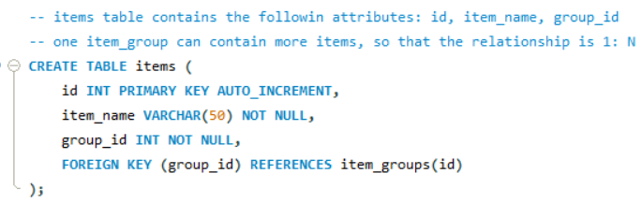

Insert 10 random correct values into the items table.

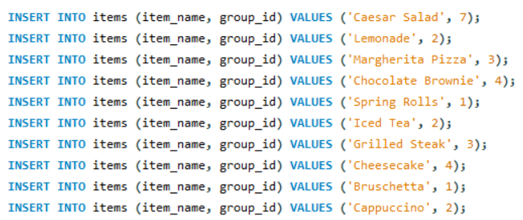

Items table contains 10 rows.

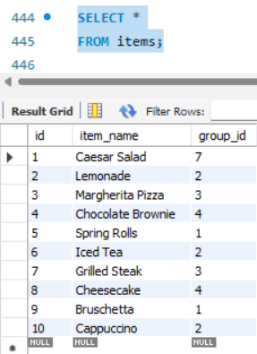

The following query is used for demonstration.

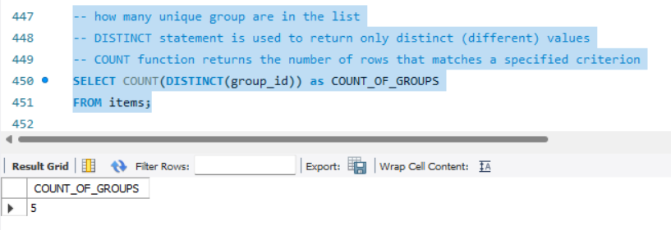

**Pricings table**

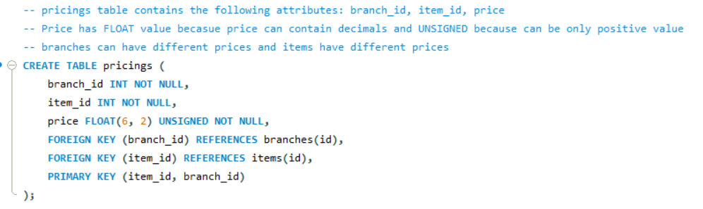

Insert 10 random correct values into the pricings table.

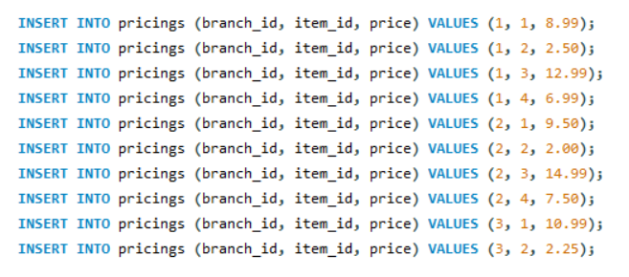

Pricings table contains 10 rows.

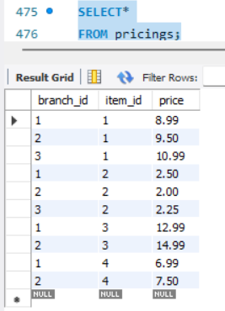

The following query is used for demonstration.

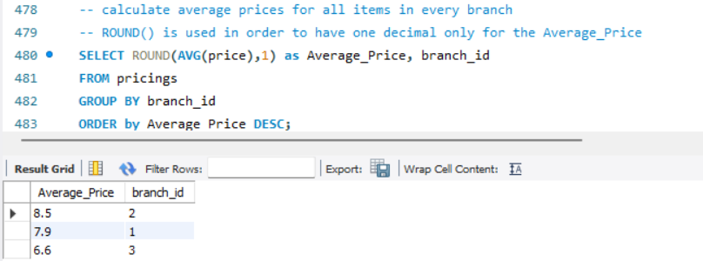

**Orders table**

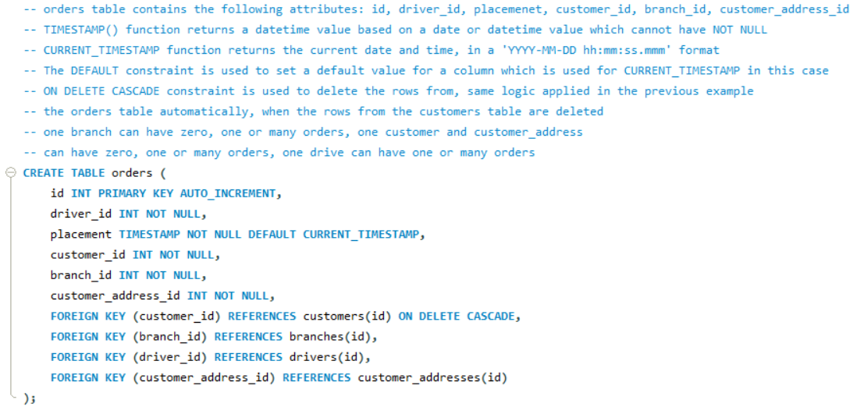

Insert 10 random correct values into the orders table.

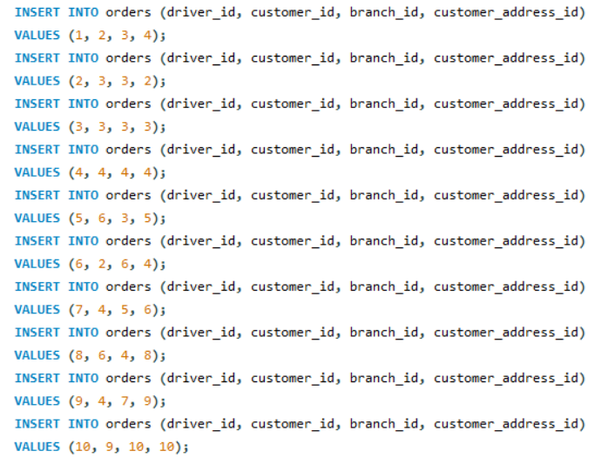

Orders table contains 10 rows.

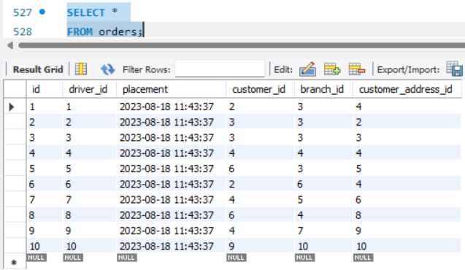

The following query is used for demonstration.

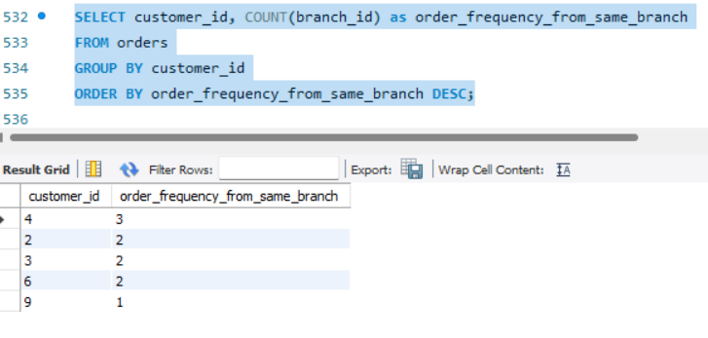

**Order_items table**

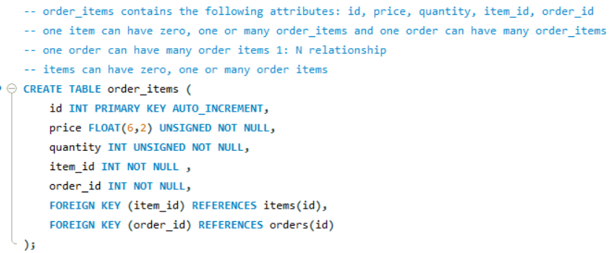

Insert 10 random correct values into the order_items table.

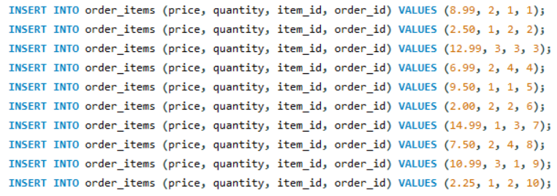

Order items table contains 10 rows.

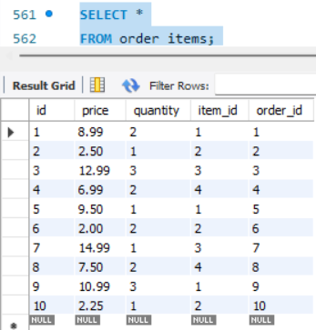

The following query is used for demonstration.

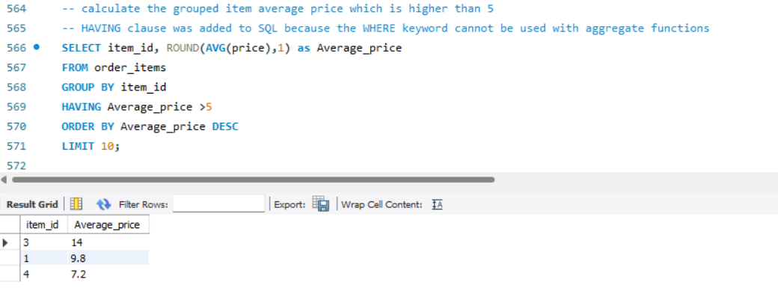

**Additional complex queries**

Any additional queries with comments beside the codes are added for the business scenario to represent the use of database in real life and how queries can deliver information.

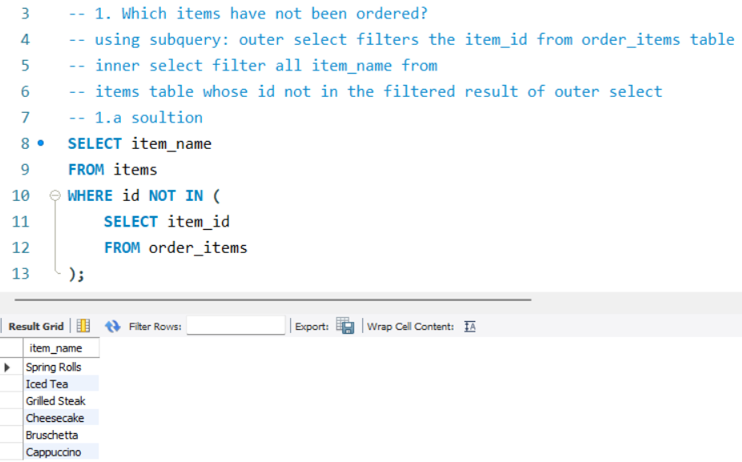

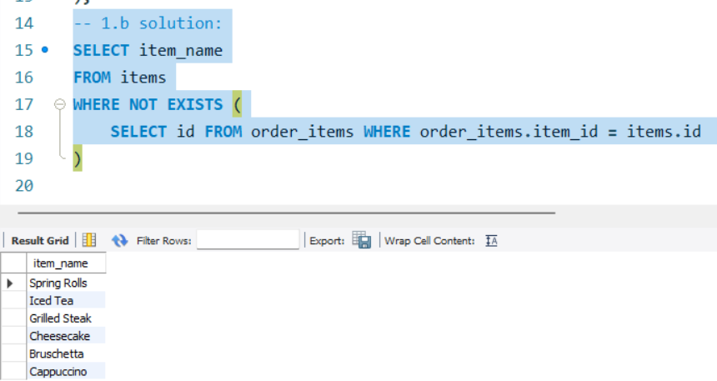

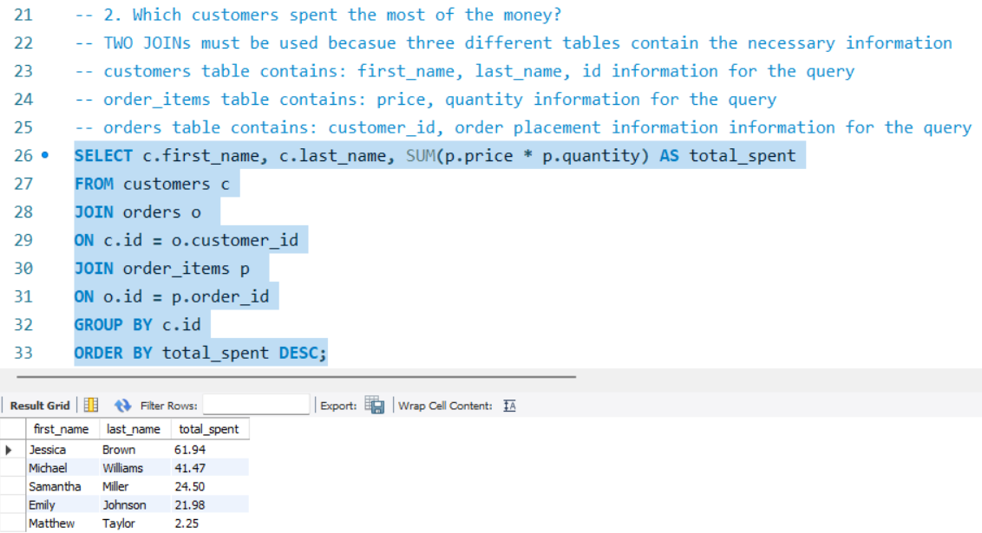

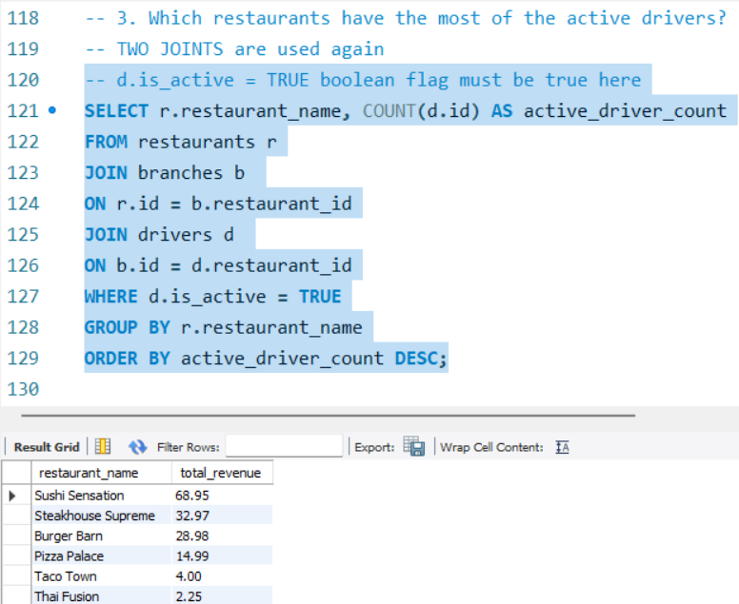

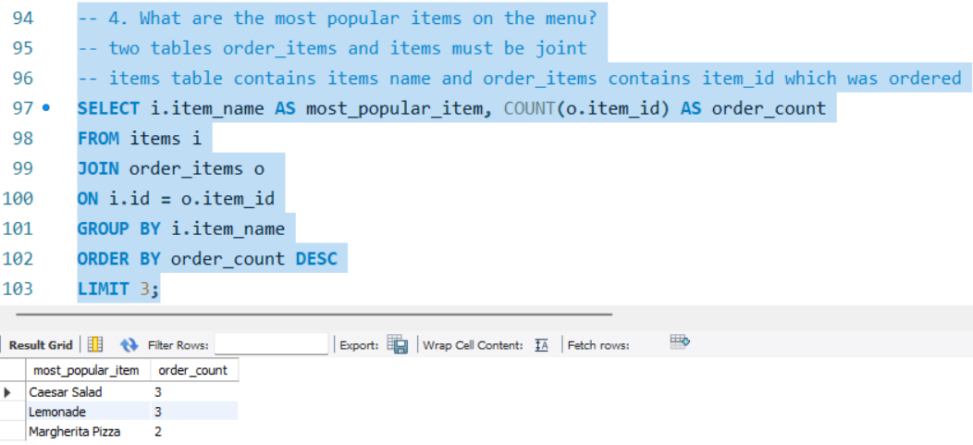

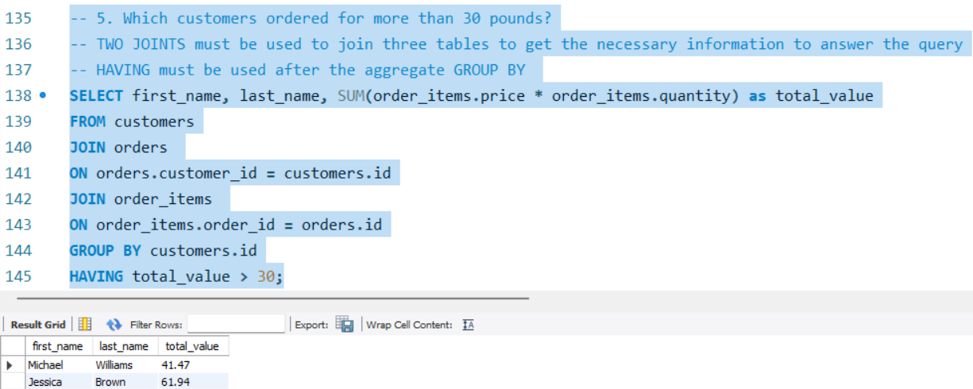

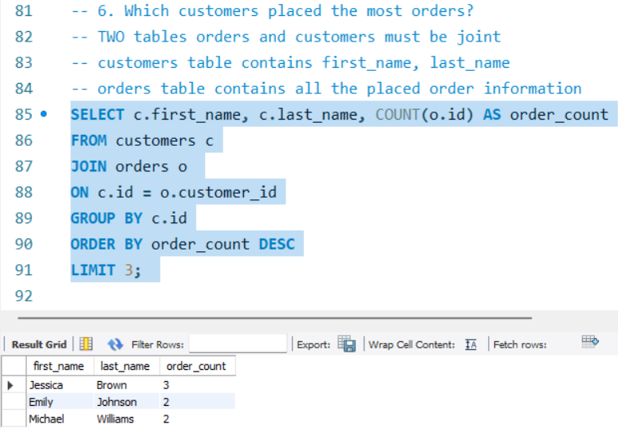

**Triggers, procedures and functions**

**Triggers**

Data triggers are intended to execute actions automatically in response to database events. There are many different commission and omission events that triggers can perform. These actions may affect data within and outside of the database management system. Triggers are utilized for enforcing business requirements, like in the scenario (triggers of checkorders, checkdrivers) guaranteeing the appropriate relationship between items added to an order and the corresponding branch or restaurant, as well as restaurant of an order aligns with the assigned driver in the restaurant. They ensure data consistency and integrity and preventing incorrect associations (Hauger and Olivier, 2015). Two before tiggers are used in this business scenario in the following.

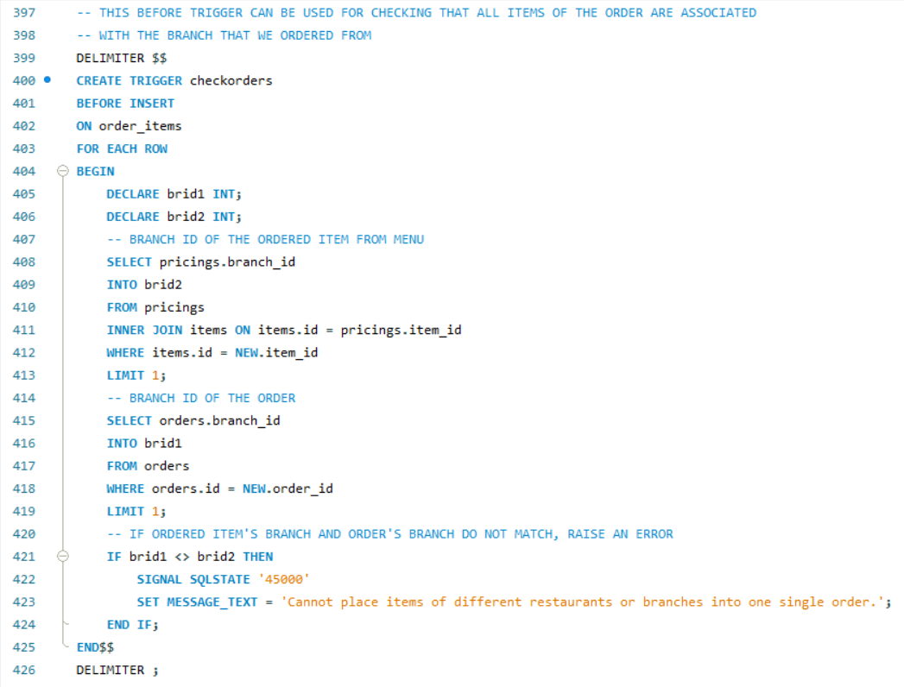

When items in the order are from the same branch, insert can be executed.

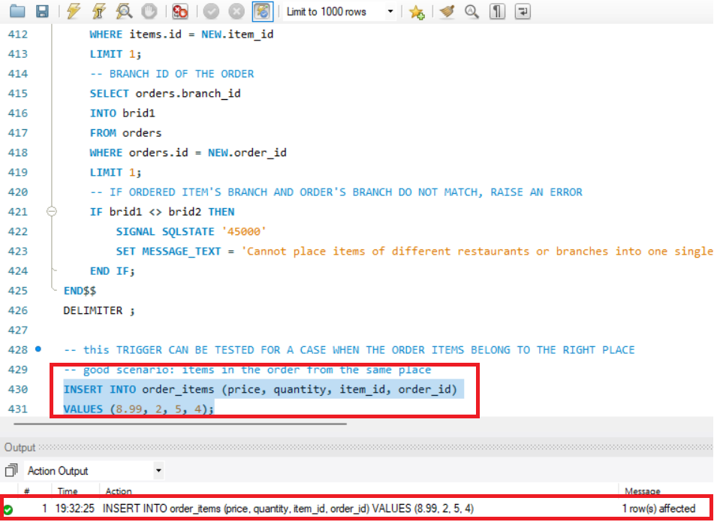

In this case, the checkorders before trigger is executed because items from different branches can not be in one order.

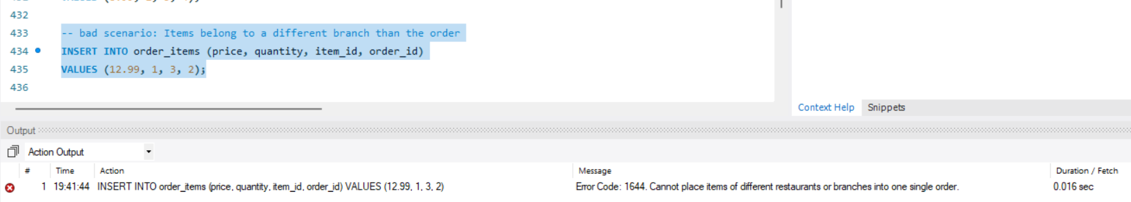



The second before trigger in this business scenario checks the driver belongs to the originally assigned branch.

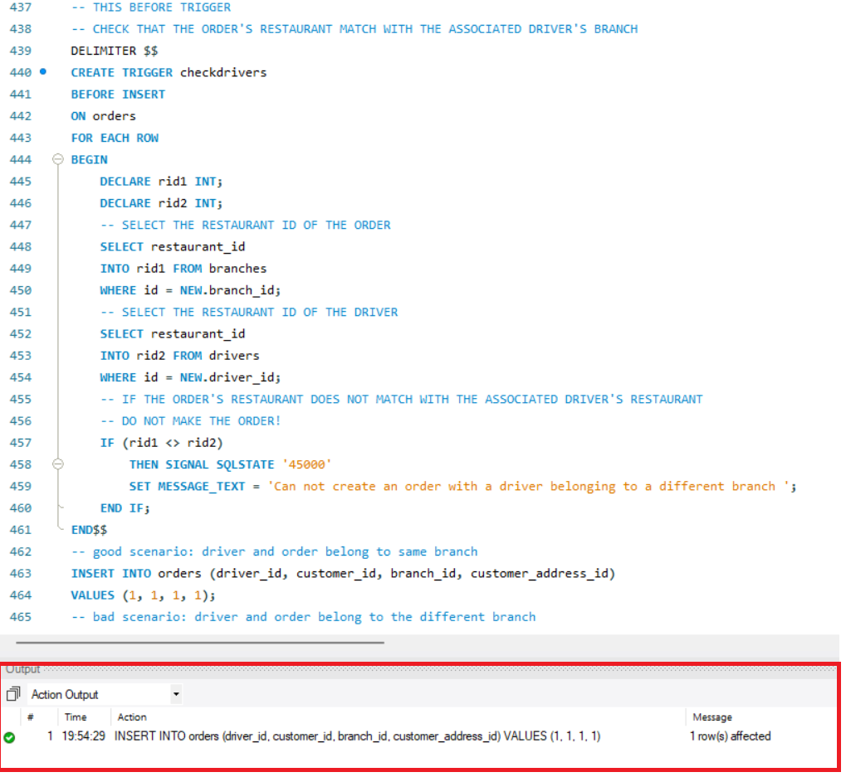

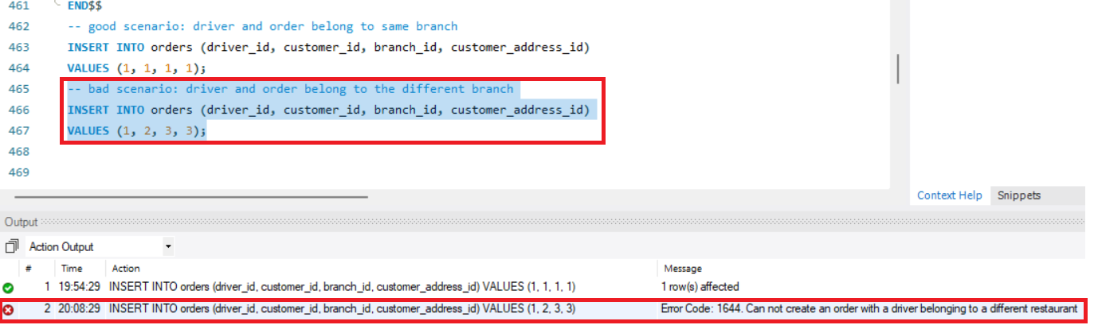

If the driver belongs to different restaurant, this before trigger will be executed as an alarm.

**Stored procedures**

Stored procedures (SPs) are database components that are utilized for the purpose of storing and executing the elements of the application function. The queries are formulated utilizing a language proprietary to the database vendor, but they are interpreted in the original SQL. SPs enhance the efficiency of SQL code execution (Barbosa and Maia, 2020).

In the given scenario, the CREATE_MANAGER_DRIVER_PAIR and CREATE_MANAGER_TO_EXISTING_DRIVER procedures facilitate that each manager oversees minimum of one driver and PROCEDURE create_order helps that a customer must order at least one item per order.

Each Manager manages at least one driver.

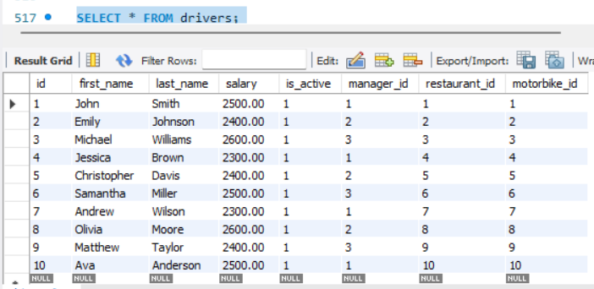

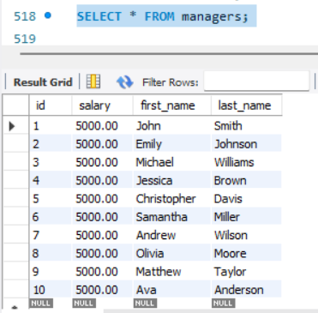

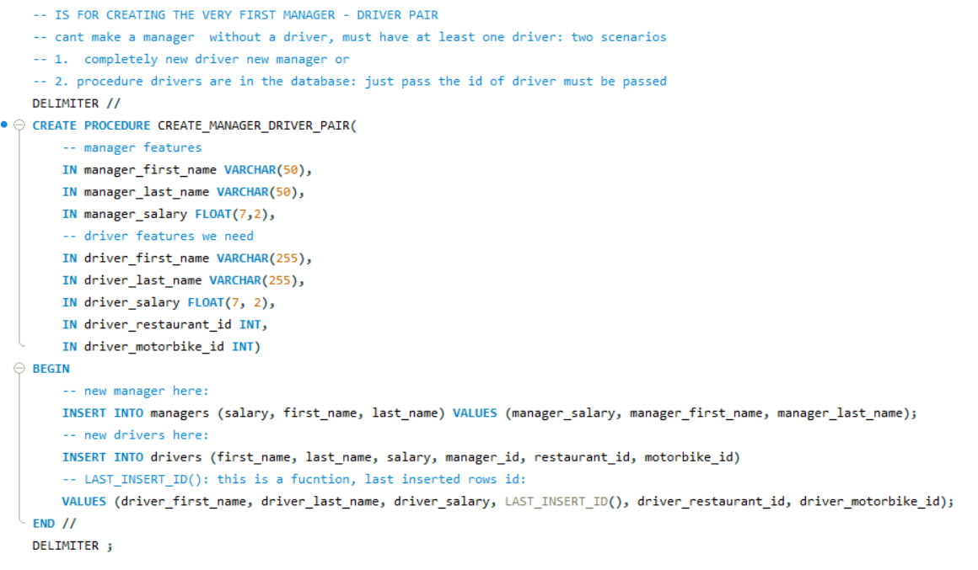

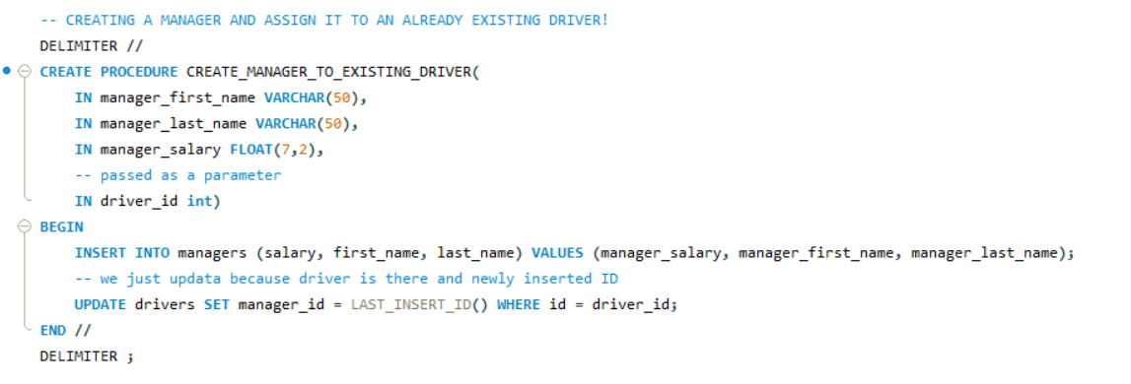



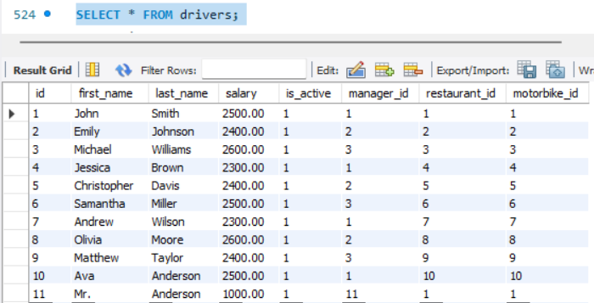

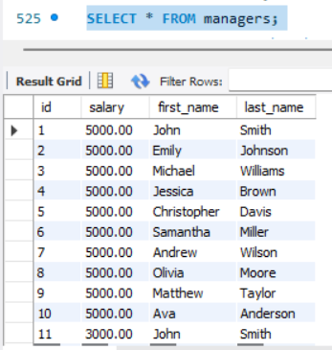

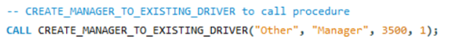

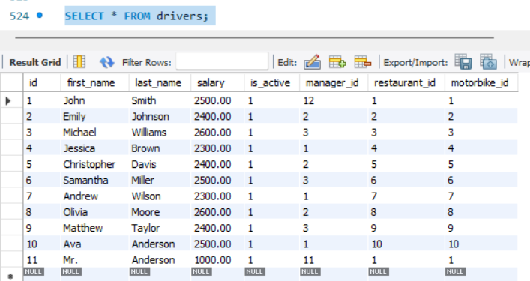

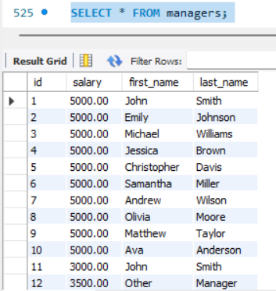

A customer must order at least one item per order.

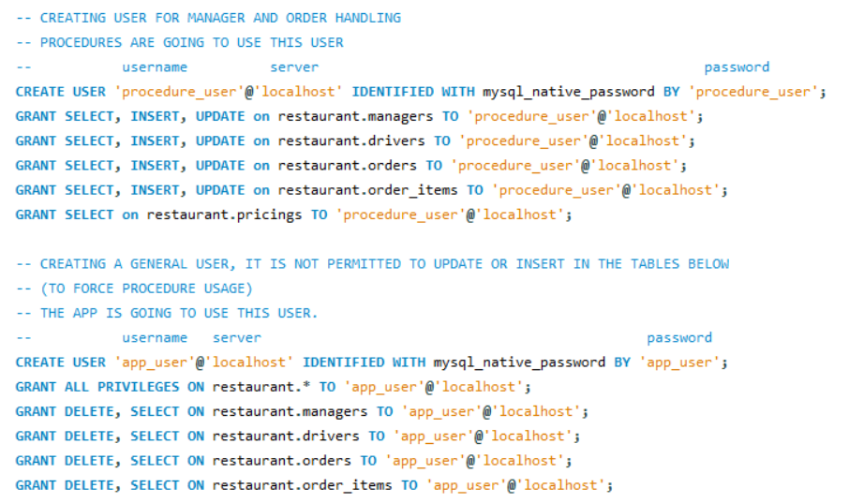

Two users are defined with different possible rights (procedure_user) can only modify the tables because it has only UPDATE. In order to secure that one order contains at least one item, the following procedure is used.

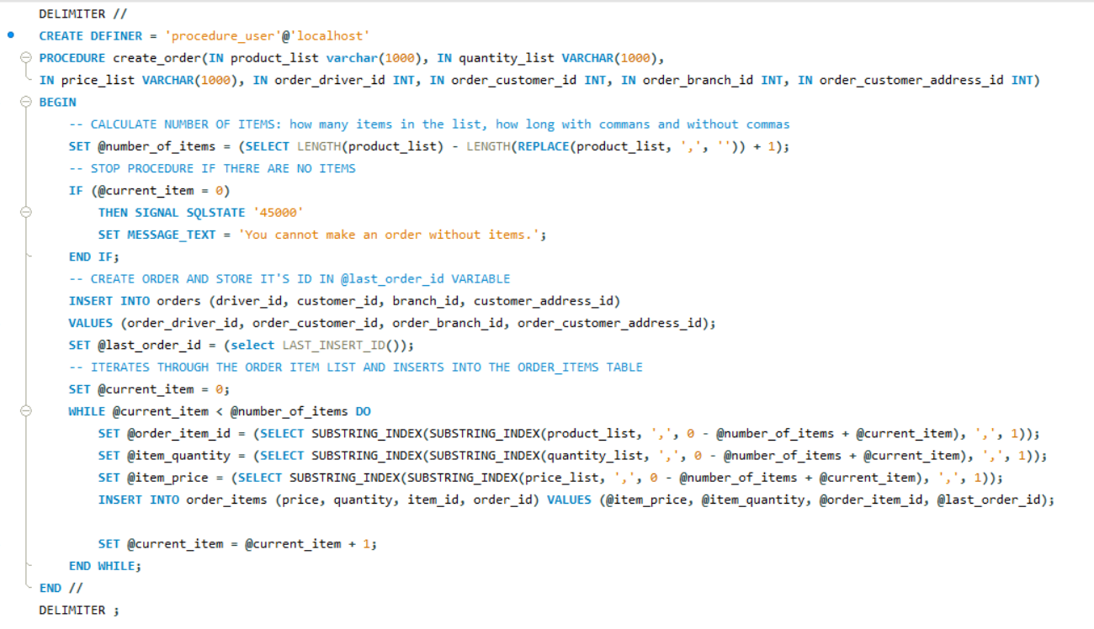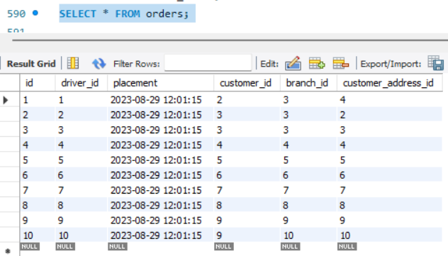

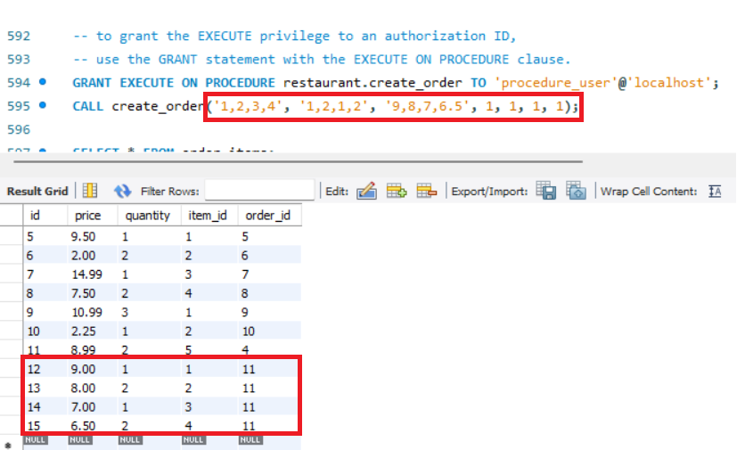



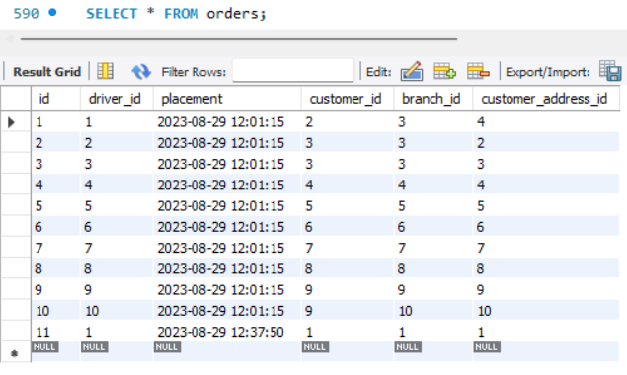

This procedure ensure that authorized user can place an order and the order must contain at least one item.

**Functions**

SQL is known for its SQL Functions. The functions can execute computations on data, modification of specific data pieces, manipulation of results to get a group of rows, date and number modification and data type modification as well (Kaur, 2017). The ORDER_VALUE function in the given scenario computes an order’s total value, which is beneficial for financial reporting and analysis in order to get the total_order_value for a certain order ID.

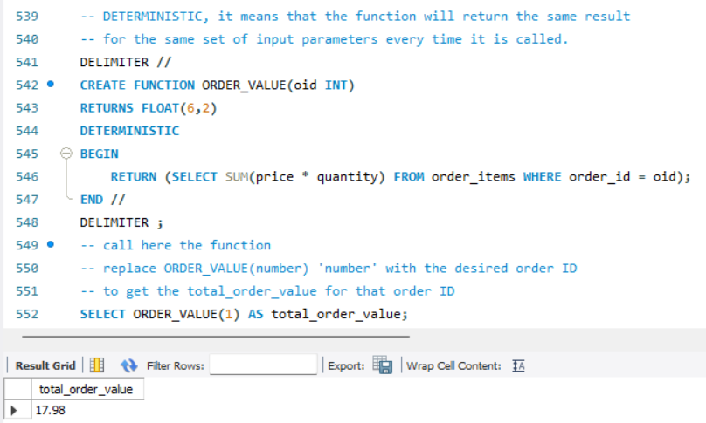

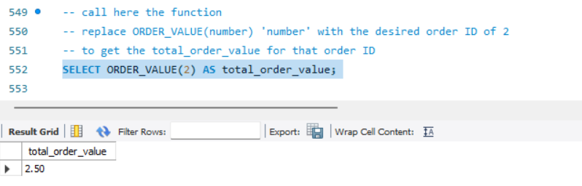

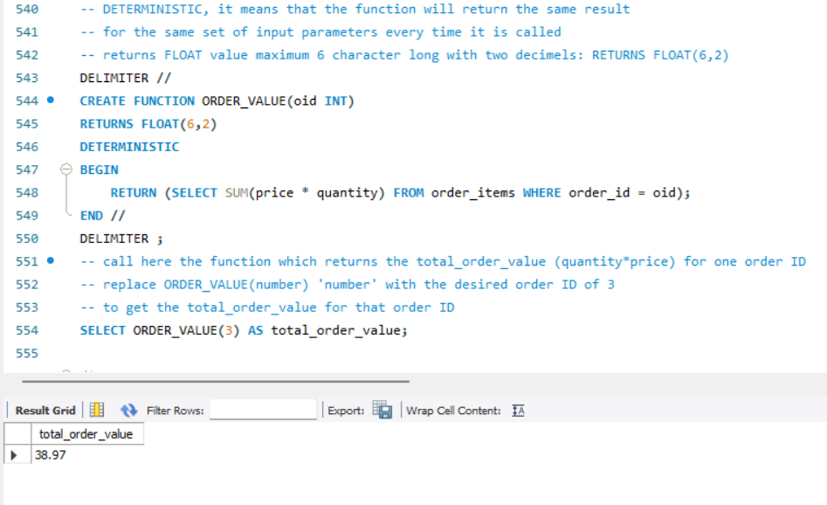

**Views**

Views are virtual tables which includes information from one or more tables. Information is stored. A view is a collection of queries to one or more records that are stored as an entity in the database. They are utilized in data storage systems for security purposes. Views prevent the user from demonstrating specific columns and rows (Kharade *et al.,* 2020). In order to improve database efficiency, views can be used. The following examples show how views work.

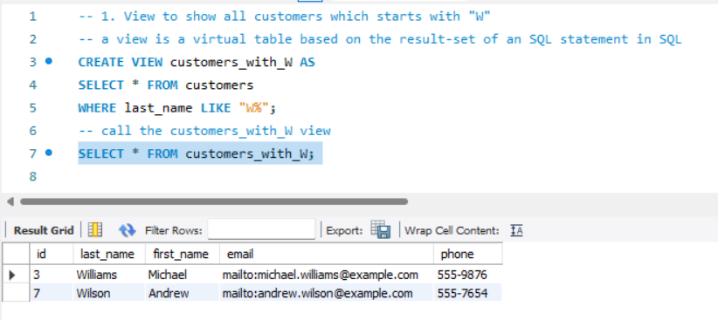

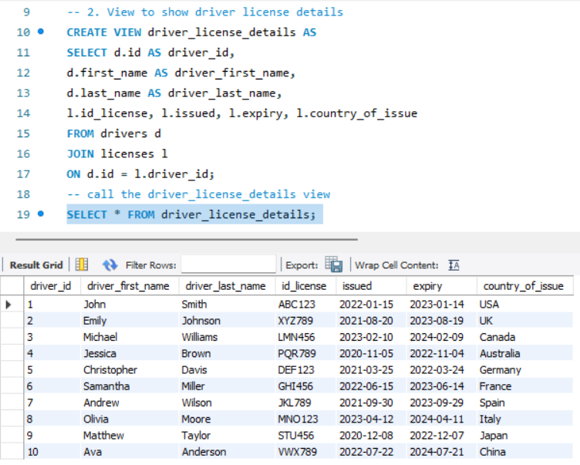

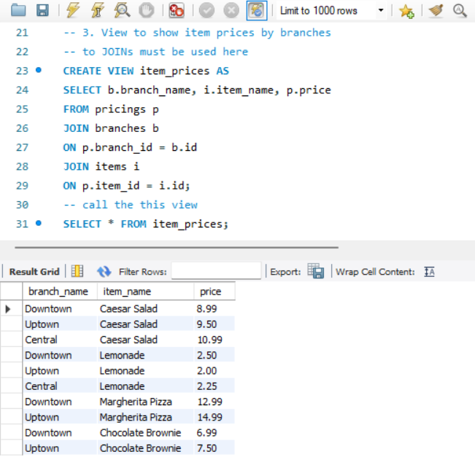

Figure 4. EDR from MSQL

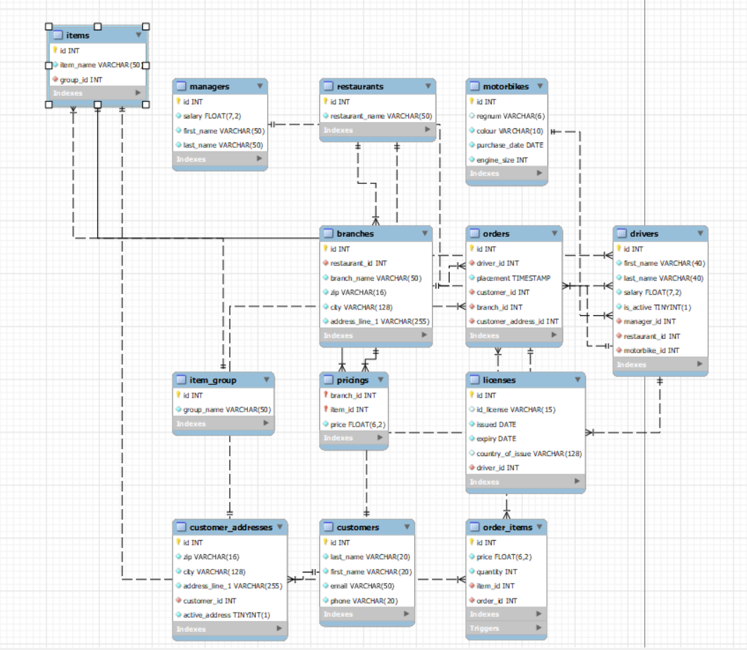

source: MSQL Database/Reverse Engineer

### **2.3 Task 3: How database** **design will support the business scenario**

Relational databases have been widely employed within different industries, including education, healthcare, and businesses and in many different other industries and applications. Structured query language (SQL) databases are made to effectively handle and organize structured data, exhibiting outstanding performance (Khan *et al.,* 2019). Utilizing an appropriate business database such as Kangaroo scenario can result in numerous outcomes. The use of queries aids in minimizing mistakes in the everyday activities and decrease the risk of critical errors if the data being requested is accurate. Database queries play a vital role in enabling firms to decrease data gaps, enhance data accessibility, boost consumer profitability, strengthen data security, enable data sharing, and optimize data formatting (Kumara, 2020). The following tables are used in the scenario to create a robust database.

Table 3. SQL summary tables

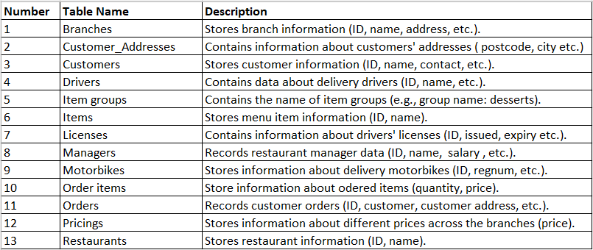

own source

The database design supports the business scenario of Kangaroo in the following way.

**Data organization**

Normalization is the process of organizing data to minimize redundancy in relational database structure. Typically, it includes separating a database into two or more tables and describing their relationships (Demba, 2013). In this scenario, there are 13 different tables. This prevents inconsistencies and makes it simpler to consistently update information.

**Data integrity**

The declarative enforcement of integrity constraints in databases offers several benefits. These include safeguarding the database against the storage definitively incorrect propositions and providing information about the database and its data to various programs, including the database management system and its users (Eessaar, 2021). The database ensures data integrity in different ways. Each table has a primary key, ensuring that each record can be identified clearly. Foreign keys are used to establish relationships between tables, guaranteeing that data consistency is preserved. CHECK constraint such as the email format constraint with ‘@’ in the customers table, are used to ensure data accuracy. Triggers (checkorders, checkdrivers) are used to comply with business rules, for instance securing that all items in an order are from the same branch or one driver can deliver from only one branch.

**Business logic**

The embedded business logic in SQL can be achieved by using stored procedures and functions (Kellenberger and Shaw, 2012). The design of the database includes business logic by setting rules and relationships. Manager-driver pairing (using stored procedure to ensure this) ensures that each manager is associated with at least one driver and order-order_items pairing (using create_order procedure) ensures that each order must have at least one order item (this procedure ensure that only authorized users can update). The ORDER_VALUE function enables the real-time calculation of an order’s total value, delivering crucial business insights for decision-making and financial monitoring.

**Scalability and flexibility**

The SQL database satisfies the scalability and elasticity needs for manipulating expanding data sets with efficiency (Schreiner, Duarte, and dos Santos Mello, 2020). The created design supports the company’s growth without difficulty. New branches, managers, drivers, customers etc. can be added to the database without requiring significant alterations to the structure. This helps with the adaptation of changing requirements in the business.

**Efficiency and performance**

Indexing is a technique for providing a sorted order of information as well as an access point to the physical storage of the location of data. Effective indexing results in improved search engine performance (Hayati and Setyanto, 2018). The index on restaurant names speeds up the searches, making it faster to find specific restaurants in a large dataset in case of any business decision support.



**Data retrieval**

The database design allows the retrieval of different data, which is essential for business objectives.

**User-friendly design**

Tables and columns in the scenario have logical names, making it simpler for developers and business executives to comprehend and manipulate the data.

**References**

Barbosa, M.H.G. and Maia, P.H.M., (2020) ‘Towards identifying microservice candidates from business rules implemented in stored procedures.’ In *2020 IEEE International Conference on Software Architecture Companion (ICSA-C)* pp. 41-48). IEEE.

Chen, Y. and Chen, Y., (2021) ‘Manual Transmission.’ *Automotive Transmissions: Design, Theory and Applications*, pp.23-60.

Davis, L.W. and Knittel, C.R., (2017) ‘Are Fuel Economy Standards Regressive?.’ *Working Paper WP-276R. Berkeley:* Energy Institute at Haas, University of California.

Demba, M., (2013) ‘An algorithmic approach to database normalization.’ *International Journal of Digital Information and Wireless Communications (IJDIWC)*, *3*(2), pp.197-205.

Eessaar, E., (2021) ‘The usage of declarative integrity constraints in the SQL databases of some existing software.’ In *Software Engineering and Algorithms: Proceedings of 10th Computer Science On-line Conference 2021, Vol. 1* (pp. 375-390). Springer International Publishing.

Ghoodjani, A., (2016) ‘Why should I use a Kruskal Wallis Test.’ *Tehran: Avicenna Research Institute*.

Hauger, W.K. and Olivier, M.S., (2015) The impact of triggers on forensic acquisition and analysis of databases. *SAIEE Africa Research Journal*, *106*(2), pp.64-73.

Hayati, M. and Setyanto, A., (2018) ‘Index Effect on Data Manipulation Toward Database Performance.’ In *Journal of Physics: Conference Series* (Vol. 1140, No. 1, p. 012036). IOP Publishing.

Hien, N.L.H. and Kor, A.L., 2022. Analysis and prediction model of fuel consumption and carbon dioxide emissions of light-duty vehicles. *Applied Sciences*, *12*(2), p.803.

Hvalshagen, M. and Samuel, B.M. (2014) ‘Aiding the comprehension of cardinality constraints with narratives.’ In *Proceedings of the 13th AIS SIGSAND Symposium St. Louis* (Vol. 1).

Kaur, K., (2017) ‘An Illustrative Approach to Use SQL Functions: A Review.’

Kellenberger, K. and Shaw, S., (2012) ‘Beginning T-SQL 2012.’ A press.

Khan, W., Ahmad, W., Luo, B. and Ahmed, E., (2019) ‘SQL database with physical database tuning technique and NoSQL graph database comparisons.’ In *2019 IEEE 3rd Information Technology, Networking, Electronic and Automation Control Conference (ITNEC)* (pp. 110-116). IEEE.

Kharade, K.G., Kharade, S.K., Kumbhar, V.S. and Kamat, R.K., (2020) ‘A comparative analysis of using indexed view to improve the performance of SQL.’ *Analysis of Using Indexed View to Improve the Performance of SQL*, pp.6-13.

Kim, H.Y., (2014) ‘Statistical notes for clinical researchers: Nonparametric statistical methods: 1. Nonparametric methods for comparing two groups.’ *Restorative dentistry & endodontics*, *39*(3), pp.235-239.

Kumara, R., (2020) ‘Impact of database management in modern world.’ *management*, *4*, p.7.

Letkowski, J., (2015) ‘Doing database design with MySQL.’ *Journal of Technology Research*, *6*, p.1.

Luo, Y., Xiang, D., Zhang, S., Liang, W., Sun, J. and Zhu, L., (2021) ‘Evaluation on the Fuel Economy of Automated Vehicles with Data-Driven Simulation Method.’ *Energy and AI*, *3*, p.100051.

Lyu, P., Wang, P.S., Liu, Y. and Wang, Y., 2021. Review of the studies on emission evaluation approaches for operating vehicles. *Journal of Traffic and Transportation Engineering (English Edition)*, *8*(4), pp.493-509.

McHugh, M.L., (2013) ‘The chi-square test of independence.’ *Biochemia medica*, *23*(2), pp.143-149.

Ntziachristos, L., Mellios, G., Tsokolis, D., Keller, M., Hausberger, S., Ligterink, N.E. and Dilara, P., (2014) ‘In-use vs. type-approval fuel consumption of current passenger cars in Europe.’ *Energy Policy*, *67*, pp.403-411.

Panjei, E., Gruenwald, L., Leal, E., Nguyen, C. and Silvia, S., (2022) ‘A survey on outlier explanations.’ *The VLDB Journal*, *31*(5), pp.977-1008.

Rayan, J.C., (2015) ‘Data Modelling using ERD with Crow Foot Notation. ‘*URL https://www. codeproject. com/Articles/878359/Data-modelling-using-ERD-with-Crow-Foot-Notation*.

Schober, P., Boer, C. and Schwarte, L.A., (2018) ‘Correlation coefficients: appropriate use and interpretation.’ *Anesthesia & analgesia*, *126*(5), pp.1763-1768.

Schreiner, G.A., Duarte, D. and dos Santos Mello, R., (2020) ‘Bringing SQL databases to key-based NoSQL databases: a canonical approach.’ *Computing*, *102*(1), pp.221-246.

Sheth, S., Gajjar, B.R. and Chauhan, P., (2014) ‘A scope and study of automatic transmission system in context of operating parameter and professional requirement.’ In *Proceedings of the National Conference on Emerging Trends in Engineering, Technology & Management At: INDUS Institute of Technology & Engineering. Ahmedabad, India*.

Sundjaja, J.H., Shrestha, R. and Krishan, K., (2020) ‘McNemar And Mann-Whitney U Tests.’

Vacca, F., De Pinto, S., Hartavi Karci, A.E., Gruber, P., Viotto, F., Cavallino, C., Rossi, J. and Sorniotti, A., (2017) ‘On the energy efficiency of dual clutch transmissions and automated manual transmissions.’ *Energies*, *10*(10), p.1562.

Wadgave, U., (2019) ‘Parametric test for non-normally distributed continuous data: For and against: Array.’ *Electronic Physician*, *11*(2), pp.7468-7470.